- 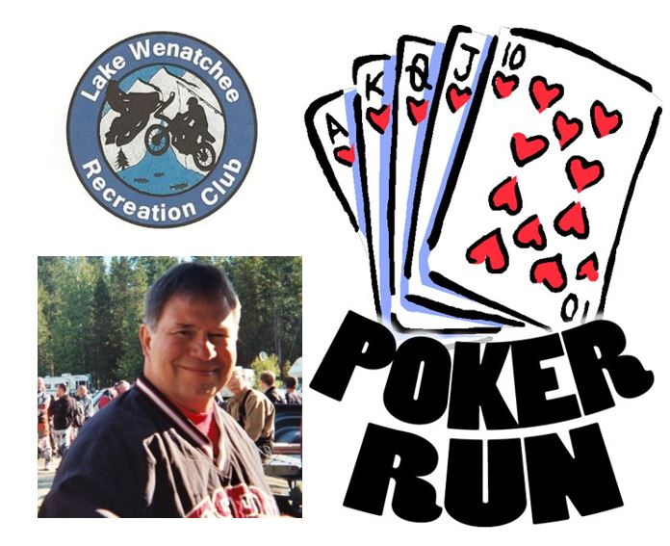  - saturday, February 19, 2022  2022 LWRC Bob Melson Memorial Poker Run  Open to public! Online pre-registration strongly suggested, but walk-ins welcome (cash, check or credit card).  Date: February 19, 2022 (weather permitting)  Pre-Registered Riders and Walk-ins must check in at LWRC clubhouse between 8-9:30 a.m.  Return to the LWRC clubhouse by 3 p.m. to draw final card, followed by prize drawings.  Cost per person: $10 for one hand, $15 for two or $25 for five hands.  Lunch available for purchase starting at noon.  Questions? Contact the LWRC at lakewenatcheerecclub@gmail.com or call Michelle at (509) 860-3220. Event information can be found at lakewenatcheerecclub.org.  Volunteer Opportunity! Contact us if you would like to help! | Ride Safe  Don’t ride alone  - Ensure your equipment is in good condition  Wear proper attire and helmet  Do not carry more than 1 passenger  Never ride impaired by drugs and/or alcohol  Follow other riders at a reasonable distance  Come to a complete stop before crossing roads  Inform others about your travel plans  Check the weather forecast  Lake Wenatchee Rec Club  14400 Chiwawa Loop Rd (Lake Wenatchee airstrip)  Leavenworth WA 98826  509-763-3858

