- 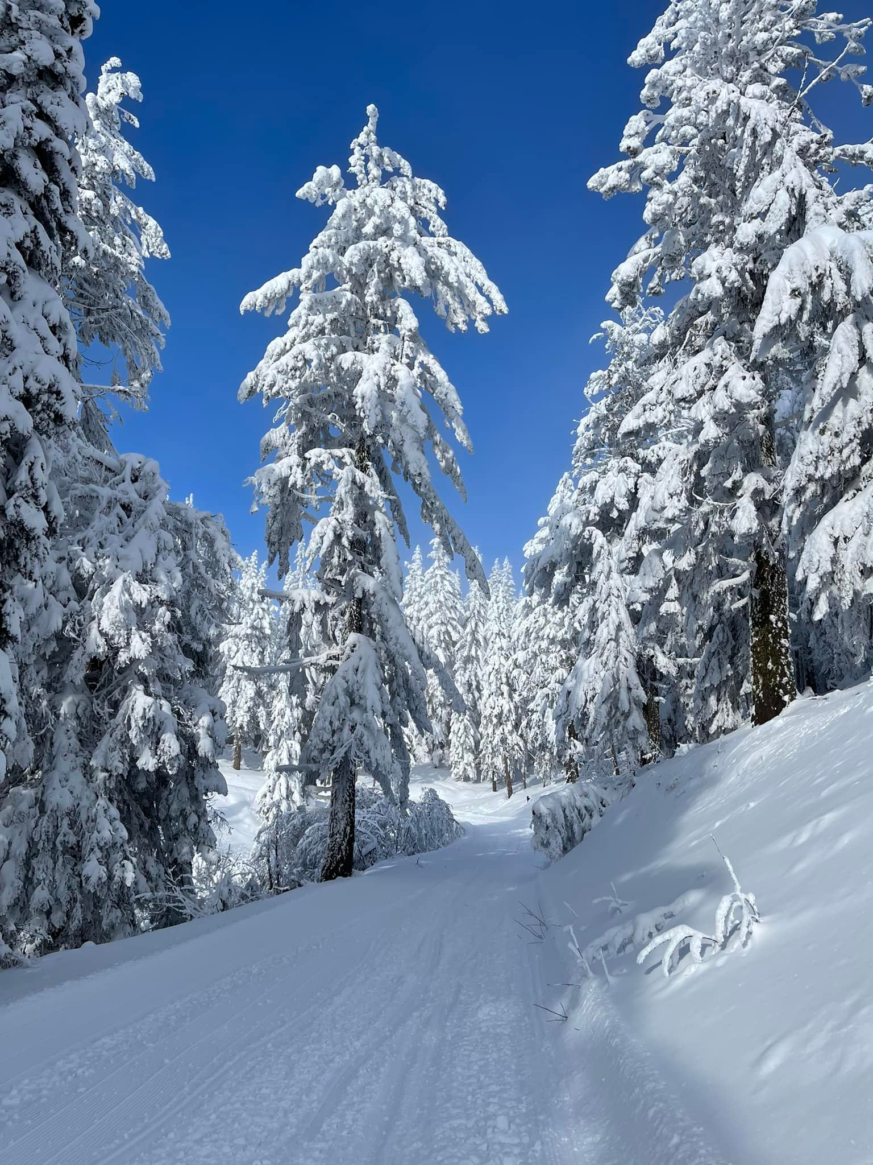  LWRC “tour thE twelve” in 2022” snowmobile adventure  Family-friendly snowmobiling activity (open to the public) with a chance to win cash or other prizes. Register any time between now and when the event closes on March 1, 2022.  During the 2021/22 snowmobile season, "tour" to 12 caches on the groomed trails to collect a sticker to affix to your "Tour the Twelve" official sticker sheet (the above picture shows Burt stashing stickers at one of the cache sites). You may register any time between now and when the event ends on March 1, and you don't need to collect all of the stickers on one day. Each entry is $25, and at the end of the event, you will be eligible to win cash and/or prizes (the more participants we have, the higher the cash prizes).  Registration: Go to lakewenatcheerecclub.org (Events) to find the link to purchase an event ticket via Eventbrite.  Questions? Contact the LWRC at lakewenatcheerecclub@gmail.com or call or text Michelle at (509) 860-3220. | Ride Safe  Don’t ride alone  - Ensure your equipment is in good condition  Wear proper attire and helmet  Do not carry more than 1 passenger  Never ride impaired by drugs and/or alcohol  Follow other riders at a reasonable distance  Come to a complete stop before crossing roads  Inform others about your travel plans  Check the weather forecast  Lake Wenatchee Rec Club  14400 Chiwawa Loop Rd (Lake Wenatchee airstrip)  Leavenworth WA 98826  509-763-3858

