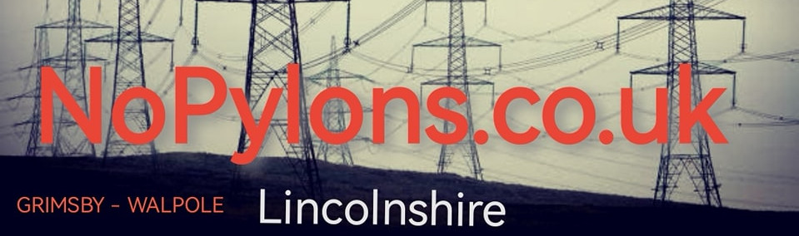
NATIONAL GRID are hoping that we won’t argue their ‘upgrade’ scheme, but they seriously underestimate the people of Lincolnshire and our determination to protect our county
They are proposing to erect around 250 of these 50m tall pylons (that’s like a 16-storey block of flats!) they will be 330m apart and stretch for 87 miles from Grimsby to Walpole, passing Louth, Alford, Burgh le Marsh, Boston, Spalding and crossing the Norfolk border. Tearing up farmland and towering over villages.
Not only will you see them everywhere, but you will also hear them and their distinctive rumbling hum. They will have a massive impact on the landscape, environment, natural habitats, tourism, farming, and all aspects of the local economy, driving down house prices and effecting the quality of life for many people.
The pylons are UNNECESSARY. An integrated offshore grid would be better, faster cheaper and more sustainable solution, you can find out more on our website.
We have until March 13th to register our individual objections: HERE IS HOW:
Email “I strongly object to the proposed pylons in Lincolnshire” to contact@g-w.nationalgrid.com or Write (the same) to Freepost G TO W (no stamp required) We do not have to use the feedback form on the National Grid website but you can. (and you can say much more than I object – but that is the minimum requirements for it to be logged)
To find out more about the proposals and our campaign visit www.nopylons.co.uk or find us on Facebook
Tell your neighbours, tell your friends!
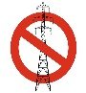
Let’s get thousands of people to tell National Grid: No Pylons in Lincolnshire

