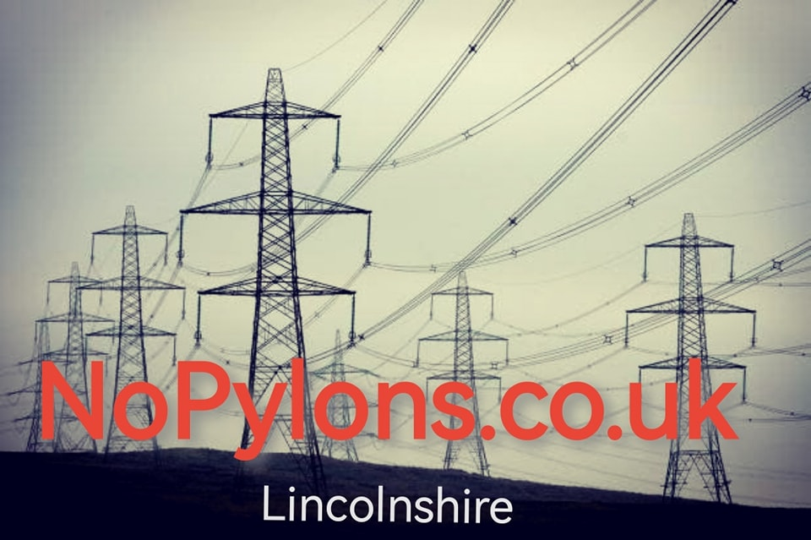
The Great Grid Upgrade is coming to your door.
The National Grid is proposing to bring 87miles of cables through our area strung from Pylons measuring 164ft (50m) and carrying a whopping 400KV right over our heads. This is electricity generated out at sea from wind turbines that will be used in and around London.
The Grimsby to Walpole stage is just one of 11 planned phases across the country in a bid meet Net Zero targets by 2050. And whilst we can all agree on the benefits of Green Energy and improving our aging Electricity infrastructure National Grid appear to be favouring the cheapest and quickest way and not the solution that offers the best results for the long term.
PYLONS ARE NOT PROGRESS
The recent underground Viking Link development has led the way in what is possible in this area and set the standard for all future projects so why have the National Grid taken a Step backward in the Grimsby to Walpole proposal.
To learn more and to make your voice heard visit our website www.nopylons.co.uk and follow us on Facebook.

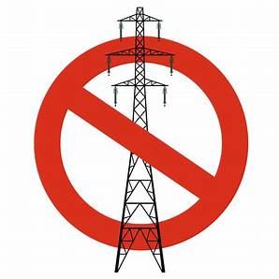
Let’s take back the power and say NO

