Basic Drill
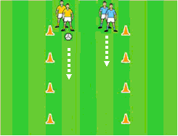
On the Ball
Players in pairs. Player in possession solos, partner attempts to tackle.

Basic Drill
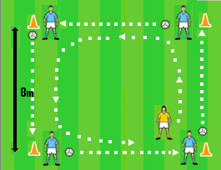
Around the Block
Players in possession at each corner, soloing. Other players move around square tackling.

Near Hand Tackle
Key Points
1. Move alongside opponent. Eyes on ball.
2. Move across with near leg when opponents far leg is forward.
3. Flick the ball away with near hand when the ball is free.
4. Recover ball to win possession

Head - Hands – Feet

STEP - Vary the activity
Vary Space Vary Task
Vary Equipment Vary Players

Intermediate Drill
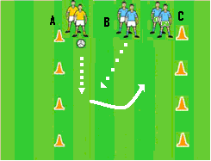
Tackle to Team Mate
Players in 3s. Player in possession solos, opponent attempts to tackle and third player picks up possession

Fun Game
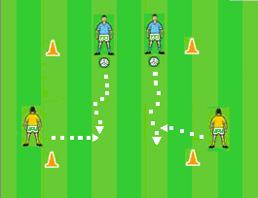
Grid Tackle
Players in possession attempt to solo through the grid. Defending players attempt to tackle.
Game Play Routine
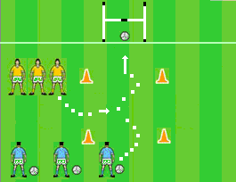
Last Man Standing
Players in possession attempt to solo through and score. Defending players attempt to tackle

