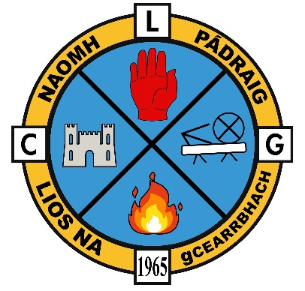**LGFA**

Annual General Meeting

Monday 29th November @7pm via Zoom

**Zoom details**

Join Zoom Meeting

<https://zoom.us/j/99576067691?pwd=UjluQ09MUWh4eFFMUmR0cnFHL09Odz09>

Meeting ID: 995 7606 7691

Passcode: vD1MXw

**Agenda for AGM**

* Annual Report of the Secretary
* Chairperson’s address
* Election of Officers & Members of the LGFA Committee (as required)
* Consideration of Recommendations & Resolutions to the incoming committee
* AOB

If you wish to nominate yourself for a specific post or have any recommendations/resolutions please email the current LGFA Secretary (Stephanie Casey) [stpatricks.antrim@lgfa.ie](mailto:stpatricks.antrim@lgfa.ie). (Please see committee structure on next page for roles) Any committee members seeking re-election must email also.

*The closing date for nominations to the committee positions and for motions and recommendations is* ***Friday 26th November @1pm***

* Only registered members of the LGFA will be able to vote at this AGM but everyone is welcome to attend.
* You must be a registered member of the club to nominate yourself to a post on the committee.

**Committee structure**

|  |  |  |  |
| --- | --- | --- | --- |
| Committee structure | Outgoing officer/member | Nominations for 2022 | Officer returned |
| Chairperson | Gerard Collins |  |  |
| Secretary | Stephanie Casey |  |  |
| Vice Chairperson | Michelle McNally |  |  |
| Ladies Players Rep. | Emma Marsden |  |  |
| Committee member | Christina Campbell |  |  |
| Committee member | Joanne Cartland |  |  |
| Committee member | Olivia Loughran |  |  |
| Committee member | Sharon George |  |  |
| Committee member | Tracey McMeel |  |  |

**TBC TBC (after agm)**