ABOUT US
St. Patrick’s GAC, Lisburn has been established as a club from 1965 and has since been developing and growing, providing Gaelic Football to the community of Lisburn and the greater Belfast area.

St. Patrick’s GAC Lisburn is the only Gaelic Athletic Club in Lisburn. The club provides activities for 400 members each season. Approximately 250 of these are under 18 years of
age and around 100 are under 10 years of age. The club has both male and female members, with female teams competing at Under 10, Under 12, Under 14 and Senior level. On the male side of the club there are teams competing at Under 10, Under 12, Under 14, Under 16 and Senior level.

Kirkwoods Playing Fields hosts training for all age groups at least once a week and during
Gaelic Season, hosts matches within the Antrim league weekly, welcoming teams from Belfast right up to Ballycastle, Glenravel and further afield. With developments to the pitches so far
including our new spectator railings around the main pitch, we will also now be able to host Championship matches which will see clubs from all over Ireland potentially using our facilities.

The Belfast Metropolitan Area planning report has marked the pitches as a designated area devoted to leisure and it is our ambition to maintain this standard, making the pitches available to as many people as possible. We now have an Outdoor Gym which will be accessed by the public from the pedestrian gate off Magheralave Road that is opened from morning to dusk to
allow public access. Currently the facilities are also used by St. Patricks GAC, three local schools, Loch Mor Gaels Hurling Club, Bootcamps and the Lisburn Model Flying Club, encouraging the area to be used by all members of the community.

Due to the fact that we are opening the pitches to the public, safety and potential vandalism will be monitored closely with the use of CCTV. We work closely with the local Council who
have been off great support to the club and help us to promote the facilities with occasional television broadcasts and promotional literature.

Within the next few years, plans to further develop Kirkwoods Playing Fields include the addition of a 3G training pitch, floodlights and running track to mention but a few. Hopes are
that these additions will increase the number of members within the club as well as increase the use by members of the public and other sporting associations.

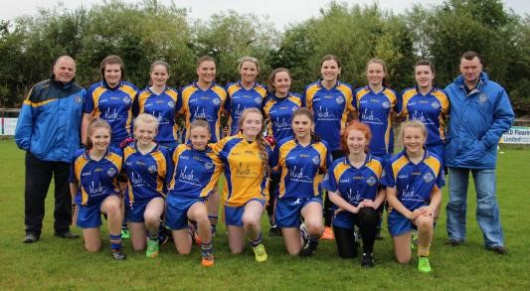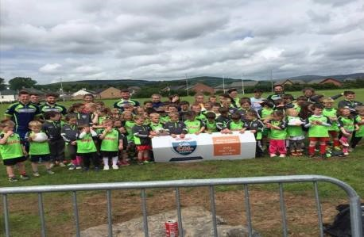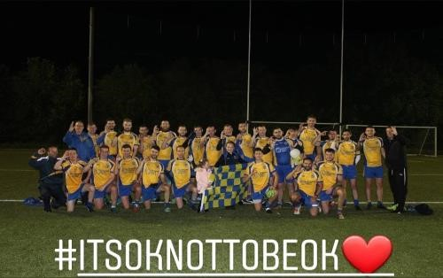
BENEFITS TO YOU!!

- 450 plus members using the facilities for training each week reinforces your company name through repetition.

- Weekly matches with various clubs within County Antrim –
10 teams in Senior Mens Football League (not including Championship)
15 teams in Senior Ladies Football League
Multiple teams competing in Underage leagues
15 players per team, plus coaches and management as well as supporters means weekly footfall to the pitches will be vast and widespread.

- Exposure across various social media platforms which is increasing daily currently sitting at:
Facebook – 1032 likes, Twitter – 1027 follows and Instagram – 992 follows

- Facilities used by other groups including 3 local schools increases the footfall and broadens the diversity and reach of potential customers.

- Recognised and opened as a public space with outdoor gym equipment meaning exposure is unlimited.

- Close monitoring and maintenance of the pitches ensures your advertising is well kept and quality is assured.

- Inexpensive advertising with opportunity to display your own design/ artwork printed to the highest quality.

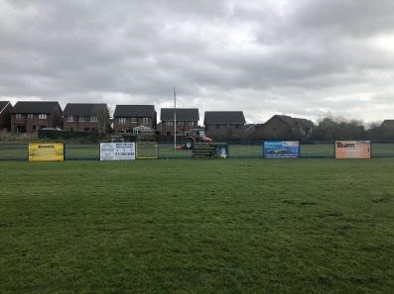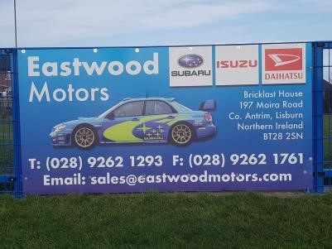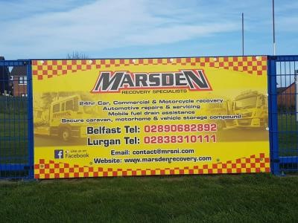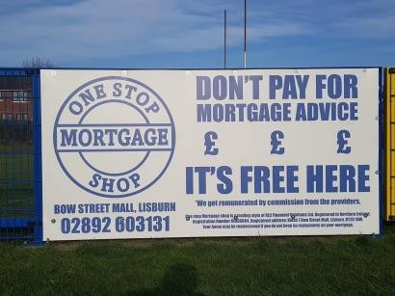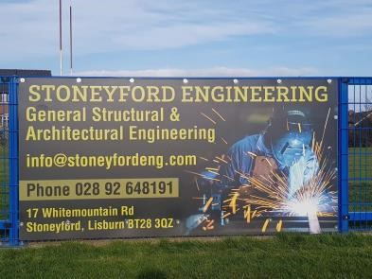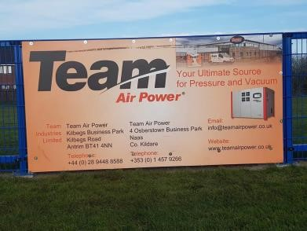

**THE OFFER**
8 X 4 SPECTATOR RAIL ADVERTISING

Option 1
1 YEARS ADVERTISING INCLUDING PRINTING AND INSTALLATION OF 8 X 4 BANNER
– DESIGN SUPPLIED BY YOU

£300.00

**SPECIAL**

Option 2
3 YEARS ADVERTISING INCLUDING PRINTING AND INSTALLATION OF 8 X 4
BANNER
-DESIGN SUPPLIED BY YOU

£550.00

Option 3

5 YEARS ADVERTISING INCLUDING PRINTING AND INSTALLATION OF 8 X 4 BANNER
DESIGN SUPPLIED BY YOU

£750.00

YEARLY ADVERTISING COSTS THEREAFETER
£150.00

Artwork or Company details along with letterhead/ logo to be sent to stephenbrannigan@live.com along with Standing Order form for production of banner.

8 X 4 SPECTATOR RAIL ADVERSTISING REGISTRATION FORM Option 1

Name of Bank: __________________________________________________

Address of Bank: ______________________________________________

____________________________________________________________

Account number:

Sort code:

I give permission for my bank to send £300.00 on the 1st day of 2021 to account number 93-83-35 25203 – 131 (Trustees of St. Patrick’s GAC No. 1 Account) held with AIB.

I give permission for my bank to send £150.00 on the 1st day of commencing 2022 and continuing yearly, until further notice to account number 93-83-35 25203-131 (Trustees of St. Patrick’s GAC No. 1Account) held with AIB.

Sinithe/Signed: _________________________ Data: ___________
Print Name: _______________________________________

8 X 4 SPECTATOR RAIL ADVERSTISING
REGISTRATION FORM Option 2

Name of Bank: __________________________________________________

Address of Bank: ______________________________________________

____________________________________________________________

Account number:

Sort code:

I give permission for my bank to send £550.00 on the 1st day of 2021 to account number 93-83-35 25203 – 131 (Trustees of St. Patrick’s GAC No.1 Account) held with AIB.

I give permission for my bank to send £150.00 annually commencing on the 1st day of
2024 to account number 93-83-35 25203-131 (Trustees of St. Patrick’s GAC No. 1 Account) held with AIB.

Sinithe/Signed: _________________________ Data: ___________
Print Name: _______________________________________

8 X 4 SPECTATOR RAIL ADVERSTISING REGISTRATION FORM Option 3

Name of Bank: __________________________________________________

Address of Bank: ______________________________________________

____________________________________________________________

Account number:

Sort code:

I give permission for my bank to send £750.00 on the 1st day of 2021 to account number 93-83-35 25203 – 131 (Trustees of St. Patrick’s GAC No. 1 Account) held with AIB.

I give permission for my bank to send £150.00 annually commencing on the 1st day of
2026 to account number 93-83-35 25203-131 (Trustees of St. Patrick’s GAC No. 1Account) held with AIB.

Sinithe/Signed: _________________________ Data: ___________
Print Name: _______________________________________

TERMS AND CONDITIONS

- Banners not to exceed size 8ft x 4ft
- Artwork/ design to be provided by companies for printed banners.
- No more than 50 banners to be displayed in any given year. Should this limit be reached, your request will be put on a waiting list in the case that a company does not wish to renew their yearly advertising.
- Payment will be made up front on the first date of the month as specified in registration form.
- Payment of £150.00 yearly will continue be taken on a standing order basis unless cancelled by company with their own bank.

I agree to the terms and conditions set out by St. Patrick’s GAC, Lisburn and approve agreement as registration form attached.

Sinithe/Signed: _________________________ Data: ___________
Print Name: _______________________________________
Company:

Sinithe/Signed: _________________________ Data: ___________
Print Name: _______________________________________
On Behalf of St. Patrick’s GAC, Lisburn

