Basic Drill
Pass and Follow
Each player Punt Kicks to the next player and continues to that line

Basic Drill
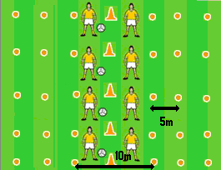
Partner Kick
Players in Pairs. Mark out various distances. Players to punt kick to partner over each distance

Punt Kick
Key Points
1. Release ball into the hand at kicking side
2. Step forward with non-kicking foot
3. Kick ball with instep
4. Toes pointed, follow through

Head - Hands – Feet

STEP - Vary the activity
Vary Space Vary Task
Vary Equipment Vary Players

Intermediate Drill
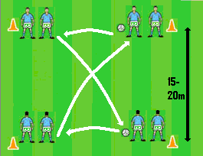
Turn and Kick
Ball is kicked along the sides and across the diagonal.

Intermediate Drill
Down the line
Players move forward and Punt Kick the ball to the next player and join the back of that line

Intermediate Drill
Six Star Drill
Players Punt Kick to the player at the second marker on their right and joins that line

Fun Game
Empty the Circle
Players in the circle keep the circle clear by Punt Kicking any balls out of it.

Fun Game
Hit the Cones
Players Punt Kick the ball to hit the cones in the middle

Modified Game
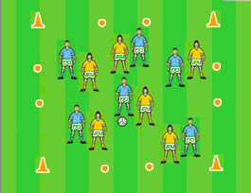
Four Goal Game
Place 4 goals – 1 in each side of a grid. Teams attack and defend 2 sets of goals

