



[This Photo](https://aemora.pt/?page_id=3161) by Unknown Author is licensed under [CC BY](https://creativecommons.org/licenses/by/3.0/)

**September 2025**

Please can everyone check to see if their funding codes need renewing, we have a few children in their ‘grace period’. ALL children eligible for the working family funding will get 30 hours from September. Don’t forget working families are also eligible to tax free childcare (20% of your invoice paid by the government) I have popped the link below if you need it.

[Homepage | Childcare Choices](https://www.childcarechoices.gov.uk/)

The deadline to bring in your booking forms is **Monday 19th May**, but if you can bring them back as soon as possible we would really appreciate it. If you have any queries, just email Kylie.



[This Photo](https://freepngimg.com/png/92431-line-lotion-drawing-yellow-sunscreen-download-hd-png) by Unknown Author is licensed under [CC BY-NC](https://creativecommons.org/licenses/by-nc/3.0/)

**Sun cream & Hats**

Please can all parents ensure their child has suncream that is labelled with their name on, a sun hat and crocs or sandals (the wellies have been rubbing their legs when its very warm)

Even on days where it does not particularly feel warm, the UV rays may still be high.

Please could you make sure your child has suncream on when they arrive in the morning.

I have attached the sun care policy for you all to look at.

**Father’s day junk modelling** is coming up on the **12th June 9am-10am**.

We invite all our daddy’s (and mummy’s) in to celebrate Father’s Day. You will have hot drinks and cake whilst creating something with your little one, we will have all the resources you just bring the creativity! There will be a prize for the best model 😊

We will be sending out invitations soon.

Little Squirrels news

May 2025

**Question of the month**

Please respond to our online question of the month. It helps us to evaluate our practice 😊

**Nursery contact information: Tel:** 01905 620498

**Nursery Email**: [shrawley@littlesquirrelsltd.co.uk](mailto:shrawley@littlesquirrelsltd.co.uk) **Finance Email**: [finance@littlesquirrelsltd.co.uk](mailto:finance@littlesquirrelsltd.co.uk) **Jo’s email**: [head@littlesquirrelsltd.co.uk](mailto:head@littlesquirrelsltd.co.uk) **Facebook page**: [www.facebook.com/LiSq13/](http://www.facebook.com/LiSq13/) **Instagram page**: <https://instagram.com/littlesquirrels_shrawley> **Nursery Website**: https://littlesquirrelsltd.co.uk

**Parent group**

We have a parent support group on WhatsApp, if you would like to join, please follow the link below.

<https://chat.whatsapp.com/FdY3G352D2z1idyv8F58EG>

**Dates for your diary**

Monday 26th May – **Bank holiday nursery closed**

Monday 26th May – Friday 30th May – **Half term**

Thursday 12th June – **Father’s Day junk modelling 9am-10am**

Wednesday 25th June **– Parents evening 6pm-7pm**

Thursday 26th June **– Parents evening 6pm-7pm**

Saturday 12th July – **Summer Fayre 11am-1pm (If anyone would like a stall let me know 😊)**

Wednesday 16th July – **Parent stay and play yoga.**

Thursday 17th July – **Graduation party 1.30pm-3pm**

Friday 18th July – **Term time only children last day.**

Monday 21st July – Monday 8th September **Summer holiday for term time only children.**



**Healthy lunch boxes**

For those who are thinking of proving their own lunch and snacks from September I have popped a couple of links underneath for healthy lunch box ideas 😊

[Are_You_Packing_A_Healthy_Lunch_A5_Leaflet ENGLISH.pdf](https://www.education-ni.gov.uk/sites/default/files/publications/de/Are_You_Packing_A_Healthy_Lunch_A5_Leaflet%20ENGLISH.pdf)

[Lunchbox ideas and recipes – Healthier Families - NHS](https://www.nhs.uk/healthier-families/recipes/healthier-lunchboxes/)

**Keep Me Safe… When I’m with Dogs**

**The Keep Me Safe…When I'm With Dogs** campaign promotes responsible dog ownership, while demonstrating the best way for people to stay safe around dogs.

[Keep Me safe... When I'm With Dogs: Herefordshire and Worcestershire Integrated Care System](https://herefordshireandworcestershire.icb.nhs.uk/about-us/safeguarding/keep-me-safe/keep-me-safe-when-im-dogs)

**Starting Reception: Support for Parents**

Created collaboratively by a range of Early Years experts as part of the government’s [Plan for Change,](https://www.gov.uk/missions) resources to support children who are starting reception are available to:

* Close the gap between what parents and teachers view as being ‘school ready’
* Build children’s confidence and independence
* Reach the government’s target to raise the number of children who are ready to start reception to 75%
* Support children with SEND and their families by recognising the importance of ensuring education settings are ready to support them and their parents to practise key skills in the home.

[Home - Starting Reception](https://startingreception.co.uk/)

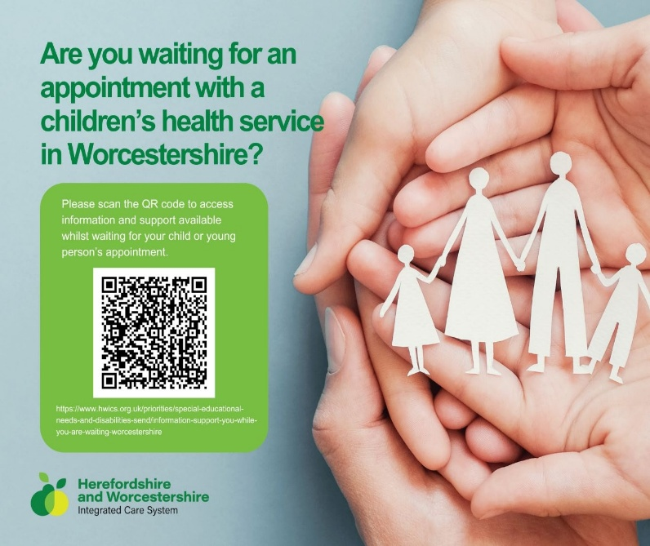

**Family support services**

This is a link to the Worcestershire virtual family hub, there are so many services you can access including local family hubs in the area, free training courses you can do online, keeping children safe, mental health and wellbeing support services and so much more. If you need any advice on any of these just let me know 😊

[Virtual Family Hub | Worcestershire County Council](https://www.worcestershire.gov.uk/council-services/childrens-social-care/virtual-family-hub)