
Fairy Cakes (makes 12)

Ingredients:

- 110g/4oz margarine, softened at room temperature
- 110g/4oz caster sugar
- 2 eggs
- 1 tsp vanilla extract (optional)
- 110g/4oz self-raising flour
For the icing
- icing sugar
- water
- hundreds and thousands to decorate

Method:

- ﻿﻿﻿Preheat the oven to 180C/160C Fan/Gas 4 and line 2 x 12-hole fairy cake tins with paper cases.
- ﻿﻿﻿Mix the butter and sugar together in a bowl until pale. Beat in the eggs, a little at a time, and stir in the vanilla extract.
- ﻿﻿﻿Fold in the flour using a large metal spoon. Add a little milk or warm water if the mixture is stiff. Spoon the mixture into the paper cases until they are half full.
- ﻿﻿﻿Bake in the oven for 10-15minutes, or until golden-brown on top. Set aside to cool.
- ﻿﻿﻿For the icing, mix icing sugar with a little water at a time to create a smooth mixture.
- ﻿﻿﻿To ice the fairy cakes, drizzle the icing over the cakes, sprinkle with decorations and set aside until the icing hardens.

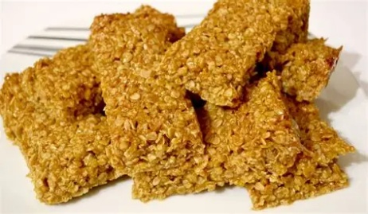
Flapjack Recipe

Ingredients:

- 175g/6oz butter
- 175g/6oz golden syrup
- 175g/6oz light brown sugar
- 350g/12oz porridge oats

Method:

- ﻿﻿﻿Preheat the oven to 150C/130C Fan/Gas 2 and grease a 20cm/8in square baking tin with butter.
- ﻿﻿﻿Melt the butter in a medium pan over a low heat.
- ﻿﻿﻿Add the golden syrup and sugar to the butter and heat gently. Once the sugar is dissolved and the butter is melted, remove the pan from the heat and stir in the porridge oats.
- ﻿﻿﻿Pour the mixture into the baking tin and squash down. Bake in the oven for 40 minutes.
- ﻿﻿﻿Once cooked, remove from the oven, leave to cool for 15 minutes, then turn out onto a chopping board and cut into square


Jam Tarts

Ingredients:

- 250g plain flour
- 125g unsalted butter
- 2-3 tablespoons of cold water
- Jam of your choice

Method:

- ﻿﻿﻿Put the flour in a large bowl and rub in the butter using your fingertips until it looks like breadcrumbs.
- ﻿﻿﻿Mix in the water a spoon at a time until the dough comes together.
- ﻿﻿﻿Preheat your oven to 180°C.
- ﻿﻿﻿Roll the Dough on a floured surface, roll out the dough to about 3mm thickness.
- ﻿﻿﻿Cut the Pastry, use a pastry cutter to cut out circles slightly larger than the tin, repeat until all pastry used.
- ﻿﻿﻿Place a teaspoon of jam into each tart and bake in the oven for 15-20 minutes until golden brown.
- ﻿﻿﻿Cool down before eating.


Chocolate cookies

Ingredients:

- 250g butter
- 250g sugar
- 400g plain flour
- 2tsp baking powder
- 100g chocolate chips
- 2 eggs

Method:

- Pre heat the oven to 180°C
- Mix sugar and butter together
- Beat the eggs and add to mixture
- Stir in the flour and baking powder
- Add chocolate chips of choice
- Put tablespoon of mixture on greaseproof paper on baking tray, leaving a gap between each scoop.
- Bake for 12 minutes
- Cool before eating

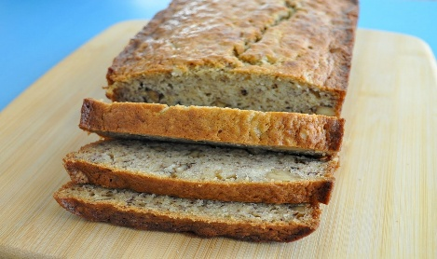
Banana Bread
This Photo by Unknown Author is licensed under CC BY-NC-ND

Ingredients:

- 3 medium ripe bananas
- 1 teaspoon of baking powder
- 150g sugar
- 1 large egg
- 205g self raising flour
- 1 teaspoon vanilla extract

Method:

- Preheat the oven and grease t an 8x4 loaf tin
- Mash the bananas until smooth
- Melt the butter and add to the bananas
- Mix in the baking powder, sugar, egg, flour and vanilla extract
- Pour into the loaf tin and bake for 50-60 minutes
- Cool and serve


Pizza Twists
This Photo by Unknown Author is licensed under CC BY-NC-ND

Ingredients:

- Ready roll puff pastry
- Grated cheese
- Tomato puree
- Ham
- Oregano
- (other pizza toppings of choice)

Method:

- Unroll pastry and spread tomato puree over half the pastry
- Add a little oregano to add flavour
- Sprinkle cheese over the tomato puree and add toppings
- Fold over the other half of pastry on top and cut into strips.
- Twist the strips and place on a grease proof paper and bake for 8-10 mins until the pastry is crispy
- Cool slightly and enjoy

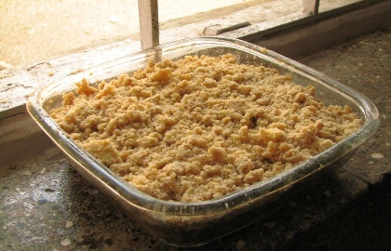
Apple Crumble
This Photo by Unknown Author is licensed under CC BY-SA

Ingredients:

- 500g eating apples
- 6 tablespoons of water
- 1 tablespoon of caster sugar
Topping:
- 200g plain flour
- 100g butter (cubed)
- 90g caster sugar

Method:

- Pre heat the oven to 180°C
- Peel, core and chop apples into small chunks
- Add to a medium deep dish and add the water and sugar
- Wash and dry hands well. In a new bowl add the flour and butter and rub between fingers to make coarse breadcrumbs
- Stir in the sugar to breadcrumbs mixture.
- Sprinkle breadcrumb mixture over the apples and bake for 40 minutes or until golden brown
- Leave to cool slightly before serving.

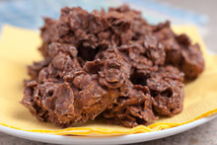
Cornflake Cakes

Ingredients:

- 225g chocolate
- 3 tablespoons of golden syrup
- 50g melted butter
- 100g corn flakes

Method:

- Put fairy cake cases into a tin
- Break up the chocolate and melt slowly in microwave
- Add melted butter and syrup
- Add cornflakes and stir making sure they are all coated
- Spoon the mixture into cake cases and put in the fridge to set.

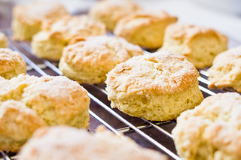
This Photo by Unknown Author is licensed under CC BY-SA

Scones

Ingredients:

- 225g self raising flour
- 1 teaspoon baking powder
- 50g butter (cubed)
- 25g caster sugar
- 150ml milk
- Extra milk for brushing
- Butter or cream and jam for filling

Method:

- Grease 2 baking trays with butter and pre heat oven to 200°C
- Sift the flour and baking powder into a bowl
- Add the butter and rub between fingertips until it resembles breadcrumbs
- Stir in the sugar and add the milk bit at a time, bring the mixture together to make a soft dough
- Sprinkle an area with flour to then roll out the dough until 1cm thick
- Cut circles from the dough using a cutter and add to baking tray.
- Repeat until all the mixture has been used
- Brush the tops with milk and bake for 7-10 minutes
- Cool on a wire rack and enjoy with butter and jam.

