



**Each staff member is responsible for reading the entire document, paying particular attention to the provisions most applicable and relevant to their position and directing any questions or concerns to their supervisor.**

**This manual is a “living” document that will be updated as SCRAPS’ methodologies, policies, and procedures for serving the needs of Spokane County’s human and nonhuman populations change. Any staff member’s suggestions for changes, additions, or deletions should be directed to their supervisor.**

57T

# TABLE OF CONTENTS

# 1 PURPOSE OF POLICY MANUAL

## 1.1 PURPOSE

The purpose of this manual is to codify organizational policies that guide organizational undertakings.

## 1.2 APPLICABILITY

When any conflict arises between this manual and any applicable law, labor contract, or other more specific document (e.g., insurance policy, written policy of an Elected Official), the applicable law, labor contract, or more specific document shall prevail.

## 1.3 DISCLAIMER

Nothing contained in the Policy Manual is intended to imply, in any manner or form, a contract of employment or otherwise form a part of the employment relationship between Spokane County and the employee.

## 1.4 EMPLOYEE RESPONSIBILITY

This manual sets forth the organization’s policies in direction of organizational personnel carrying out their duties and responsibilities.

Each staff member is responsible for reading, comprehending, and complying with the contents of this manual, including changes and additions. Violations of this manual’s contents may be grounds for disciplinary action.

## 1.5 OTHER OFFICAL DEPARTMENT PUBLICATIONS

In addition to this manual, employees are expected to keep abreast of email and other written communications that provide specific information regarding the organization’s operation. Any conflict between an email or other written communication and this manual shall be broached with the Director.

# 2 INTRODUCTION

## 2.1 PURPOSE OF COUNTY GOVERNMENT

The Spokane County Commissioners and other Spokane County elected officials are stewards of Spokane County resources and elected to provide services to Spokane County citizens. Appointed employees assist the Commissioners and elected officials in carrying out their public service obligations. Each Spokane County employee, whether elected or appointed, is accountable to the public served.

## 2.2 OBJECTIVES OF COUNTY GOVERNMENT

Spokane County, through its elected officials and appointed employees, strives to provide public services with efficiency, economy, integrity, and dedication. Toward that end, Spokane County:

* Supports and encourages integrity in relations;
* Encourages the continuing education and skill development of employees; and
* Supports innovation and creativity, encouraging employees to become problem solvers.

## 2.3 SCRAPS’ MISSION STATEMENT

To “build[] a more humane community, protect[] public safety and ensure[] animal welfare through compassionate, responsive, professional enforcement of laws and public policy”.

## 2.4 DEPARTMENT ORGANIZATION CHART

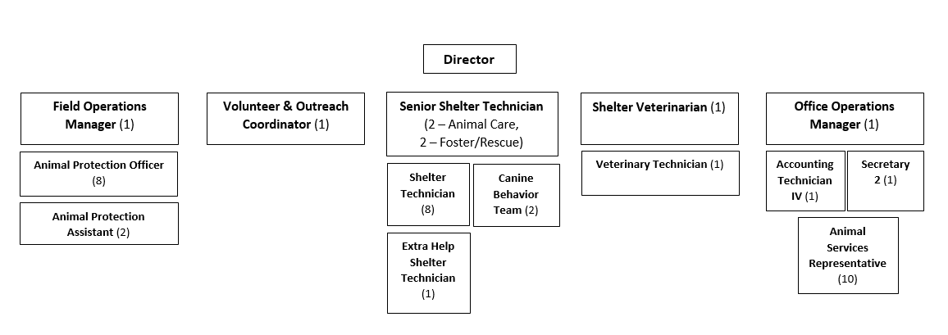

# PERSONNEL MATTERS

## 3.1 CHAIN OF COMMAND

An employee should direct complaints, questions, and concerns to their supervisor or manager (or, in their absence, the Director).

## 3.2 CONTACT INFORMATION

Employees are responsible for providing SCRAPS with their current addresses and telephone numbers, even when a change of address or telephone number is of a temporary nature.

## 3.3 PHYSICAL FITNESS

Employees are required to maintain a level of physical fitness that allows them to perform their duties effectively and efficiently. If a question arises about an employee’s ability to satisfy job requirements, the employee may be required to submit to a “fit for duty” examination by a Spokane County physician and improve their physical fitness.

## 3.4 REPORTING FOR DUTY

Employees will report for their shifts on time, sufficiently physically and mentally fit to perform their duties, and properly equipped to perform their duties.

## 3.5 REPORTING LATE OR SICK

Employees reporting late for a shift or calling out sick must notify their supervisor or manager at least two hours before said shift’s scheduled start time.

**Lindsey Soffes – Director**

*Work:* 509-477-1967

*Cell:* 425-530-2712

**Ashley Proszek – Field Operations Manager**

*Work:* 509-477-6865

*Cell:* 509-263-8097

**Lynnette Brown – Office Operations Manager**

*Work:* 509-477-4221

*Cell:* 509-979-2522

**Beth O’Keeffe** **– Shelter Veterinarian**

*Work:* 509-477-2747

*Cell:* ____________________

## 3.6 WORKING A FULL SHIFT

Employees must remain on-duty for their entire, assigned shifts unless excused by their supervisor or manager, or the Director.

## 3.7 SICK LEAVE/BEREAVEMENT LEAVE

An employee who (1) contracts a sickness or incurs a disability that renders them unable to perform their duties or (2) suffers a death in their immediate family that requires their presence shall receive accumulated paid sick leave. The employee must complete a leave request form upon returning to work, and SCRAPS may require a treating physician’s statement to determine if an employee’s return to work is approved by Risk Management.

For limitations, usage, and reasonableness determinations, *see Spokane County Employee Policy 313; Local 1553, Article 10 Section 10.4.3 and 10.9.*

## 3.8 INITIATING A SUIT

No employee will bring a civil suit against a citizen for damages sustained in the line of duty without first reporting the case in writing to the Director, Spokane County Chief Executive Officer, and Spokane County Risk Management Department.

## 3.9 BEING NAMED AS A RESPONDENT

Any employee who (1) becomes aware that they will be named as a respondent in a civil suit borne out of actions they took in their official capacity or (2) is served with a subpoena or other legal document relating to the procedures of the department will immediately notify the Director, the Spokane County Chief Executive Officer, and the Spokane County Risk Management Department in writing.

## 3.10 RESIGNATION AND SEPARATION FROM EMPLOYMENT

When an employee separates from SCRAPS via retirement, resignation, or dismissal, the following must be addressed:

* Letter of resignation (if applicable);
* Return of department-owned equipment;
* Accrued vacation pay-out; and
* Exit interview with Spokane County Human Resources.

## 3.11 CONTROLLED SUBSTANCES

All controlled substances and delivery systems must be kept securely and accessed only by authorized, properly trained employees.

# 4 RULES OF CONDUCT

## 4.1 BEHAVIORAL STANDARDS

In engaging with coworkers, members of the public, and Spokane County leadership, employees must be courteous, attentive, patient, forthright, and respectful, in addition to abiding by the Spokane County Behavioral Standards.

## 4.2 COMPETENCE

Employees must perform their assigned duties in a competent manner.

Incompetence may be demonstrated by:

* A lack of knowledge or understanding of the implicated policies, procedures, or laws;
* An unwillingness or inability to perform assigned tasks;
* A failure to conform to work standards, take appropriate actions, utilize discretion diligently, or abide by Spokane County Behavioral Standards; and/or
* Repeated work evaluations demonstrating substandard performance.

## 4.3 DIVULGING PERSONAL INFORMATION

Employees may *not* divulge any personal information concerning another employee unless authorized by that employee or the Director.

## 4.4 WORKING OUT OF CLASS

Employees must receive advance approval for all out-of-class work from the Director (or, in their absence, the employee’s supervisor or manager).

## 4.5 POLITICAL ACTIVITIES ON DUTY

Involvement in partisan political activities (e.g., soliciting or receiving a contribution for a political party, distributing political literature) is not permissible during an employee’s on-duty time.

## 4.6 PUBLIC/MEDIA STATEMENTS

Employees may not make statements on behalf of SCRAPS for publication or broadcast unless authorized to do so by the Director. In such a case, employees are responsible for ensuring that all public statements are accurate and, when applicable, presented as reflecting personal opinion.

## 4.7 PERSONAL APPEARANCE

Employees must maintain a neat, clean appearance while on-duty.

## 4.8 NEGLECT OF DUTY

While on duty, employees must remain attentive to their assigned responsibilities; shirking of duties or the like may be deemed neglectful.

## 4.9 VERBAL ABUSE AND HARRASSMENT

Employees may not verbally or otherwise abuse or harass either their co-workers, supervisors, or customers. SCRAPS will not tolerate harassment or discrimination based on race, color, religion, sexual preference, or a mental, physical, or sensory handicap; unwelcome sexual advances, requests for sexual favors, or other verbal or physical conduct of a sexual nature that constitutes sexual harassment; or false accusations, knowingly or maliciously made, alleging verbal abuse or harassment.

## 4.10 USE OF ALCOHOL

Employees may not consume alcoholic beverages of any kind while on-duty and may not report for duty while under the influence of alcohol to any degree.

The consumption of alcohol before or during operation of a County vehicle is prohibited. Alcoholic beverages should not be purchased by an employee in uniform or driving a County vehicle, and no Spokane County vehicle shall be parked at or near a bar or tavern unless the employee driving the vehicle has official business on the premises of the bar or tavern.

## 4.11 DRUGS AND MEDICATIONS

Employees may not have in their possession any controlled substances, narcotics, or hallucinogens *except* when legally prescribed by a physician or dentist.

Employees taking prescription medications that may affect their work performance must notify their manager or the Director.

## 4.12 DUTY TO REPORT MISCONDUCT

Employees must report to their manager or the Director violations of department orders, neglect of duty, or illegal conduct by other employees.

## 4.13 DISCIPLINARY ACTION

Complaints against employees (whether originating from a citizen, a fellow employee, a manager, the Director, or another agency) will be thoroughly reviewed.

If a complaint is found to be sustained, disciplinary action may be taken. Depending on the severity of the violation involved and the employee’s past record, such action may include but will not necessarily be limited to:

* *Oral reprimand.* Will not form the basis of further disciplinary action after 12 months if there have been no secondary offenses concerning the same matter.
* *Written reprimand*. Will not form the basis of further disciplinary action after 24 months if there have been no secondary offenses concerning the same matter.
* *Suspension.*
* *Termination*.

Employees will be notified promptly of any disciplinary action to be taken and have the right to Union representation where prescribed.

## 4.14 REPORTS, RECORDS, DEPARTMENT INFORMATION

Employees must accurately/truthfully and timely complete and submit all required records, reports, and forms and treat subject information with confidentiality as necessary or appropriate.

## No employee may falsify, destroy, illegally alter, or remove any record, report, or form, and any employee having knowledge of such behavior by another employee must report it their manager or the Director.

## 4.15 COMMUNICATION

Employees must answer or otherwise promptly respond to phone calls coming in to their work stations.

Employees must check their voicemails and emails routinely throughout their shifts.

## 4.16 VEHICLE USE POLICY

All County vehicle operators must have in their possession a valid Washington State Driver’s License.

Employees may not drive a Spokane County vehicle outside of Spokane County unless on official business or with permission from their manager or the Director.

Employees may not invite non-employees to “ride along” unless approved by the Director.

*See* *Policy No. 630 of the* *Spokane County Personnel Policy Manual* for the detailed vehicle use policy: [8Thttp://countyideas/Internal%20Services/Human%20Resources /Pages/default.aspx](http://countyideas/Internal%20Services/Human%20Resources/Pages/default.aspx)3.

## 4.17 BOMB THREAT

In the event of a bomb treat, all staff must be notified using the organization-wide paging system; all staff must exit the facility; and 911 must be called immediately.

# 5 BUILDING OPERATIONS

## 5.1 HOURS OF OPERATION

Shelter:

12:00PM – 7:00PM: Monday, Tuesday, Wednesday, Friday.

11:00AM – 5:30PM: Saturday, Sunday.

Phones: 10:00AM – 5:00PM Daily.

Emergency Services: 5:00PM – 8:00AM via PassWord.

## 5.2BUILDING SECURITY

All Page: By picking up a phone receiver and dialing 1397, an announcement can be made to everyone in and around the shelter.

Panic Buttons: In the event of an emergency, press a panic button in on both sides to summon help. (Whenever possible, call 911 first.)

Panic buttons are located at: (1) the 3 main workstations at the front counter (excluding the station directly across from the Office Operations Manager’s office); (2) both stations in the animal receiving room; (3) on the northeast side of the outside garage wall; (4) on the north wall to the east of the rolling door between the euthanasia room and the crematorium.

## 5.3 POWER OUTAGE

In the event of a power outage, an employee must call Avista (800-936-6629), the Spokane County Informational Technology Department (509-477-6020), and PassWord (509-622-9750).

When power returns, the Spokane County Information Technology Department and PassWord must be notified.

# 6 All DEPARTMENT GENERAL INFORMATION & POLICIES

## 6.1 DEPARTMENT DOCUMENTS

Documents used by staff are available in SCRAPS’ shared documents folder on the One Drive, accessible here: ________________________.

Employees should store documents to be accessed by multiple staff members here (in the most appropriate folder), while documents for a particular employee’s use only should be saved in their home directory.

**6.2 STRAY HOLDING PERIODS**

For purposes of establishing a stray animal’s holding period, stray animals are considered “identified” when (1) impounded with a pet license, Rabies tag, or other tag that provides traceable and viable owner information; (2) impounded with a microchip that has been registered, implanted by SCRAPS, or implanted by a facility that has retained and is willing to share viable owner information; (3) at the time of impound or within the legal holding period that follows, a person/organization or law enforcement provides traceable and viable owner information; (4) the animal is impounded pursuant to a law enforcement request predicated on the owner’s arrest or hospitalization; or (5) the animal is impounded as a result of the death of the owner.

If traceable and viable owner information is not provided or available at the time of an animal’s impound but is later provided or later becomes available, the appropriate legal holding period will be consider to extend from the date and time of the animal’s impound (rather than the date and time that the information was provided or became available, with the exception that a missed microchip triggers a fresh, five-day hold from the date of the microchip’s finding).

If one or more pieces of traceable and viable owner information conflicts with other traceable and viable owner information, fact- and circumstance-specific consideration must be undertaken in consultation with a supervisor or manager, or the Director.

Traceable: For owner information to be considered “traceable”, it must include an address, a phone number, and/or an email address; an owner’s name without any of the aforementioned pieces of information does not constitute “traceable” owner information, and social media handles do not constitute “traceable” owner information.

Viable: For owner information to be considered “viable”, it must provide a means reasonably anticipated to allow for contact to be made with the animal’s owner. (By way of example, a phone number found to be disconnected is not considered a “viable” piece of owner information.)

Dogs:

* *Identified dogs* are held for a minimum of five (5) business days from the date and time of impound.
* *Unidentified dogs* are held for a minimum of three (3) business days from the date and time of impound.

Cats:

* *Identified cats* are held for a minimum of five (5) business days from the date and time of impound.
* *Unidentified cats* are not held for any prescribed period of time.

*Animal Service Representatives* are to make all reasonable efforts to contact a stray animal’s owner(s), including:

* Calling all associated phone numbers, including any listed on an animal’s tag(s);
* Sending an email to any known email address of the animal’s owner;
* Mailing a postcard to the last known address of the animal’s owner;
* Contacting any institution (e.g., jail, hospital) at which the animal owner is believed to be residing; and
* Tracing the animal’s microchip in NetSAMS and ShelterBuddy and, whenever necessary, through the microchip’s manufacturer and/or institution of implantation.

*Animal Protection Officers* are to make all efforts to contact a stray animal’s owner(s), including those listed previously for Animal Service Representatives. If leaving a violation notice in the field, the officer must also call all phone numbers and mail a postcard to the owner’s last known address.

All steps taken to contact a stray animal’s owner(s) must be recorded under General Ownership Notes in ShelterBuddy.

Once an animal’s legal stray hold expires, SCRAPS becomes the legal owner/guardian of the animal and, as such, enjoys full discretion with regard to care and placement determinations.

An owner/guardian may be permitted to reclaim his/her animal after the legal stray hold has expired, but such animal must be spayed/neutered (at the owner’s/guardian’s expense) and microchipped prior to the owner/guardian retaking physical possession of the animal.

## 6.3 PERSON IDENTIFICATION

Persons seeking to adopt or reclaim an animal must provide a form of government-issued, photo identification (e.g., a state-issued Driver’s License). Approval to proceed in the absence of such identification may only be made on a case-by-case basis (when there is sufficient proof of identification through, e.g., multiple forms of non-photo, government-issued identification, law enforcement identification of the person, etc.) and must be approved by the Director.

A person unable to visit the shelter in person with government-issued, photo identification may submit via email to SCRAPS a photograph of themselves holding up government-issued, photo identification next to their face along with a note specifying the date the photograph was taken. If the information on the identification matches the person, such person may then provide approval for a third-party to reclaim their animal on their behalf. The third-party reclaiming must provide government-issued, photo identification at the time of the reclaim.

Persons seeking to relinquish an animal into SCRAPS’ care must provide a form of government-issued, photo identification (e.g., a state-issued Driver’s License) whenever at all practicable (e.g., if they claim to have forgotten their identification, they must leave and return with it as long as the animal they are relinquishing is not in medical or behavioral distress). Persons seeking to relinquish an animal under legally questionable circumstances or circumstances in which the staff reasonably believes the persons to be untruthful must provide a form of government-issued identification in all cases, unless exempted by the Director.

Persons adopting an animal from or relinquishing an animal into SCRAPS’ care must be at least 18 years of age.

## 6.4 PROOF OF OWNERSHIP/GUARDIANSHIP

Persons seeking to reclaim an animal impounded by SCRAPS must proffer proof of legal ownership/guardianship to ensure that animal is being returned to the proper party.

In the absence of contradictory information, the following may serve as proof of ownership:

* microchip registration information (or information from the implant facility);
* animal licensing information obtained from a tag being worn by the animal at the time of impound;
* ownership/guardianship information obtained from an identification tag being worn by the animal at the time of impound;
* ownership/guardianship information obtained from a previous owner/guardian listed on the animal’s microchip, license, and/or identification tag;
* adoption paperwork clearly identifying the animal;
* recent veterinary records clearly identifying the animal;
* and/or multiple, recently-taken, date-stamped photos clearly identifying the animal.

In making an ownership determination, all available information must be considered, and a reclaim should only be processed if legal ownership/guardianship is demonstrated convincingly. Contradictory evidence of ownership must be put before a manager or the Director for determination.

In cases in which no such demonstration is made, the claimed owner/guardian may be offered to adopt the animal after the legal hold expires (assuming that no successful ownership claim is advanced by another party during the legal hold period).

**6.5 WAIVING & BILLING OF FEES**

##### Animal license fees are required by law and may not be waived.

Upon redemption of an animal, fees other than the animal license fee may be waived with express approval from the Director.

If a microchip is missed by staff upon an animal’s impound, board fees accrued prior to the time of the microchip’s finding shall be waived upon reclaim.

**6.6** **MEET-AND-GREETS**

Meet-and-greets between potential adopters (and their current dogs) and adoptable dogs are not required *unless* specifically noted in a particular, adoptable dog’s ShelterBuddy record. Nevertheless, meet-and-greets will always be facilitated by staff and/or volunteers when requested by potential adopters.

Potential adopters must spend time with any adoptable dog in whom they are interested prior to participating in a meet-and-greet with their current dog(s) and an adoptable dog.

Meet-and-greets between potential adopters (and their current dogs) and Behavior Team dogs must be organized with the Behavior Team by emailing scrapsbehavior [team@spokanecounty.org](mailto:team@spokanecounty.org).

Meet-and-greets between different species (e.g., a dog and a cat) may not be facilitated on shelter premises.

**6.7** **INJURED/DISEASED ANIMALS**

Impounded animals with injuries or illnesses will expeditiously receive necessary treatment, including evaluation by a third-party veterinarian whenever deemed necessary by a Senior Shelter Technician, the Staff Veterinarian, or the Director.

Treatment and other veterinary/medical records must be entered into and/or attached to the animal’s ShelterBuddy profile. Owners reclaiming their animal(s) will be responsible for veterinary care expenses incurred by SCRAPS.

## 6.8 EUTHANASIA

Each animal shall be evaluated as an individual, and euthanasia will only be considered when all alternative, available, reasonable, and humane options have been exhausted. More specifically, euthanasia will be considered only for animals who are:

* Suffering mentally, emotionally, and physically, and having a poor prognosis.
* Experiencing unremitting mental, emotional, or physical suffering that cannot be reasonably alleviated.
* Recognized by local/state law and/or SCRAPS’ staff to present a significant danger to themselves, other animals, or people.

Euthanasia cannot be performed without the express approval of the Director.

## 6.9 BREED LABELS

Recognizing that visual determination of dog breed is highly and consistently inaccurate and that a dog’s visual appearance does not meaningfully inform their personality, dogs entering SCRAPS will not be assigned a specific breed label in the absence of accompanying documentation from the dogs’ guardians; alternatively, dogs entering SCRAPS’ care shall be assigned a label of “Mixed Breed”.

## 6.10 FORM OF PAYMENT

Personal checks shall be accepted for licensing and donation payments only. Payment for redemption and adoption fees must be made via cash or credit/debit card.

# 7 ANIMAL PROTECTION OFFICERS (APOs)

## 7.1 APPEARANCE & PREPAREDNESS

All APOs of SCRAPS must present a professional appearance and both carry and use equipment in accordance with organizational policy.

* Uniform:
  + Each APO must maintain at least two complete field uniforms and one Class A uniform, including a duty belt that consists of:
    - Issued metal badge;
    - Issued cellular phone;
    - OC10 spray;
    - Bite stick;
    - Radio;
    - Latex gloves.
  + When on-call, APOs must wear a part of their uniform that clearly identifies them as an APO, pants, closed-toed shoes, and their duty belt.
* Other:
  + Tattoos are permitted as long as not indecent, inflammatory, or offensive.
  + Facial piercings must be removed unless specific permission granted by the Field Operations Manager; earrings may not hang from the ear.
  + Rings and necklaces that are conservative in style and do not pose a safety hazard are permissible.

## 7.2 COMMUNICATIONS

APOs must have their radios turned on at all times while driving a Spokane County whether on- or off-shift and must carry their portable radio on their person anytime they’re in the field and outside of their vehicle. APOs must respond to radio traffic directed to them, even if only to acknowledge the traffic.

## 7.3 LAPTOP POLICY

APOs may use their Spokane County-issued laptops for work purposes only. When in the office, laptops should be plugged into the APO’s assigned docking station.

Laptops must be locked in the provided laptop mount when being used in a Spokane County-issued vehicle (one mount key will be on the APO’s vehicle key chain, and a spare key will be held by the Field Operations Manager) and may not be stored in vehicles when off-shift or during extreme weather conditions.

## 7.4 ON CALL

APOs are required to be on-call. The on-call schedule is set for an entire year at a time (generally in November of the preceding year), and every effort is made to ensure that each APO is assigned a commensurate number of shifts. Shift bids are by seniority, which will also be considered in the assignment of any vacant shifts that occur during the year due to absences or staffing changes.

On-call shifts begin at 1730 hours and end at 0800 hours. If an APO cannot fill an assigned on-call shift due to illness or a primary-bid scheduled vacation, a most-senior-to-lease-senior list will be used. The compiled list will be used from the top down, revolve in the same order, and not change with the tart of a new calendar year. If the APO at the “top” of the list cannot take the shift, they may use a “bye”, of which each APO receives two per year (not to be carried over to a succeeding year), unless the APO is already out on sick or vacation leave (in which case they are automatically skipped); if each APO takes a “bye”, the person at the “top” of the list is required to take the shift. The “bye” system will also be used for missed on-call days during anticipated sick leave and an APO’s primary bid vacation but not for an APO’s non-primary bid vacations, during which the vacationing APO must make arrangements for coverage.

* Vacation leave requests that require on-call substitutions will be ordered by either seniority (for primary vacation bids) or by date received.
* Sick leave requests requiring on-call substitutions will be ordered by date received.

## 7.5 REQUIRED COURT APPEARANCES OFF-DUTY

Employees who are required to appear in court in connection with their official duties must appear and testify as requested even if off-shift (overtime compensation will be provided).

## 7.6 GENERAL ANIMAL PROTECTION OFFICER GUIDELINES

APOs must:

* Start and end their shifts at the shelter or in their assigned areas.
* Communicate professionally and courteously on the radio at all times.
* Wear their orange vests when working out of their vehicles in traffic situations and call the Sheriff’s Office or the Washington State Patrol to help control traffic in extreme situations.

## 7.7 USE OF FORCE

After making every reasonable effort to avoid the necessity for use of force (e.g., by removing himself/herself from a hostile encounter) and, if feasible, providing a verbal warning to cease threatening behavior, an APO may use force to protect himself/herself when having the reasonable belief that a person or animal poses an imminent danger.

* **Reasonable belief:** When facts or circumstances the staff member knows or should know are such as to cause an ordinary and prudent person to act or think in a similar way under similar circumstances.
* **Imminent danger:** An appearance of threatened or impending injury as would put a reasonable and prudent person to his/her instant defense.
* When an APO uses force that results in the likelihood of physical injury to a person, he/she must take steps to ensure that the person receives the appropriate medical attention as quickly as possible.
* After utilizing force against a person (and regardless of whether the use of such force resulted in injury), an APO must complete a Uniform Incident Report and submit it to the Field Operations Manager or Director before the end of his/her shift.

An APO may use force as a means of defense against an animal only when said animal presents an imminent danger *and* when the use of a control pole or other, non-force-based measures have failed or would not be practicable.

* When an APO uses force that results in the likelihood of physical injury to an animal, the APO must immediately secure the appropriate veterinary care for said animal.

When an APO utilizes force, he/she may continue its application only until the subject of the force no longer poses an imminent danger.

### 

An APO is permitted to carry (1) an extendable baton and (2) pepper spray on their duty belts while on-duty.

* **Baton:**
  + An APO must sign a *Baton Issuance Form* and complete the requisite, Spokane County-required training before being issued a baton.
  + The baton must be worn on the duty belt.
  + When an APO uses the baton against an animal, he/she must prepare a description of the incident and provide it to the Field Operations Manager or Director before end of his/her shift.

The Director shall review all use-of-force reports and decide whether any given incident merits additional investigation.

* When an APO’s use of force results in serious physical injury to or the death of a person or animal, the Director shall temporarily relieve the APO from duty (with pay), pending an administrative review; shall require the employee to participate in a stress-counseling program within 72 hours of the incident and decide when an employee may return to duty.

The Field Operations Manager is responsible for ensuring that all APOs receive a copy of this policy and any necessary clarification or direction. Each APO must acknowledge receipt and understanding of this policy by signing a *Receipt of Written Directives* form, which must be completed before an APO may carry any defensive weapon.

## 7.8 REPORTS

* Reports must:
  + Be formatted using Sheriff Uniform Incident Forms.
  + Be assigned a dispatch call number.
  + Be attended to by an officer or supervisor.
  + Display the assigned report number on each page.
* Bite/scratch reports must be handled in a timely manner and shall be completed no later than thirty (30) days after the associated incident was reported.
  + Once a bite report is completed (less proof of rabies vaccination or current licensing), the white copy should be mailed to the Spokane County Health District, and the yellow copy should be placed in the administrative file.
  + If an owner/keeper is not contacted or an animal not found and the Rabies quarantine period is almost expired, a copy of the bite/scratch report must be faxed to the Spokane County Health District.
* The APO who begins a report is responsible for said report’s completion unless assigned to a different APO.
* Reports and affidavits shall be completed no later than fifteen (15) days after the taking of a statement, and the Field Operations Manager shall be responsible for ensuring timely completion.
  + If an APO becomes unable to complete a report within the required timeframe, he/she must communicate this promptly to the Field Operations Manager or, in his/her absence, the Director.

## 7.10 REPORTED DOG BITES/SCRATCHES

When a dog bite/scratch is reported, the responding APO must:

* Make all efforts to possible identify the offending dog.
* Verify the bite/scratch through witness statements/observations, medical reports, photographs, and the like.
* Photograph the bite/scratch injuries.
* Confirm whether the offending dog has been Rabies vaccinated, as required by state law.

The responding APO must impound the offending dog if:

* He/she was running at large *and* inflicted a severe bite;
* He/she was being quarantined at home *and* is found running loose during the 10-day quarantine period.

In response to all reported dog or cat bites/scratches, a Spokane County Regional Health Department Quarantine letter must be either mailed or hand-delivered to the animal owner.

## 7.11 POTENTIALLY DANGEROUS & DANGEROUS DOGS

All potentially dangerous or dangerous dog paperwork must be completed—and, as appropriate, mailed and/or personally served—within 48 hours of the associated incident’s report to SCRAPS.

* In addition to completing the associated potentially dangerous or dangerous dog pack in its entirety, the responsible APO must make a copy of the complete packet, including Attachment A, for organizational record. Additionally, the “certificate” page must include the items mailed to the animal owner, and the responsible APO must initial said page.

In cases in which the offending dog is being designated as “dangerous”, the responsible APO must, after serving the appropriate paperwork, impound, photograph, and microchip the dog.

At the time of a designated dog’s redemption, the animal owner must pay any fees associated with the dog’s designation (e.g., a Dangerous Dog’s annual registration) fee, the associated license cost, and the cost of the dog’s spay/neuter if the cost was initially borne by SCRAPS. Board, trip, and other fees may be billed with approval of the Field Operations Manager or, in his/her absence, the Director.

## **7.12 INVESTIGATING** ANIMALS LEFT IN VEHICLES

A complaint of an animal confined to a vehicle in summer heat or winter cold will be considered a high priority call, necessitating a prompt response:

* *If the animal appears to be in distress* (e.g., exhibiting signs of heat stroke), the responding APO will remove the animal from the vehicle in such a way as to cause as little damage as possible to the vehicle while preserving animal and officer safety. The APO must document the temperature (both inside and outside of the vehicle) and take photographs of the vehicle, in addition to recording other pertinent items. The APO will, then, leave a Violation Notice on the vehicle, indicating that the animal has been taken into SCRAPS’ custody.
* *If the animal does not appear to be in distress*, the responding APO will record the temperature (both inside and outside of the vehicle), confirm that the animal’s welfare will be preserved regardless of length of time in the vehicle, and leave a violation notice on the vehicle, advising the owner/keeper of the complaint.

## **7.13 INVESTIGATING** AN ILLEGAL KENNEL

If an investigation determines the operation of an illegal kennel, the responding APO shall:

* Obtain owner/keeper information, including full name, date of birth, and contact information.
* Record a list of animals present on the property, including descriptions and ages.
* Photograph each animal present on the property and the facilities.

If the facility does not have a kennel license, the responding APO shall contact the jurisdiction’s planning and zoning division to determine if the owner/keeper can satisfy the necessary requirements to obtain a kennel license (to bring the operation into compliance).

* *If the land requirements can be satisfied*, the APO shall provide the owner/keeper with a kennel license application and allow for no more than 30 days (or, in the case of a commercial kennel requiring a conditional use permit, 60 days) during which to secure approval
* *If the land requirements cannot be satisfied*, the APO shall allow no more than 30 days in which the owner/keeper must come into compliance with regard to the animal requirements.

The responding APO will be responsible for monitoring progress and ensuring that application deadlines have been complied with – rechecks shall be unannounced and undertaken in person.

* If the owner/keeper fails to obtain a kennel license or otherwise achieve legal compliance, the responding APO will issue appropriate charges no more than 15 days after the deadline for compliance.

## 7.14 CHECK ON CONDITIONS & ANIMAL CRUELTY FOLLOW-UP

Requests for checks-on-conditions and complaints about animal cruelty must remain open until the responding APO reaches a conclusion or enters a follow-up call.

* Failure to determine that no violation exists requires that the call be kept open, and follow-up must be done until a conclusion is reached (i.e., a determination that there is a violation or a determination that there is not a violation).
* Direct contact between the responding APO or dispatch and the animal owner/keeper is required.

**7.15 BARKING COMPLAINTS**

Complaints about barking and other vocalizations by neighborhood dogs are challenging for all parties involved. In addressing these complaints, APOs must remember that their focus is on meeting the needs of all parties involved to the best of our abilities.

* **1st Complaint***:*
  + Dispatch mails an informational packet to the complainant. The complainant is asked to allow the dog owner 10 days from the reporting of the complaint to correct the problem. The complainant is advised that, if the barking continues, they will need to keep a barking log (included in the packet) of the dates and specific times the offending behavior occurs; once they have at least three (3) log entries, the complainant is asked to call us to request a follow-up. The complainant may be kept confidential.
  + Dispatch mails a barking letter to the dog owner(s) listing the dates and times associated with the received complaint(s), referencing the applicable ordinance, and providing suggestions for preventing the offending behavior going forward.
* **2nd Complaint:** Dispatch records the dates and times recorded by the complainant on their Barking Dog Log sheet, advises the complainant to continue logging dates and specific times, and advises the complainant to contact us again in seven (7) days if the offending behavior persists. The assigned APO then makes contact with the dog owner(s) to discuss the complaints.
  + The APO researches the address associated with the dog owner(s), the dog owner(s) themselves, and the dog(s) involved to identify any previous complaints, reports, or other enforcement issues.
* **3rd Complaint:** Dispatch schedules an investigation. The assigned APO meets with the complainant to take their statement as part of the ongoing investigation, advises that their identity will no longer be kept confidential, and counsels that the taking of further action is more easily facilitated by the signing of statements by multiple complainants from the same neighborhood—these statements may provide the basis for pursuit of a citation against the dog owner(s). The complainant is advised to continue logging dates and specific times.
* **Additional Complaints:** If no additional complaints are received within a 12-month period, the process begins anew.

## 7.15 VETERINARY TREATMENT NOTICE

Vet Treatment Notices are issued to animal owners reclaiming impounded animals when those animals present with veterinary care needing prompt attention. An APO should be called to consult with the animal owner at the time of reclaim whenever possible, and a Dispatch Job must be entered to prompt APO follow-up.

This Notice along with other APO specific forms are saved and available in SCRAPSDocs.

## 7.16 POLICE RECORDS REQUEST

APOs should contact Police Records themselves to confirm a suspect’s full name and/or date of birth. Police Records will provide the APO with a report number, which the APO should affix to any associated infraction (to be submitted to District Court or the Spokane Valley Precinct Court), citation, or report (to be submitted to Police Records).

**7.17 ON-CALL DUTIES** **& RESPONSES**

The on-call APO must respond to reports of the following:

* An injured, sick, and/or disabled domestic animal (*unless* the illness or injury should neither be threatening to the animal’s life nor causing of significant pain/discomfort).
* Animal cruelty in progress/exigent circumstances/animal’s life in jeopardy.
* A dog or cat bite *when* the offending animal is still at large.
* A dog whose behavior is threatening or aggressive *and* who is still at large.
* A domestic animal caught *and* injuring himself/herself in a live trap.
* A request for assistance made by law enforcement/fire department/hospital.
* A confined dog or cat *if*:
  + Confined by a business;
  + Confined in a live trap *and* either injuring him/herself or causing a disturbance;
  + Displaying aggression;
  + Injured/in need of immediate medical attention;
  + Conditions pose an immediate danger to well-being (e.g., vehicle in hot weather, outside without shelter in cold weather); *and/or*
  + Designated PD or DD.
  + **For confined animal calls that do not satisfy the above criteria, the caller should be advised to hold the animal overnight/find someone to hold the animal overnight (e.g., STAHR) and post the animal on Craigslist, Facebook, etc. The caller must never be advised to release the animal.
* A dog on I-90 *if*:
  + Law enforcement or the Department of Transportation requests assistance;
  + The dog is injured; and/or
  + Multiple reports of the dog’s presence have been made.

Call priority depends on individual circumstance with concerns for public and/or animal safety receiving top billing.

The on-call APO must enter all calls to which he/she responds.

## 7.18 VEHICLE OPERATION

All performance and safety concerns must be directed to the Spokane County shop, which also undertakes routine maintenance (e.g., oil changes).

Each ambulance cage must be thoroughly cleaned and disinfected *after* housing an animal and *before* housing a different animal.

APOs are required to take their vehicles home and, therefore, are allowed to make stops on their ways to and from work on their own time; on-call APOs must have their vehicles with them for the entirety of their shift.

Non-SCRAPS employees are not permitted to drive APO trucks.

## 7.19 EQUIPMENT REQUIRED IN VEHICLE

Each APO truck must be outfitted with the following equipment and supplies:

* Control pole;
* Dog leashes;
* Snappy snare;
* Cat net;
* Microchip scanner;
* Muzzles (various sizes);
* Canned food;
* Water;
* Food Bowls;
* Trash bags;
* Disposable and leather gloves;
* Hard-copy map;
* Live dog trap;
* Live cat trap;
* Squeeze cage;
* Blanket;
* Spotlight;
* Road flares;
* Violation notices;
* Fatal Plus and drug log;
* Garage door opener.

# 8 ANIMAL SERVICE REPRESENTATIVES

## 8.1 ASR UNIFORM POLICY

If a uniform is provided, ASRs must report to work wearing uniform articles of clothing. Non-uniform clothing (e.g., pants) must be in good repair.

ASRs must wear close-toed shoes unless working in Dispatch.

## 8.2 PUBLIC RECORDS REQUESTS

To submit a Public Records Request, a citizen must legibly complete a Public Records Request form that includes the citizen’s name, mailing address, phone number, and a specific/delineated request..

Spokane County requests a small fee per page and requires that the total cost of the request be paid with cash or check.

## 8.3 CASH HANDLING

Organizational operation is supported by three cash trays, two located at the front counter and one in Receiving. All drawers are kept locked, with key access available to staff members assigned to the associated work stations. At the close of business each day, the cash trays are removed from their stations and placed in the designated combination safe.

ASRs record all financial transactions in ShelterBuddy but do not have administrative permissions do cancel, void, or otherwise altered an entered transaction. Refunds may not be given in cash unless the transaction to be reversed occurred during the same day that the refund is being requested and a supervisor/manager provides approval; in other circumstances, refund vouchers are prepared and processed through the Spokane County bill payment system.

## 8.4 DISPATCH BASICS

**Complaint Basics:** For each complaint received, Dispatch must seek to obtain:

* The complainant’s full name, address, and date of birth;
* The animal owner’s full name, address, and date of birth;
  + Dispatch must check ShelterBuddy and NetSAMS for any history attached to this person and advise the responding APO of any findings.
* The animal’s address, including zip code;
  + Dispatch must check ShelterBuddy and NetSAMS for any history attached to this address and advise the responding APO of any findings.
  + *In the absence of an address that can be identified, all available information (e.g., directions to location, color of house, cross streets) must be obtained.
* A detailed description of the animal (e.g., species, sizes, color, coat-type);
* The date and time of the incident leading to the complaint;

**Email/Mail/Fax Complaint Basics:** For each complaint received, an ASR must call/email the complainant back, advise that the complaint was received, and ask whether the complainant wishes to remain confidential. The associated call number must be annotated on the complaint itself and placed on the back counter for scanning.

**Dispatch Codes**

* **CS**: Charging Summons
* **DD**: Deemed Dangerous
* **DNL**: Did Not Locate
* **DOA**: Dead On Arrival
* **EB**: Eastbound
* **HBC**: Hit By Car
* **HD**: Health District
* **JEO**: Just East Of
* **JNO**: Just North Of
* **JSO**: Just South Of
* **JWO**: Just West Of
* **LMR**: Left Message on Recording
* **LVN**: Left Violation Notice
* **NB**: Northbound
* **PD**: Potentially Dangerous
* **S/N**: Spay/Neuter
* **SB**: Southbound
* **UTL**: Unable to Locate
* **WB**: Westbound

**Radio Communication**

* *Dispatch to APO*: Dispatch begins with “Base, [Office No.]”; when the APO responds (e.g., “Go ahead”), Dispatch shares call number, the nature of the call, the animal(s)’s description, the location of the animal/incident, and the location of the complainant if the APO needs to see the complainant.
* *APO to Dispatch*: APO begins with “[Office No.], Base”; when Dispatch responds (e.g., “Base, go ahead”), APO shares pertinent information.
  + If the APO is sharing dispatch call information, Dispatch must pull up the appropriate call and enter any information provided, followed by the dispatcher’s initials.
* *See* Appendix L - Radio Policy.

**Status Check**

* Dispatch will check on the status of APOs daily at 11:00am, 1:00pm, 3:00pm, and 5:00pm.
* If an APO fails to respond to two separate radio calls, Dispatch will attempt to reach the APO by phone; if there is still no response, Dispatch will advise a supervisor.

## 8.5 DISPATCH CALL TYPES

**Animal at Large** (no threats involved)**:**

* *1st Complaint*: Dispatch must enter and complete a call for DAL or CAL LTR.
  + If the dog is actively running at large at the time of the complaint, Dispatch must also enter a dispatch call for DAL OC.
  + The complainant may remain confidential.
* *2nd Complaint*: Dispatch must enter a call for DAL or CAL OC.
  + The complainant may remain confidential.
* *3rd Complaint*: Dispatch must inquire whether the complainant is willing to sign a statement and set an appointment for an APO to meet with the complainant.
  + If the dog is actively running at large at the time of the complaint, Dispatch will enter a call for DAL OC, in addition to scheduling an appointment for an APO to meet with the complainant.

**Barking Complaint:**

* *1st Complaint:*
  + Dispatch mails an informational packet to the complainant. The complainant is asked to allow the dog owner 10 days from the reporting of the complaint to correct the problem. The complainant is advised that, if the barking continues, they will need to keep a barking log (included in the packet) of the dates and specific times the offending behavior occurs; once they have at least three (3) log entries, the complainant is asked to call us to request a follow-up. The complainant may be kept confidential.
  + Dispatch mails a barking letter to the dog owner(s) listing the dates and times associated with the received complaint(s), referencing the applicable ordinance, and providing suggestions for preventing the offending behavior going forward.
* *2nd Complaint*: Dispatch records the dates and times recorded by the complainant on their Barking Dog Log sheet, advises the complainant to continue logging dates and specific times, and advises the complainant to contact us again in seven (7) days if the offending behavior persists. The assigned APO then makes contact with the dog owner(s) to discuss the complaints.
* *3rd Complaint*: Dispatch schedules an investigation.
* *Additional Complaints*: If no additional complaints are received within a 12-month period, the process begins anew.

**Bite/Scratch:**

* When receiving a report of an animal bite or scratch, Dispatch must verify whether skin has been broken.
  + *If skin has been broken (but the injury is not severe)* and *the offending animal is a dog or cat*:
    - If offending animal is running at large and posing a threat, Dispatch must immediately enter a priority call and notify the APO assigned to the appropriate area.
    - Dispatch must complete a Spokane Regional Health District Animal Bite Report, ensuring that the following information is provided:
      * The check boxes in the form’s top block;
      * The fields in the “victim” block, including full victim information;
      * The “yes” checkbox referencing that the victim’s skin was broken, and the associated box regarding injury type (e.g., single bite, multiple bites, scratch);
        + Dispatch should request that the victim provide a photograph of the injury.
      * The “incident” block, including:
        + The date and time of the incident being reported;
        + The location (including zip code) at which the incident being reported occurred;
        + Information about how the incident occurred.
      * The “animal” block, including:
        + The offending animal’s species, description, name (if known), history (if known), Rabies vaccination status (if known), license number (if known);
        + The location at which the offending animal is confined.
      * The “owner” block, including:
        + Full owner information (if known) *or* the “stray” checkbox, as appropriate.
      * The “animal control block”, including listing SCRAPS as the investigating agency.
    - Dispatch must assign a report number and write this number on the top of the form.
    - Dispatch must pull apart the duplicate copies of the form and send in the white copy (the appropriate envelopes are located at the front counter).
  + *If the resulting injury is severe (e.g., resulting in a broken bone, disfigurement, lacerations requiring sutures or surgery)* and *the offending animal is a dog or cat*:
    - Dispatch immediately enters a priority call and notifies the APO assigned to the appropriate jurisdiction;
    - Dispatch completes a Spokane Regional Health District Animal Bite Report (see instruction *supra).*
  + *If skin has been broken and the offending animal is not a dog or cat*, Dispatch must refer the caller to the Spokane Regional Health District.
* If Dispatch makes contact with the offending animal’s owner, Dispatch must advise that the animal must enter a 10-day quarantine period, during which no Rabies vaccination may be given and the animal cannot be rehomed or euthanized.
  + If the owner advises that the animal has passed away, Dispatch must notify the Spokane County Health District right away.
* If the offending animal is still at large:
  + *Dog –* Dispatch must enter a priority dispatch call for a Patrol Aggressive.
  + *Cat –*  Dispatch should enter a dispatch call for an APO to deliver a humane trap.
* Dispatch must enter a dispatch call for bite report review, affix the call’s number to the report, and submit the report to the appropriate APO.

**Check on Conditions:**

* *Unsafe Confinement:* Dispatch must:
  + Ask the caller if he/she can standby, and ascertain the location of the animal/vehicle, a description of the vehicle, the vehicle’s license plate, a description of the animal(s), and the duration of the confinement;
  + Immediately notify the appropriate APO of the complaint, and enter a dispatch call.
  + *If the call becomes canceled, Dispatch must make the appropriate APO aware and enter thorough notes under the dispatch call.
* *Abandoned, No Shelter/Food/Water:* Dispatch must:
  + Obtain a description of the animal;
  + Ascertain the animal’s location (including address and location at address), and search for this address in ShelterBuddy and NetSAMS (to determine whether a history exists);
  + Inquire as to whether the animal has access to food, water, and/or shelter, whether the animal is underweight, and whether anyone has been seen caring for the animal;
  + Enter a dispatch call, specifying it as a priority if the animal’s immediate safety is in question, and notify the appropriate APO.

**Dead On Arrival (DOA) Animals**:

* *City of Spokane*: Dispatch must enter a call for an APO to pick up a deceased dog, cat, or small wild animal from public roads and alleyways.
* *Other jurisdictions*: Dispatch must enter a call for an APO to pick up a deceased dog or cat from a public road; calls about other types of animals must be referred to _______.
* Dispatch calls must include a description of the animal and the animal’s specific location.

**Dog at Large – Threats / Patrol Aggressive:**

* Dispatch must obtain:
  + The dog’s address;
    - Dispatch must check ShelterBuddy and NetSAMS for any history attached to this address and advise the responding APO of any findings.
  + The date and time of the incident being reported;
  + A description of the dog;
  + A description of the threats being reported (e.g., barking, chasing);
  + Whether the complainant is seeking the issuance of a warning to the dog owner or an investigation.
* Dispatch must enter a call for either the issuance of a warning or an investigation—if the threats are active, the call must be prioritized.

**Injured**:

* Dispatch must ask the caller if he/she can standby, and inquire as to animal’s location, whether the animal has any identification, and whether the animal is confined;
* Dispatch must enter a call for a Priority Injured, and dispatch immediately to the appropriate APO.

**Patrol**:

* On private property, APOs can only address at-large complaints involving an animal entering upon the property of a person other than their owner or keeper (excluding common areas).
* Dispatch must seek to obtain the following information:
  + Whether the dog is confined;
  + Whether the dog is wearing identification;
  + Whether the dog’s home address is known (if so, call becomes a DAL);
  + The direction the dog is heading and the current location of the dog.
* Dispatch must enter a dispatch call for a Patrol.

**Stray Confined:**

* Dispatch should first ask whether the animal has any identification—if so, Dispatch may be able to provide owner information; if not:
* Dispatch should ask the caller if he/she is able to bring the confined animal to the shelter; if not, Dispatch must ascertain:
  + A description of the animal;
  + The location of the animal;
  + Whether the caller is going to be home for the day, and, in their absence, where the animal is going to be confined;
  + Enter a dispatch call for a Confined.

**Stray Unconfined:**

* Dispatch should first ask whether the animal has any identification—if so, Dispatch may be able to provide owner information;
  + If not, Dispatch should advise the caller that APOs do not pick up unconfined, healthy, stray cats.
* If a stray dog is being reported, Dispatch should ask whether the call is able to confine the dog and bring him/her to the shelter; if not, Dispatch must ascertain:
  + A description of the dog;
  + The location of the dog.
* If the caller is able to confine the dog, Dispatch must enter a dispatch call for a Confined; if the caller is unable to confine the dog, Dispatch must enter a dispatch call for Patrol, noting the dog’s current location.

**Wildlife:** Questions or concerns regarding wild animals should be directed to the Department of Fish and Wildlife (509-892-1001).

* *Exception*; Small, wild animals within the City of Spokane limits – see *supra* *Dead on Arrival (DOA) Animal*.

## **8.6** **ANIMAL INTAKES**

SCRAPS accepts all stray animals from the jurisdictions with which it contracts and accepts owner-surrendered animals only as organizational capacity allows / as the animal’s immediate interests dictate.

Animals from outside of the jurisdictions with which SCRAPS contracts may not be impounded.

All animals taken into SCRAPS’ care must be recorded in ShelterBuddy at the time of impound.

**Owned Animals**: Any person releasing an animal he/she owns to SCRAPS must complete an Owner Release Agreement at the time of release.

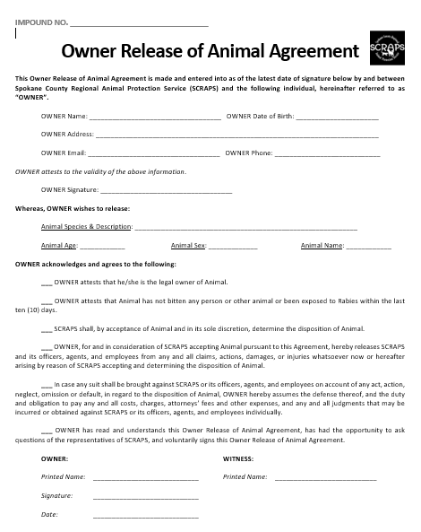

**Stray Animals:** Any person relinquishing a stray animal must complete a Non-Owner Release Agreement.

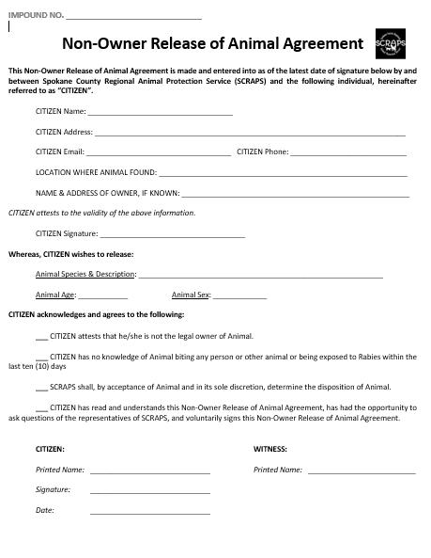

## **8.7 ANIMAL OUTCOMES**

Impounded animals will be adopted out, returned to owner/guardian, field released (feral and community cats) or transferred to a partner agency whenever possible.

**Adoption**

SCRAPS ascribes to an “open” adoption policy, meaning that any adopter over the age of 18 will only be denied the opportunity to adopt for a particular, identifiable, and objective reason that concerns the person’s willingness and ability to properly, conscientiously, and legally care for the adopted animal.

The adopter must present a form of government-issued, picture identification at the time of adoption. The adopted animal’s ShelterBuddy record must include the adopter’s full (first, middle, last) name, address, telephone number, date of birth, and, whenever possible, email address.

The adopter must read, agree to, and sign an Adoption Agreement for each animal adopted.

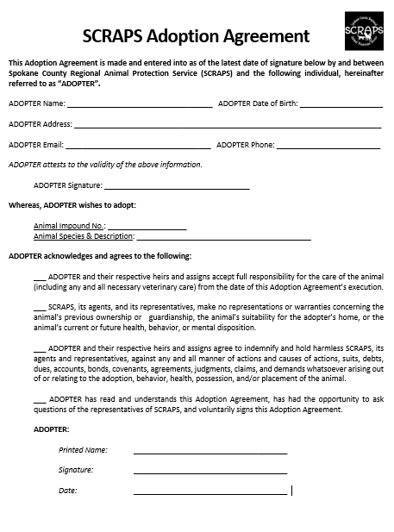

**Owner Release for Euthanasia**: SCRAPS no longer provides euthanasia services to privately-owned animals. Animal owners/guardians seeking this service should be referred to their personal veterinarian or the Spokane Humane Society.

**Redemption**

Persons claiming ownership of an impounded animal must provide identification (*see section 6.___)* and proof of ownership/guardianship (*see section 6.___)*. The reclaimed animal’s ShelterBuddy record must include the owner’s full (first, middle, last) name, address, telephone number, date of birth, and, whenever possible, email address.

Regarding waiving and/or bill fees, *see section 6.___*

Once an animal’s legally-mandated hold period has expired, SCRAPS may, in its sole discretion, choose not to redeem an animal to a claimed owner.

When a caretaker seeks to redeem an animal on behalf of the identified owner, the owner must be listed in the primary, and the caretaker must be listed as an “Other Contact” in ShelterBuddy. There must be a “permission” note included in the animal’s ShelterBuddy record that specifies the owner’s approval of the caretaker redeeming on his/her behalf after confirmation that the animal’s actual owner has been identified. Additionally, detailed notes must be entered as to what transaction is taking place (e.g., Jane Smith is redeeming on behalf of DO John Doe. Jane Smith, 509-123-4567, 1111 Main St Spokane 99201. Jane Smith paid $xx fees.)

Persons reclaiming an animal shall be offered a microchip at no cost.

**Returns**

SCRAPS always accepts the return of animals adopted from SCRAPS.

*Animals returned within 30 days of adoption* are accepted without the charging of release fees, and the adopter is eligible for a full refund of the adoption fee paid.

*Animals returned more than 30 days after adoption* are accepted with the payment of a $65 release fee and without a refund of the adoption fee.

**8.8** **PET LICENSING**

Spokane County Code requires the licensing of all dogs and owned cats who are over the age of six months and reside in one of the jurisdictions served by SCRAPS. The cost of a license must be paid in full and cannot be billed.

**Fees**

All dogs and cats residing in Spokane County *and* over the age of six months, must be licensed with Spokane County annually.

* Dog:
  + Sterilized: $28
  + Unsterilized: $53
* Cat:
  + Sterilized: $18
  + Unsterilized: $28
* Service Animal: Service animals may be licensed at no cost regardless of spay/neuter status. Staff may ask what work/task the dog is trained to perform, but proof of service dog status is never required. A person may have multiple service animals.

**8.9 FIRST CHOICE**

Potential adopters may request the right to meet an animal first after his/her stray hold expires; staff will provide the potential adopter with a date and time and notate this in the animal’s ShelterBuddy record. No guarantee of right to adopt accompanies this reservation.

**8.10 IMPOUND FEES**

**Licensing**: All dogs and cats residing in Spokane County *and* over the age of six months, must be licensed with Spokane County annually.

* Dog:
  + Sterilized: $28
  + Unsterilized: $53
* Cat:
  + Sterilized: $18
  + Unsterilized: $28
* Service Animal: $0

**Impound**:

* Dog:
  + *First*: $35
  + *Second*: $50
  + *Third*: $75
* Cat:
  + *First*: $55
  + *Second*: $65
  + *Third*: $75

**Board**: Charged only if an animal has been placed in a non-Holding kennel or cage.

* Dog:$15 for each 24-hour period
* Cat: The first three 24-hour periods (i.e., days) do not cost extra; each additional 24-hour period: $15

**Intake Exam**: Charged only if the animals has been examined by a Shelter Technician and/or the Staff Veterinarian and/or given vaccinations.

* Dog: $10
* Cat: No additional charge

**Trip Fee**: Charged per trip, not per animal.

* *Regular hours of operation*: $25
* *After regular hours of operation / Emergency*: $50

**Medical Treatment**: Charged for the provision of veterinary care, both in-house and third-party.

**8.11 ADOPTION FEES**

* + **Dogs:**
    - Over 6 months of age: $120
    - Under 6 months of age: $150
  + **Cats:**
    - Over 6 months of age: $40
    - Under 6 months of age: $70

# 9 ANIMAL CARE STAFF (SHELTER TECHNICIANS)

## 9.1 UNIFORM POLICY

If a uniform is provided, Shelter Technicians must report to work wearing uniform articles of clothing. Non-uniform clothing (e.g., pants) must be in good repair.

Technicians must wear sturdy, closed-toed shoes.

## 9.2 ANIMAL HANDLING

A staff member must never handle an animal with whom he/she is uncomfortable.

Animals may never be handled with tongs (tongs may only be used to retrieve items from inside a kennel or cage), and only APOs may utilize catch poles in handling dogs (but only when, in the APO’s professional opinion, using the catch pole serves as the most reasonable and safest option for both human and animal).

Generally, disposable gloves must be worn when handling an animal. Gloves must be changed between animals/litters.

**Dogs:**

* May never be dragged by a leash, harness, or other method of control.
* Other than fully-vaccinated puppies over the age of four months, puppies must never touch the floors in the shelter (i.e., they must be carried).

**Cats:**

* May not be lifted by their scruffs unless simultaneously having their backends supported.
* Must be covered with a sheet, towel, or other fabric when inside a transport cage to reduce stress and the potential for self-harm.

**9.3** **CHEMICALS**

All on-site chemicals must have a Material Safety Data Sheet (MSDS) to explain necessary safety precautions and possible hazards. Senior Shelter Technicians must obtain a MSDS for each new chemical at the facility and place a copy in the designated notebook, available to all employees at all times.

Senior Shelter Technicians must ensure that all containers containing chemicals are properly labeled.

**REScue**: Only REScue (accelerated hydrogen peroxide) is the chemical used to disinfect all animal care housing units/enclosures, reusable animal care supplies, animal care-related work surfaces, and shelter floors.

* Dilution Ratios:
  + *Non-Animal Related Areas (e.g., offices):* 1:128 (1oz/gal), 3-minute contact time.
  + *Daily Disinfection of Animal Housing Areas/Enclosures:* 1:64 (2oz/gal), 10-minute contact time.
  + *High Risk/Quarantine Areas & Confirmed Outbreak Conditions:* 1:16 (8oz/gal), 5-minute contact time.

**9.4** **ANIMAL CARE**

**Feeding**:

* Cats: Must be fed at least 1/3 – 1/2 of a 5.5oz of wet cat food and a generous scoop of dry food each AM; pregnant cats and kittens must be fed extra food (should always have food available).
* Dogs: Must be fed a mixture of wet and dry food each AM:
  + *Dry Food Guidelines*:
    - 25-50lb: 2 cups of dry food
    - 51-75lb: 3 cups of dry food
    - 76-100lb: 4 cups of dry food
  + If requiring additional feedings, the dog shall have an appropriate, additional feeding form affixed to his/her kennel, and animal care staff shall make appropriate notations at each feeding:

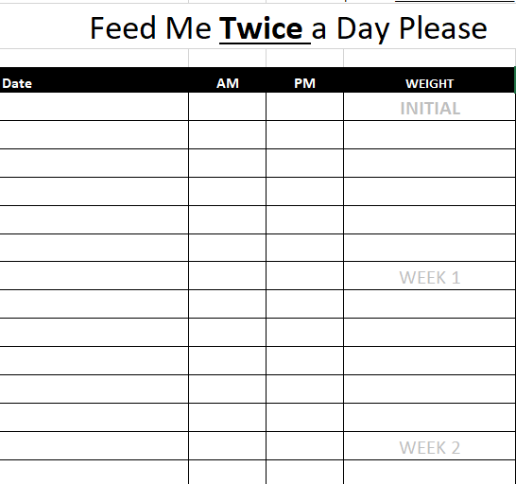

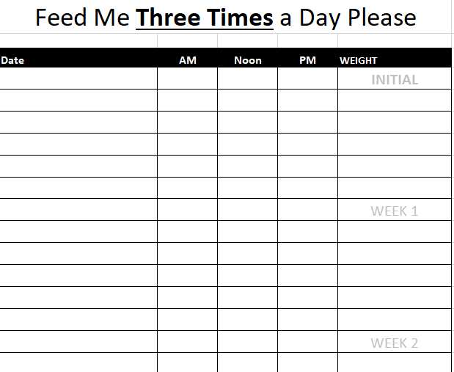

**Watering**: All animals must receive freshly filled water bowls each AM, and water bowls must be rinsed/refilled/triaged as need throughout the day (being checked individually as part of the closing checklist each evening).

**Cleaning/Tidying/Disinfecting:** To reduce animals’ stress, occupied kennels and cages shall be spot-cleaned daily whenever deeper cleaning is not indicated. Unoccupied kennels and cages shall be fully cleaned and disinfected prior to the introduction of a new resident.

Dog kennels shall be spot-cleaned at a minimum of every two hours during the afternoon Animal Receiving shift.

When cleaning, Shelter Technicians shall not enter a dog kennel unless securely separated from the kennel resident by a closed guillotine door.

**Cage Setup:**

Dogs: Unless otherwise directed by a Senior Shelter Technician, the Shelter Veterinarian, or the Director, each dog shall be provided with a kuranda bed of suitable size, soft bedding, a water bowl, a food bowl, and approved forms of in-kennel enrichment (e.g., Kong, toys).

Cats: Unless otherwise directed by a Senior Shelter Technician, the Shelter Veterinarian, or the Director, each dog shall be provided with a hidey of suitable size, soft bedding, a water bowl, a food bowl, and approved forms of in-kennel enrichment (e.g., toys, scratcher).

## 9.5 MICROCHIPPING

**Dogs:** Microchipped prior to leaving the shelter with adopters.

**Cats:** Microchipped on intake unless subject to a 5-day legal hold and no later than at the time of adoption.

**Reclaimed Animals:** May be microchipped at no charge with the consent of the redeemer.

## 9.7 PHYSICAL EXAM UPON INTAKE

**Physical Exam:**

Upon impound, each animal must be weighed and examined/assessed by either a Shelter Technician or an APO for the following:

* Body condition;
* Attitude/Hydration;
* Ears;
* Eyes;
* Skin & Coat;
* Mouth, Teeth, & Nose;
* Abdomen;
* Limbs & Tail;
* Urogenital/Gastrointestinal.

Depending on severity, abnormalities should be immediately reported to the Staff Veterinarian and/or Director *and/or* becomethe subject of an Animal Care Request.

**Animal Age:** All impounded animals should be assigned an age category based on the following guidelines:

* Neonate: **≤** 4 weeks
* Baby: 4 weeks to 8 weeks
* Juvenile: 8 weeks to 6 months
* Adults: 6 months to 8 years
* Seniors: over 8 years

## 9.8 VACCINATION

Upon intake, each animal should receive the following vaccinations, recorded at the time of administration as Vet Treatments in ShelterBuddy:

**Dog:**

* Under 4 weeks of age: None
* 4-6 weeks of age:
  + *DA2PP* (SQ intrascapular)
* 6+ weeks of age:
  + *DA2PP* (SQ intrascapular)
  + *Bordetella* (intranasal)

**Cat:**

* Under 4 weeks of age: None
* 4+ weeks of age: *FVRCP* (SQ low on right, front leg)

Vaccines should be boosted as follows and recorded at the time of administration as Vet Treatments in ShelterBuddy:

Dog:

* *DA2PP*:
  + Under 18 weeks of age – booster every 2-3 weeks until 18-20 weeks of age.
  + Over 18-20 weeks of age – booster in 2-3 weeks of original.
* *Bordetella*:
  + Over 18-20 weeks of age – booster every 6 months if in shelter.
* *Rabies*: required at 12 weeks of age or older; booster in 1 year.

Cat:

* *FVRCP*:
  + Under 18-20 weeks of age – booster every 2-3 weeks until 18-20 weeks of age.
  + Over 18-20 weeks of age – booster in 2-3 weeks of original.
* *Rabies*: required at 12 weeks of age or older; booster in 1 year.

## 9.9 PARASITE TREATMENT

Upon intake, each animal shall receive the following antiparasitic treatments, recorded at the time of administration a Vet Treatments in ShelterBuddy:

**Dog:**

* 0-2 weeks of age: *If* fleas are seen or suspected, a Dawn bath
* 2-8 weeks of age:
  + Pyrantel Pamoate (Strongid)
  + *If* *fleas are seen or suspected*, a Dawn bath
* 8+ weeks of age:
  + Pyrantel Pamoate (Strongid)
  + Revolution

**Cat:**

* 0-2 weeks of age: *If* fleas are seen or suspected, a Dawn bath
* 2-8 weeks of age:
  + Pyrantel Pamoate (Strongid)
  + *If* *fleas are seen or suspected*, a Dawn bath
* 8+ weeks of age:
  + Pyrantel Pamoate (Strongid)
  + Revolution
  + *If fleas seen*, Praziquantel

## 9.10 DAILY HEALTH LOG

Each animal residing in the shelter shall have a daily log affixed to their kennel/cage. Animal care staff shall make appropriate recordings each day and report any concerns to the Director or Staff Veterinarian.

**Dog:**

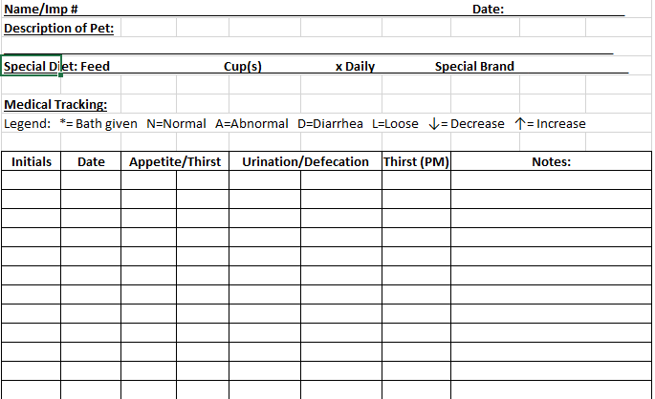

**Cat:**

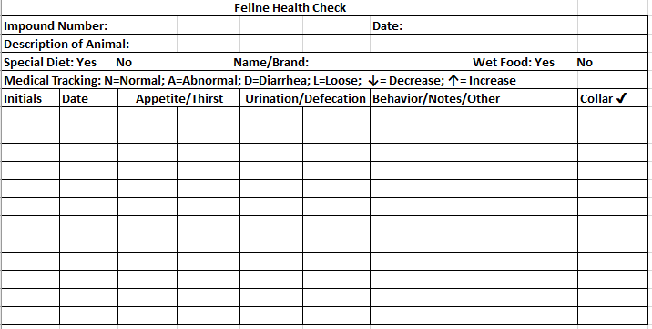

Additionally, dogs who present as housebroken must be provided with a “Walk Me” log affixed to their kennels, ensuring that Shelter Technicians take the dogs outside for potty breaks twice per day at a minimum.

### 

### 9.6 VETERINARY CARE

### Medical Concerns

### Any non-emergency, health-related concerns shall be reported to the Shelter Veterinarian by entering an Animal Care Request in ShelterBuddy. Upon assessment, the Shelter Veterinarian shall discuss their findings with the Director and enter comprehensive notes under the animal’s Medical Notes in ShelterBuddy.

### Emergent, health-related concerns shall be reported immediately to the Shelter Veterinarian or, in their absence or unavailability, to the Director.

### Medications

### Medications may be dispensed only with the prescription or approval of the Shelter Veterinarian or a third-party veterinarian treating the particular animal for whom medications are being prescribed or dispensed. Any prescribed or dispensed medication shall be entered as Medications in ShelterBuddy.

### Medical Protocols

### *See* SCRAPS – DOGS/PUPPIES PROTOCOL BOOK and SCRAPS CATS/KITTENS PROTOCOL BOOK, available separately.

## 9.7 FOSTER PROGRAM

**9.8 POST-ADOPTION MEDICAL CONCERNS**

Adopters may return to SCRAPS with adopted animals for treatment of upper respiratory infections that arise within 10 days of adoption. For other medical concerns or upper respiratory infections that occur later than 10 days post-adoption, the adopter is responsible for securing private veterinary care (or, alternatively, returning the animal to SCRAPS for care).

Adopters may return to SCRAPS with adopted animals for treatment of post-spay/neuter complications that arise directly from a spay/neuter surgery undertaken at SCRAPS (as opposed to complications arising from the adopter’s post- surgical – e.g., licking at the surgery site due to the absence of an e-collar). The Shelter Veterinarian determines which post-surgical complications are appropriate for SCRAPS treatment and which must be referred to the adopter’s private veterinarian.

**10 EMERGENCY EVACUATION**

Emergency evacuations of the building shall be undertaking in accordance with SCRAPS’ Emergency Evacuation Plan (EEP).

The EEP is available to all staff on the SCRAPS Shared Drive: Applications > SCRAPS Docs > Policy&Procedure > Emergency Evacuation Plan.

# 12 HEART ACTIVATION

***Revised February 28, 2011***

### INTRODUCTION

The Humane Evacuation Animal Rescue Team (HEART) is a volunteer group that is available in the event of a disaster and/or when SCRAPS is overwhelmed. This could include events such as flooding or wildfire. It could also be a hoarding case or other cruelty case when a large number of animals are involved.

HEART volunteers are trained in Federal Emergency Management Agency (FEMA) classes regarding disaster response. They also have additional training in animal handling, sheltering, etc. HEART is prepared to assist SCRAPS with animal sheltering, evacuation and rescue.

HEART will be activated when the animal protection director or their designee deems that SCRAPS is overwhelmed and additional resources (people and/or equipment –supplies) are needed.

### TO ACTIVATE HEART CALL

President: Donna Breidenbach

Home#: 509-624-6691

Cell #: 509-981-2580

Email: donnab10@comcast.net

President: Nan Livengston

Home#: 509-448-4888

Cell #: 509-939-8174

Email: livin4bbs@msn.com

### 

### EMERGENCY – ANIMAL SHELTERING

If there is a need for an emergency animal shelter, SCRAPS will activate HEART. HEART may respond to the SCRAPS shelter and/or the emergency shelter ready to initially work under the direction of SCRAPS. Once the emergency shelter is established - command of that shelter may be turned over entirely to HEART.

SCRAPS animal protection director or their designee will determine if the emergency shelter operation will be turned over to HEART. If so, HEART will set up a chain of command to provide an efficient operation of the shelter and will be assigned a SCRAPS liaison to report to. HEART will communicate regularly with SCRAPS providing updates and any requests for additional resources.

HEART command staff will determine which HEART members are sufficiently trained to work in the designated areas or the shelter and operation. Additionally, HEART command staff will make sure that HEART members provide good customer service to the public and humane treatment of the animals while maintaining a clean and healthy environment for all.

SCRAPS, with input from HEART, will determine when the emergency shelter is to be closed.

### 

### CRUELTY, ILLEGAL KENNEL AND/OR HOARDING INVESTIGATIONS

HEART may be activated to assist SCRAPS on an animal cruelty, illegal kennel and/or hoarding investigation. SCRAPS will be the lead and HEART will work under the direction of SCRAPS. These cases are generally criminal investigations and chain of evidence and documentation are critical. HEART may be asked to work at the SCRAPS animal shelter or at a field location. This will be determined on a case by case basis.

### EMERGENCY ANIMAL RESCUE

SCRAPS may activate HEART in the event of a disaster where animals have to be evacuated or rescued. HEART members will be carefully screened for appropriate training/qualifications to be involved in this activity. Generally, HEART members will be assigned to work with and assist an APO. HEART members with appropriate training may be allowed to work alone under the direction of SCRAPS.