**37 Determine project work scope**

**Obtain permit** - Lamar.  Site plan is on Slabtown website [www.theslabtown.com](http://www.theslabtown.com). Stormwater plan provided by Urban Catalyst Consulting. Planning approved next Building Department.

**Concrete.**  Buildout contractor. Place plumbing drains in concrete. Supply water in overhead. 6” of concrete unless hear otherwise from building supplier.

**Building.** Lamar responsible for this. Superior Metal Buildings out of Valdosta is providing building.

**Lot.** Buildout contractor. Fill as required by Engineering.

**Parking.**  Buildout contractor. Per site plan at [www.theslabtown.com](http://www.theslabtown.com). Planning said must have 10’ setback from asphalt to property line.

**Employee restroom.**  Buildout contractor. Sink, toilet and electric hand dryer, window unit type A/C and grab rail as shown below. Exterior walls plywood so things can be strongly mounted to them. PVC drain for A/C condensate to be directed outside building.

**Small office**.  Buildout contractor. Room/window unit type A/C. PVC drain for A/C condensate to be directed outside building. Exterior walls made of plywood so things can be strongly mounted to them.

**Counter.**Buildout contractor.Would like simple plywood counter where some special wood could be added later.  24” wide x 34” high.

**Electrical.**  Buildout contractor. Inside the building I would like outlets as shown on the elect/lighting plan. I may need to use some 220v tools on the west side.  Not sure what kind of receptacles I need. LED lighting like shown below. 10 feet starting 10 feet from wall. Motion lighting at corners of the building exterior.  Suggest distribution box be placed on South wall.

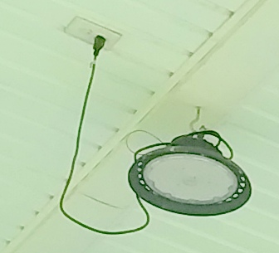

**Fencing.**  Buildout contractor. The front fence will have to be modified to accommodate the building.  I need a gate at the west side of the fencing similar to existing gates.

**Septic**  Buildout contractor. Tank and drain field.  North side.  As shown on site plan. [www.theslabtown.com](http://www.theslabtown.com). Permit obtained.

**Well.**Buildout contractor. Needs plumbing and electrical hookup to building New well has been installed

**Plumbing.**  Buildout contractor. Would like a spigot on each side of the building on exterior.

Approximate location shown on site plan.