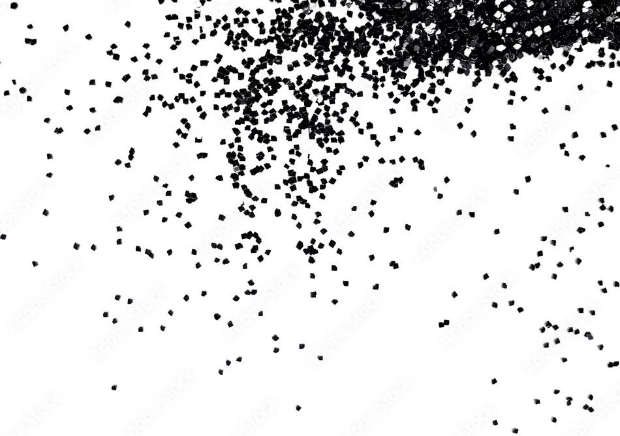

Wear your sequins and beads and all shiny things but please… NO GLITTERY THINGS

Let’s leave a good impression at the Expo Center in Lebanon
NOT a lasting impression

Glitter sticks around forever!

