  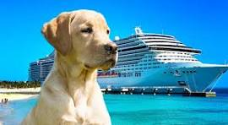  - General Grand Chapter  Service Dog Cruise to Alaska  - Princess Cruises: 7-Day Inside Passage with Glacier Bay National Park, Round-Trip Seattle!  Dates: May 1-8, 2027  Ports: Seattle, Juneau, Skagway, Ketchikan, Victoria  Pricing Information:  Interior Cabin: Category IB  - Double Occupancy: $1,449.00 Total Per-Person, Cruise Only  - Single Occupancy: $2,499.00 Total Per-Person, Cruise Only  Balcony Cabin: Category BC  - Double Occupancy: $2,159.00 Total Per-Person, Cruise Only  - Single Occupancy: $3,919.00 Total Per-Person, Cruise Only  Balcony Cabin: Category BB  - Double Occupancy: $2,169.00 Total Per-Person, Cruise Only  - Single Occupancy: $3,939.00 Total Per-Person, Cruise Only
  Let’s Go Cruising!
  ____
  Making Lasting Memories Together!
  ____
  SPACE IS LIMITED! RESERVE YOUR SPOT TODAY!
  ____
  To Reserve Contact:
  All World Travel
  Garrett Snowbeck
  (480) 585-2848 garrett@awtaz.com
  Debbie Tanner, GGC General Chairman, Service Dogs
  ggcsevicedogs@yahoo.com
  


