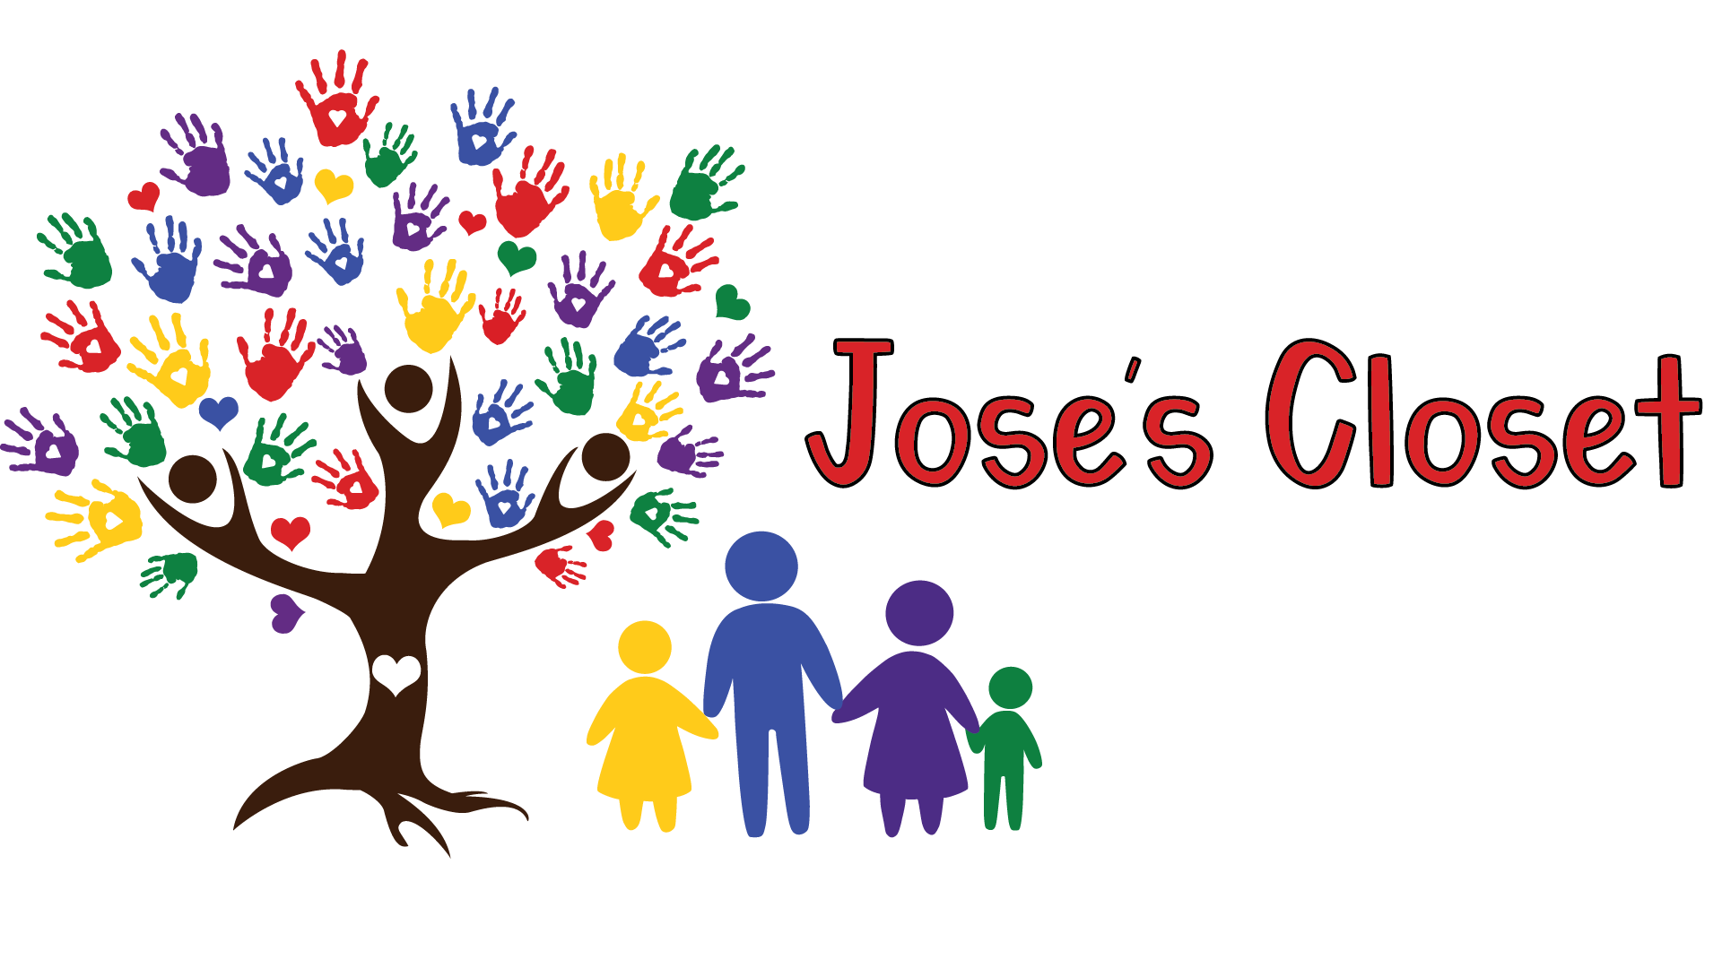

Jose’s Closet is a resource center for foster, adoptive, and kinship families. We provide clothing, shoes, toys, books, games, baby gear & equipment, sports equipment and more to children in need. We operate a modest food bank, as well as a diaper bank.

Arizona has between 15,000-20,000 children in foster care each year. These vulnerable children go through a transition that - even when handled with care - can be very traumatic to them. A foster child may arrive at their new home with nothing more than the clothes on his/her back. Jose’s Closet helps make caring for these special children easier, by offering the items they need.

We need your financial support.

We are thankful to receive donated items to offer to our member families, but keeping those items safe and secure requires funding. The same expenses that a regular store has to pay face Jose’s Closet every year. Donations from generous people like you help us cover those costs and focus our efforts on helping families.

Your donation will help us to cover operating expenses for our resource center in Apache Junction, Arizona. We are available to families statewide, with the majority that we serve living in Pinal & Maricopa counties.

Donations and Tax Credits

Arizona provides tax credits for individuals who make contributions to Qualifying Foster Care Charitable Organizations (QFCO). Individuals making cash donations to these charities may claim these tax credits on their Arizona Personal Income Tax returns.

What does that mean?
Helping us can help you… by reducing your tax bill! You can direct your Arizona tax dollars to Jose’s Closet via your donation. Your donation makes the lives of foster, adoptive, and kinship families easier. Please note QFCO # 10040 on any tax credit donation.

How much can I donate?
Your donation up to $500 can be applied as an Arizona Tax Credit for single filers. Married, filing jointly donors can claim $1,000 per year.
If donating between January 1 and April 15th, please indicate to which tax year you would like your donation applied.*
Does your employer match contributions to charities? Let us know, and we will contact them to make your donation go even further!

Jose’s Closet is a lifesaver for large families. There tends to be help from organizations when you foster but Jose’s Closet is a rare gem that helps families after adoption. Be it help with sports equipment, a wheelchair for a kid in a cast, back to school supplies or holiday gifts, Jose’s Closet helps subsidize when the rest stop. I can’t tell you how thankful I am to have Jose’s Closet.”
– Foster Mom Lisa P.

Can I donate to Jose’s Closet AND to my local school, using tax credits?
Yes! Arizona offers several tax credit programs, with limits set within each program. You can donate to Jose’s Closet AND claim tax credits for schools.* Tax credits allow you to get a dollar-for-dollar reduction on your AZ tax bill!
For example, if you are married, filing jointly and your Arizona State Income Tax due is $1,500, you can donate $1,000 to Jose’s Closet, $400 to the school of your choice and then pay the State of Arizona the remaining $100 balance.*

*Please consult your personal tax advisor for more information.

Donating is Easy!

Donate via check:
Complete the form below and mail with your check to:
Jose’s Closet – Tax Credit
PO Box 1641
Queen Creek, AZ 85142

Donate via PayPal or credit card:
Visit our website to make a donation via PayPal or credit card:

www.josescloset.org

(“Tax Credit” link on the right side of the website)

To claim your tax credit for your donation, you will need to complete and submit Form 352 with your tax filing.* This form is available on the Arizona Department of Revenue’s website:
www.azdor.gov (Search for QFCO)
Additional information will be provided in the donation receipt after we process your donation.

Help in other ways
Donate gently used items to our store.
- We accept items for children from birth through age 18.
Participate in our special donation drives for new items:
- Holiday Gifts (New toys and gifts)
- Back-to-School (Supplies and Backpacks)
Volunteer at our resource center

Tell your friends!
Members say it best…
“Jose's Closet has not only been a blessing to my family but has given me a wonderful opportunity to know amazing women and men and see the good works they are doing every day. I was a new foster mom, completely overwhelmed, but going to Jose's Closet felt like finding a family that truly cares. It's not just about the support of clothing and items to help the kiddos , I feel it's more about the love and kindness every time you go.”
Foster Mom Melissa S.

“Jose's Closet is my favorite! I have been to different organizations that help foster families and I can honestly say that Jose's closet is best for my needs. We are a family of 8 and ages can change at any time. I love that I don't have to keep a wardrobe of every size of clothing on hand for new kids. I don't have to request clothes on FB and run all over the valley to get them. Jose's closet has everything at one convenient location.
- - - - - - - - - - - - - - - - - - - - - - - - - - - - - - DETACH HERE AND RETURN - - - - - - - - - -- - - - - - - - - -- - - - - - - - - -
When we get a new placement we can go in and get whatever is needed for that child. One of our 8-year-old foster kids came weighing 150 lbs and went down to 95 lbs in a year. At Jose's Closet I could continue to update her wardrobe as she lost weight.
I love that they still love their adoptive families. I don't have to worry that if I adopt the kids that I can no longer go and have to start paying more for clothing after adoption like I do at other places.
I enjoy going in and volunteering when I can. It helps me feel like I am giving back when I have so many needs. The food is very helpful with lots of mouths to feed. Paper products are also very helpful!
I love Jose's Closet. They feel like a extended foster family that we can all help each other as we go along at different stages in our adventure.”
- Foster Mom London P.
household of 8 and counting“
Mail your Form and Payment to:
Jose’s Closet
Attn: Tax Credit
PO Box 1641
Queen Creek, AZ 85142
Credit Card Donations may be processed through our website:
www.josescloset.org
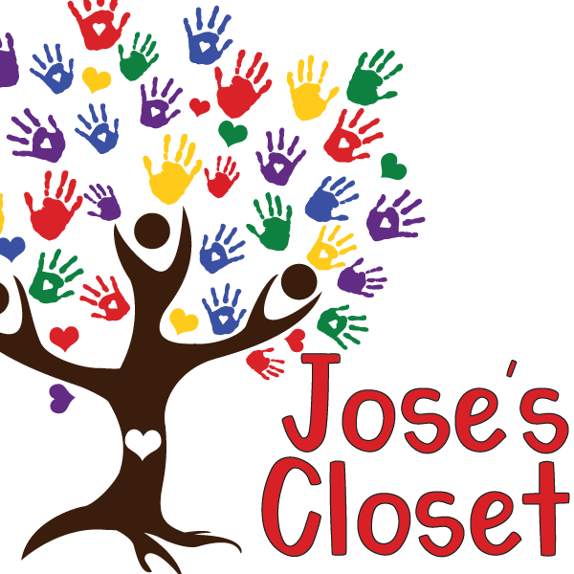
Thank you!
Arizona Tax Credit Donation Form
Name:
Address:
City/State/ZIP:
Phone:
Email:
☐ My employer matches charitable contributions.
Amount of Donation: ☐ $500 ☐ $1,000 ☐ Other $
($500 single / $1,000 married filing jointly is eligible for AZ Tax Credit)

Please make checks payable to “Jose’s Closet” and note
“QFCO 10040” on the memo line.

