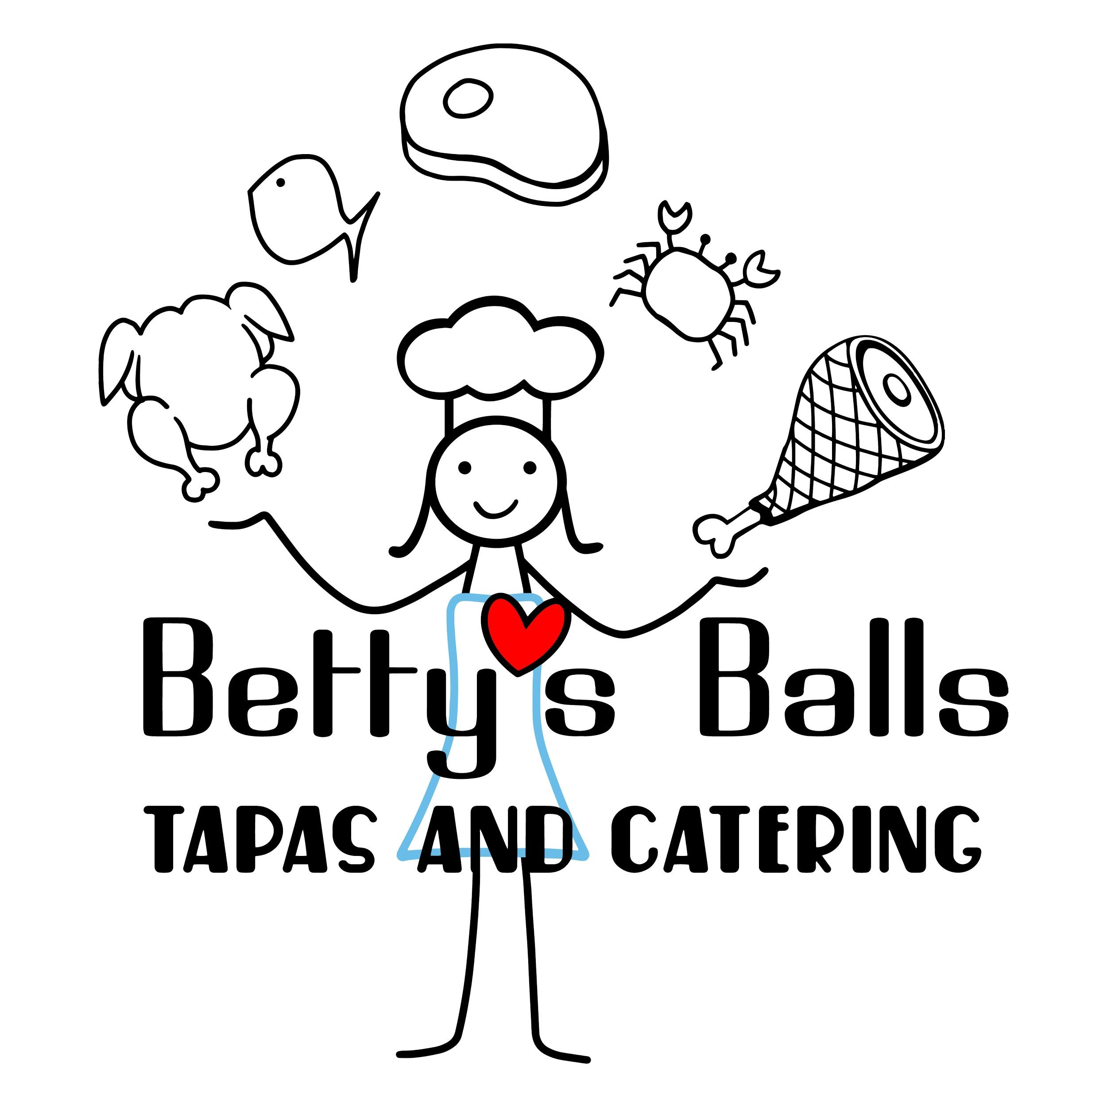
From QR code go to our website for today’s menu
produce from Thao Ranch and sprouts from Indigenous Farms
All meatballs made gluten free

BBQ Chicken Sliders $16
Sliced chicken breast on three rolls with house BBQ sauce
Served with cole slaw
The Big Ball Plate $16
Two beef meatballs made with lots of herbs on two rolls served with marinara and horseradish cream with a side of coleslaw
Vegan Nutballs $16
Two of our almost famous nutballs on toasted flatbread with spring mix and vegan chimichurri, pickled red onion and a side pasta salad
Caprese Salad $10
Spring mix with heirloom tomatoes, heirloom cherry tomatoes, fresh mozzarella,
basil, and balsamic glaze

Tapas/Small Plates $5 Add feta to any tapa $1
Dolmas – Four grape leaves stuffed with rice and Mediterranean spices served with horseradish cream sauce over spring mix ask for vegan sauce
Watermelon Salad – Spring mix, watermelon, lemon, mint and balsamic glaze
Mediterranean Pasta Salad – Orzo, artichoke hearts, kalamata olives and cherry tomatoes with a zesty vinaigrette with sesame seeds
Pickle Platter – A mix of vegetables with a slightly sweet dill flavor, served with chimichurri sauce

Kids Menu $7 - served with watermelon, chips or a rice krispy treat (choose 2)
- Beef meatball with marinara on a roll
- BBQ Chicken slider
Chips $2, Soda $2, Water $1, Rice Krispy $1

