eXplore Brown County
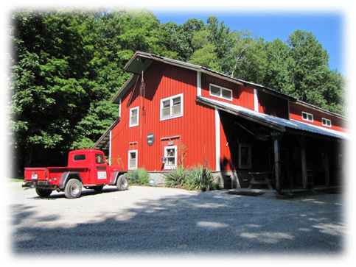
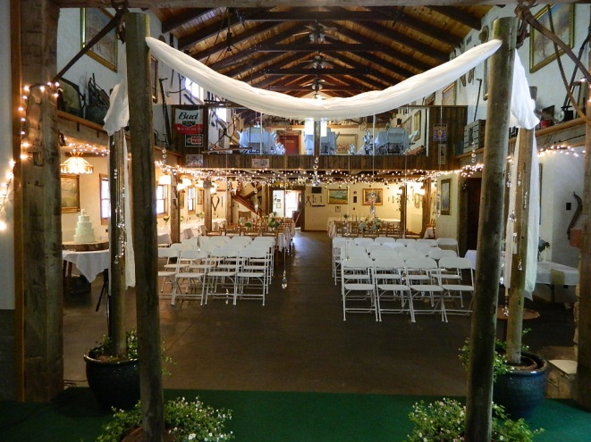
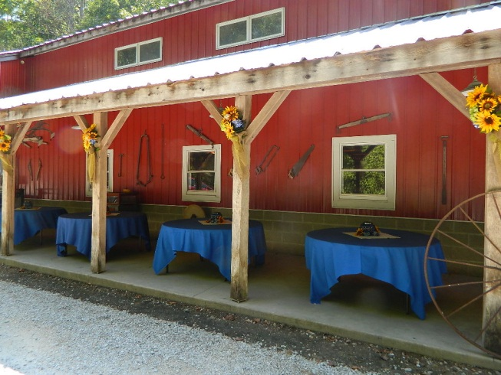
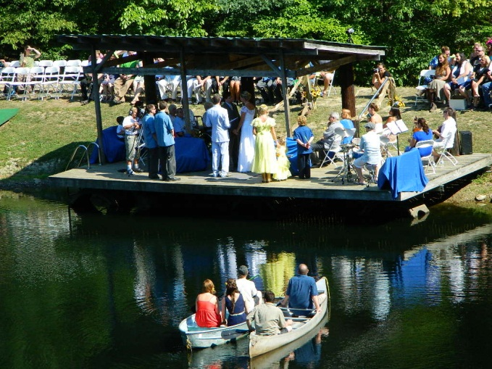
Weddings 2019

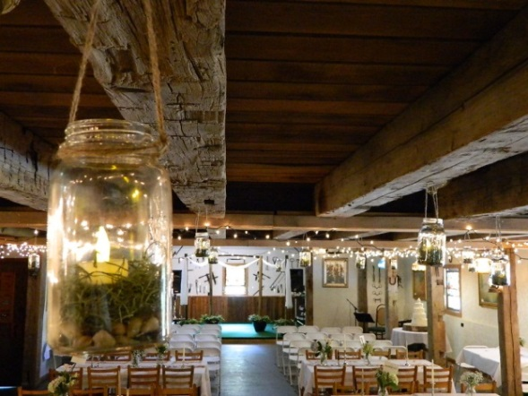

Weddings Tips | FAQ

- Do you offer traditional weddings as well as adventure weddings?
Yes! We allow our future brides and grooms to customize their packages to their liking.

- What is an Adventure Wedding?
Adventure Weddings often include many outdoor adventure activities and are considered completely unique wedding experiences. These types of weddings are best suited to those who enjoy an adventurous lifestyle (or those who want to introduce more adventure into their lives)!
Adventure weddings can last one day or an entire weekend! We offer many activities including Zip Line Tours, Arrow Tag, All-Terrain Tours, and Paintball. We also have an onsite lake and over 30 miles of hiking and mountain biking trails. Some examples activities that may occur during an adventure wedding here:
- Zipping over the lake in your wedding gown.
- A stress-relieving game of paintball the night before the nuptials or a Bachelor/ Bachelorette Paintball or ‘Arrow Tag’ game.
- Enjoying a picnic-style rehearsal dinner.
- Being married out on the lake, with many of your attendees watching from the lake in a canoe or rowboat.

- I’m concerned that older members of the wedding party may not want to participate in adventurous activities. Can you be too old to participate?
You can never be too old to participate in our activities! People of a myriad of ages have enjoyed zipping, riding ATVs or buggies, and playing paintball or ‘Arrow Tag’ in the past. We also offer hiking and mountain biking trails of varying intensities. Needless to say, we’re friendly to all ages and abilities here! If some of your guests still feel uncomfortable with participating, they are more than welcome to act as a spectator in many of the activities.

- Do I need to have zipping, paintball, Arrow Tag, ATV riding, hiking, biking, or boating experience?
You do not need to have any experience! We have the ability to cater all of our activities to people or various skill levels. In addition, our biking and hiking trails have different intensities which are mapped out and kept at the front of our building for your convenience. Q’s bikes also rent both mountain bike and fat tire bikes along with electric bikes.

- I would like to offer my guests the option of renting a cabin or campsite, as well as the opportunity to participate in your activities, but I don’t want to be responsible for their payments and reservations. Can you help me with this?
Absolutely! We can provide you with a unique XBC Code, specific to your event. You can then distribute that code through your invitations, website, email, etc. This way your guests can use that code to reserve their own adventure during your event, while still getting any group discounts that we discuss.

- Although I love the idea of spending my time outdoors, I am worried it will rain on my wedding day! Do you have an indoor venue we could rent for our reception?
We have our beautiful Harvest Hall which is fully heated and air conditioned and it can be used as a backup in case it rains! It’s a rustic-style hall furnished with tables and chairs, a small bar area, a stage area for bands or dancing, and it is decorated with rustic antiques and original paintings by Patricia Rhoden Bartels a highly accredited Impressionistic painter.

- The average person spends over $15,000 on their wedding; I can’t afford to spend nearly that much. How expensive are adventure weddings?
Our packages are completely customizable depending on your needs. We recognize that couples have varying budgets and we make adventure weddings affordable for most budget types. We offer discounts for multiple activities and for large groups. You can easily afford to have a traditional or adventure wedding here on a tight budget. We offer you the ability to cater your own event saving you Big Bucks usually covering the cost of our Harvest Hall.

- I would like to visit your facility. Do I have to schedule an appointment for this?
We ask that you call ahead to ensure that the Harvest Hall is not currently in use. We may have same-day appointments available. You can book a viewing of the Harvest Hall by going to explorebrowncounty.com/book-now or by calling (812) 988-7750

- I have more questions about your Harvest Hall, such as questions regarding pricing, discounts, the use of outside caterers, and the serving of alcohol at our event. Where can I find more information?
Please visit our “Rentals FAQ” page for more information about the Harvest Hall, rentals, and regulations. You are also welcome to call or email us with any of your questions.

http://www.explorebrowncounty.com/faq

HARVEST HALL FAQs

- What is the capacity of the hall?
A: The capacity of the hall is based on the seating arrangement that you design. There are tables and chairs inside the hall for a total of 165 guests, with additional options for seating on the porch outside the hall, 4 picnic tables adding an additional 32 seats. Inside and out, the hall can seat up to 200 guests. You are welcome to bring additional tables/chairs into the hall to expand the available seating.
- Is the Kitchen included in the price?
A: The prep kitchen is included in the price if needed. It has a stove, fridge, 12’ prep table, dishwasher, 2 microwaves, and 3 sink system.
- Do you decorate the hall?
A: No. You do the decorations in the hall, set up, cleaning, and disposal of all trash. We are a facility that recycles. Recycling is a requirement for the facility and a fine of $50 will be imposed for not recycling.
- No glitter or small confetti is allowed.
- No tape or push pins are allowed on walls. Push pins are allowed on wood beams.
- For an extra $100 we will clean up after your event (you will still be required to take out the any trash containing food to our dumpsters upon leaving).
- Do you need a liquor license for Alcohol?
A: Alcohol is permitted inside the hall, renter must assume all liability and responsibility and maintain the alcohol in a private setting, and not exposed to the general public. Indiana state laws relating to the distribution and consumption of alcohol must be strictly followed. eXplore Brown County at Valley Branch Retreat Inc. is not authorized by the State of Indiana to handle alcoholic beverages.
- How long do you rent the hall? e.g. do you rent it for 24 hours?
A: For a typical Saturday, renters will have the hall from 9am to 11pm. Additional time after 11pm can be added at $100 per hour. The evening before will be given at ½ rate, for a maximum of 7 hours, if needed for a reception dinner, set-up, or other event.
- Can you rent cabins and campsites for a discounted price?
A: Sometimes, we can add on cabins and campsite rentals to a reservation for an additional cost. Discounts are based on availability, days rented, time of year, number of cabins or campsites rented. We recommend that cabins or sites be rented at least 30 days prior to your wedding date to ensure that there is availability.
- What is included in the cost of the hall?
A: The hall has many amenities for your group. There are 37 tables, chairs for each of the tables, and a bar area that can be utilized. In the upstairs loft there is a gaming area with Ping-Pong, checkers, and foosball or it can be set up to accommodate more seating. There is also a prep kitchen and internet access. Many extras can be rented at a nominal extra fee such as a computer input projector and screen.
- What extras do you rent? Sound system, tablecloths etc..?
A: There are many extras that you can rent in the hall; we will provide a list for you. We can also provide a list of local vendors to help supply anything that we cannot provide.

- Do you provide catering?
A: No, at this time, we do not provide catering through eXplore Brown County, nor do we require that you use any of our listed available caterers.
- Can you provide a list of caterers?
A: Yes, we do have a list of local caterers that we can provide for your use. If you want us to provide the set up and contract with a caterer we charge 15% in addition to the base cost of the food.
- Is there a deposit?
A: Yes, there is a nonrefundable rental fee to be paid in full upon booking. Bookings are NOT guaranteed unless they are paid in full at the time of reservation.
- How far in advance do I need to rent the hall for my event?
A: The hall is based on a first come first serve basis, so earlier is always better. We suggest that you reserve at least 6 months prior to your event. Though, it is possible to reserve within 3 months of your event, if there is availability. For September and October weekends, we suggest reserving 6 months to a year in advance.
- Do you have the electrical capacity for a DJ, lights, and dance floor?
A: Yes, we do have plug-ins in the hall for lighting at the stage area, and also, for a DJ to have an area for his needs.
- Are there dressing areas for the bride and groom?
A: Yes, we have restrooms inside the hall, as well as a room that would available for the bride-to-be and her bridesmaids to get ready for the big day. Our cabins are also available to rent for preparation purposes.
- Are there discounts for paintball and zipping for the wedding party?
A: Yes, there are group discounts for groups of 10 or more.
- Is there internet access in the hall?
A: Yes, there is internet available in the hall, and also outside on the front porch area. There is also internet available on the front porches of most of the cabins.
- Where is the parking area for the Hall events?
A: Parking is available around the hall. There are also 2 large fields that can be used for parking.
- Is there a cleanup fee?
A: You are responsible for clean-up, recycling, wipe down of tables, and trash removal to dumpster. Tables and chairs must be put back similar to the way you found them.
B: If you would like us to do the clean-up for you there is a $100 clean up fee (though we still require you to take out any trash containing food items).

Hall Table & Chair Availability
Standard Set Up:
Downstairs
Buffet – 2 - 28” x 8’ Tables
Seating – 12 Tables of 8
6 Tables of 4
7 Tables of 2
Total Seats – 134Upstairs
Ping Pong Table, Foosball Table, Checkers w/ 2 chairs (maybe removed to accommodate more tables)
Seating- 6 Tables of 8
Total Seats - 48

Hall Table Options:
Table Size: Qty: Table Seating: Total Seats:
2 x 3 7 2 14
3 x 3 6 4 24
3 x 6 16 8 128
28”x 8 2 8 16
Small Round 1 4 4
Large Round 1 6 6
Misc Size 2 2 4
Total seating at tables: 196

Hall Chair Options:
High Back Chair | 40 | Wooden Slats | 60
Round Heart | 30 | Folding Wooden | 25
Orange Cushion Chair | 24 | MISC chairs | 10
Total chairs: 189
Front Porch Seating Options:
4 Picnic Tables that will seat 8 each for a total of 32 seats

Price Listing for Harvest Hall, Facility, Outdoor Stage, Lake and Additional Items 2019
HARVEST HALL rentals Friday, Saturday, & Sunday is $975.00/day. This amount is non-refundable and must be paid as follows: $500 initial payment at time of booking, with the remaining balance being due 60 days later. If the second installment is not paid within the 60 days you will forfeit your initial payment and the Hall will be made available for another patron to book. The Harvest Hall is available 9AM to 11PM for full day rental.
HARVEST HALL rental for Monday – Thursday is $500 or $100 per hour, minimum $400 for 4 hours. A full day rental is 9 AM-11 pm. The rental payment is non-refundable and required at the time of the reservation. Access to the Hall begins at 9 AM; extended hours and access to the Hall for set-up and to decorate are based on availability and subject to an additional fee. Week day rates for small groups may be negotiated with the owner.
If you are renting Harvest Hall and need the Hall the night before for a rehearsal dinner or to decorate early, the cost is 50% of your rental. You will have your choice of 7 total hours between 12:00PM and 9:00PM. This amount for the additional day is due at the time of booking. Bookings without payment will not be held or guaranteed.
If you are renting the Hall and planning an outdoor wedding ceremony on the property there is a reduced charge based on location, the OUTDOOR STAGE is $350.00 for the day, and the LAKE is $300.00; both includes 4 campsites. If you are planning use of the Outdoor Stage, Lake or ground but are NOT renting the Harvest Hall there is an additional $100-200 charge based on location of the event, size of group and length of event.
Kitchen, Fireplace, and Outdoor Fire Pit are included with Hall rental.
You are responsible for clean-up, recycling, wipe down of tables, and trash removal to dumpster. Tables and chairs must be put back similar to the way you found them. If you would like for us to do the clean-up for you there is a $100 clean up fee. Even with our facility doing clean-up you will still need to remove any trash that contains food before leaving for the night.
Harvest Hall Clean-Up Option $100.00
Fine for putting GREASE in the Sink $50.00
Kitchen Add-ons: | Qty: | Price (per item):
All day Ice | 1 | $50.00
Coffee Pot 30 Cups | 1 | $10.00
Coffee Pot 12 Cups | 1 | $5.00ea
3 Gallon Drink Dispensers | 3 | $5.00ea
5 Gallon Drink Dispensers | 3 | $5.00ea
Crystal Punch Bowls | 2 | $10.00ea
Beer Tub and Beer Tap | 1 | $10.00
Table Cloths | 15 | $8.00ea
Projector w/ 4x6 screen | $40.00
Jukebox (Oldies) Play all night | $50.00
Sound System Use (CD player and CDs not included) | $90.00
Amp and Microphone | $10.00
Outdoor Grill, charcoal not included | $25.00
Wedding Arch | $15.00
30x30 or 30x40 Tent | Call for quote
Campfire Wood:  Trailer, delivered  Wheelbarrow  Armload | $50.00
 | $15.00
 | $7.50

PARTY!!! eXplore Brown County Style!!!

Bring your bachelorette party, bachelor party, corporate group, family, or other groups

ZIP LINES:

Super Hero Flights: 3 flights - $25 | Zip Top Shot: 3 - $30

Leap of Faith: 4 elements - $25-$35

Screamer Tour: 2-line Zip Tour | $35 | Minimum 8 people

Sneak Peek Tour: 3-line Zip Tour | $35

Zip On! Tour: 5-line Zip Tour | $65
eXplorer Tour: 5-line Zip Tour | $75 | Leap of Faith add-on $10

Night Flights Escape Tour: 3-line Zip Tour | $45 (May thru October)

Night Flights eXpedition Tour: 5-line Zip Tour | $80 (May thru October)

PAINTBALL:

Per player | $45 includes semi-auto marker, mask, all day HPA, CO2, 500 balls

Per player | $32 includes semi-auto marker, mask, all day HPA, CO2, 250 balls

Per player | $40 bring your own equipment

Airsoft Fields | all day pass | $10 per player

ARROW TAG:

1 ½ hr. $30 per player

ATV TOUR:
1 Hour Ridge Runner Tour $69
1 ½ Hour Cemetery Tour $96
2 ½ Hour Sunset Tour $179

BUGGY TOUR:
1 hour: 1st Driver $86 | 2nd Driver: $43 | Non Driving Passenger: $25
1 ½ hour: 1st Driver $96 | 2nd Driver: $50 | Non Driving Passenger: $32

OFF-ROAD ROCK CRAWLER TOUR:
1 hour: 1st Driver $96 | 2nd Driver: $43 | Non Driving Passenger: $25

OFF-ROAD HUMMER TOUR:
Per rider (adult) | $38 | (child 6-12) | $20

MOUNTAIN BIKING, HIKING:

Per person | $5 per day

CAMPING CABINS:

Spring, Summer, Fall | April 2-October 31 | $65 per night

Winter | November 1-April 1 | $60 per night

Holidays and Special Events | $65 per night (2 night minimum)

Rates are based on 4 person occupancy, additional guests | $12 per night

CAMPING:

Primitive tent sites | $24 per night

Electric and water hook-ups | $28 per night

Full hook-ups, electric, water and sewer | $30 per night

(2 Night Minimum on Holidays Only)

Rates are based on 4 person per site, additional campers | $5 per person

Combine Any Activity and Take $5.00 off Each Activity
eXplore Brown County
2620 Valley Branch Road, Nashville, Indiana 47448
812-988-7750
www.explorebrowncounty.com

Group Events/Parties Rules:
No Glass or Glass Bottles outside of the Hall

Operating Hours:

Fri/Sat - 9:00am to 11:00pm (additional time $100/hour) No amplified music after 12:00 am.

Sun/Thur - 9:00am to 10:00pm No amplified music after 10:00 pm.

Band/DJ:
Scheduling a Band/DJ for 4 or more hours will require them to be finished prior to quiet hours begin (10:00pm/12:00am).

Valley Branch Retreat /Explore Brown County is NOT responsible or liable for the use or distribution of alcohol on its property. We try to provide current information but cannot guarantee that the information provided below is the most current. YOU, the renter of the Hall or grounds is responsible to seek current/ up to date information regarding the use and or distribution of alcohol on our property. All Laws and regulations related to the distribution and consumption of alcohol must be followed.

A temporary permit is good for beer and wine only - not liquor. If you want to have liquor served at your event, you must have a licensed alcoholic beverage caterer. A temporary permit is valid for on premises consumption only. Carry-out sales are not permitted and persons are not allowed to bring alcoholic beverages into the temporary function.
The fee is Fifty Dollars ($50) per day. The fee must be paid by business check, money order, certified check or cashier’s check. Cash will only be accepted if the application is hand-delivered to the ATC in Indianapolis.
In order to receive a temporary permit, you must submit the following to the Commission:
- A completed application containing all required signatures (see below)
- A floor plan submitted on a 81/2 X 11 sheet of paper (floor plans must be legible and if a family room is to be utilized, it must be specified on the floor plan)
- The proper fee
Required Signatures in Marion County: (Obtain in the order listed)
- The signature of the chief law enforcement officer for the agency who has jurisdiction over the area where the event is to be held. The Indianapolis Police Department's signature can be obtained at the roll call site that oversees the area where your function is being held. Call (317) 327-3811 for information about the exact location.
- The signature of the Excise Police Officer located at 6400 E. 30th Street, Indianapolis. Call 317-541-4100 for additional information. (THIS SIGNATURE MUST BE OBTAINED LAST)
Required Signatures in Counties other than Marion County: (Obtain in the order listed)
- The signature of the Local Law Enforcement who has jurisdiction over the location.
- The signature of the Excise Police Officer who has jurisdiction over the location. (THIS SIGNATURE MUST BE OBTAINED LAST)
NOTE: If the event will be held in a town park in a town with a population of less than 10,000 persons, prior approval must be received from the Town Council. The Town Council has thirty (30) days to rule on the request.
When obtaining Excise approval signatures, if you do not know the local Excise district for your event, you can obtain this information from our website - http://www.in.gov/atc/isep/2379.htm An Excise Officer reserves the right to hold the application for review if he / she deems necessary. The temporary permit may be revoked for good cause.
THE COMPLETED APPLICATION MUST BE SUBMITTED TO THE LOCAL EXCISE OFFICE AT LEAST FIFTEEN (15) DAYS PRIOR TO THE EVENT. FAILURE TO DO SO MAY RESULT IN DENIAL OF THE APPLICATION.

You must have individuals (at least 21 years of age) who are licensed servers and bartenders to serve at the temporary function. Temporary Employee permits are available that can only be used during the temporary function.
Temporary Employee Permit application - http://www.in.gov/atc/files/TempEmployeeApplication.pdf

If you have any questions, contact Andrew Myers at the ATC at (317) 234-4315, or the ATC main office at (317) 232-2430.

Temporary Beer/Wine Permit Form - http://www.in.gov/atc/files/TempBeerWine(1).pdf

HARVEST HALL FLOOR PLAN

