Instantly Reduce Your Electric Bill by Up to 90%

Demand for New Energy-Saving Devices at an All-Time High
- 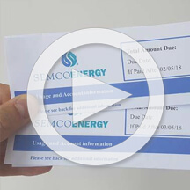

- 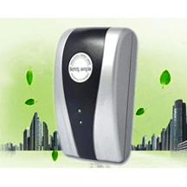

- 

- 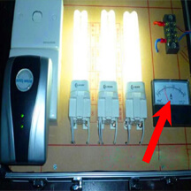

- 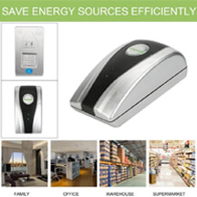

- 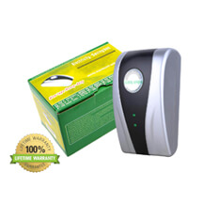

- 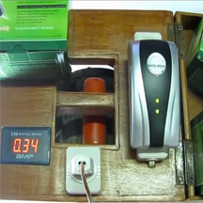

- 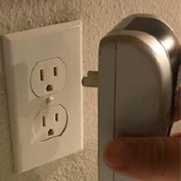
Are your electricity bills getting higher and higher each month, year by year? It's no coincidence!
Retail residential electricity rates (the amount you pay per kilowatt-hour, or ¢/kWh) have sharply risen across the nation: about 27% over the last 3 years.
This trend is unlikely to be disrupted in the future: natural gas prices are likely only to increase, and as they do, electricity rates will rise.

How Does it Actually Work?
PowerVolt was designed to constantly improve and optimize your power stream, by capturing and straightening the current energy that would otherwise be lost. Once it is completely optimized, your electricity consumption will be lower.
If your home is large, it is beneficial to place one unit close to the breaker box and additional units as far away from it as possible. It is as simple as that. We recommend 1 PowerVolt device for every 500 sq ft.
- PowerVolt is used for economizing electricity, effectively saving electricity and up to 60%-90% of electrical consumption for a heavy-duty load. The product saves you money right out of the box.
- The function of PowerVolt is to stabilize the voltage, balance the current, and offer surge protection in order to achieve a power-saving effect. The product itself has almost no consumption of energy, so you can use it to save power consumed by electric appliances, such as refrigerators, air-conditioners, televisions, and so on.
- It is incredibly easy to use, plug into any socket or line. The LED light will become green immediately.
- PowerVolt can abate electrical overheating when it operates normally at the rated load. The external shell has advanced fire-proof and explosion-proof material, and internal leakage protection measures make it safe and reliable. The longer the power energy saver is used, the better the effect will be. This is truly a great advantage for your household appliances.
- PowerVolt is suitable for houses, condominiums, apartments, shop lots, restaurants, offices, small factories, etc.; however, there are no electricity saving benefits for heating appliances, such as electric stoves, electronic cookers, etc

