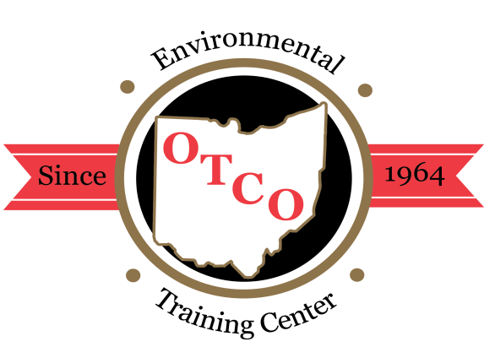
OTCO’S 2020 WORKSHOPS

Overview: The Regional Workshops are designed for individuals involved in the operations, maintenance, or management of water or wastewater facilities. These workshops will focus on current issues in the water and wastewater field around the state focusing on operations, maintenance, laboratory, management, water quality, backflow, GIS/GPS and asset management; presented by public & private water supply staff and consultants.

Who Should Attend: managers, superintendents, treatment operators, inspectors, and engineers who are interested in gaining a better understanding of the ever-advancing technology in the water and wastewater treatment process. These workshops can be used to fulfill the requirements for Ohio EPA licensed operator’s required contact hours.
Water Supply / Wastewater Certification: Class A, I, II, III, & IV
WW Collection & Water Distribution Systems Certification Class I,II

CANCELLATIONS
Cancellations received five days prior to the event will receive a full refund; otherwise, a $25.00 service charge may apply. Substitutions are permitted; however, NO REFUND FOR THOSE WHO REGISTER AND FAIL TO ATTEND.
REGISTRATION FORM
You may register by mail, fax, email, or online. After your registration has been processed, a confirmation will be sent to you either by fax or email.

CLICK HERE to register on-line:
OTCO STUDENT ID #
OHIO EPA CORE ID #
FIRST NAME
LAST NAME
TITLE
EMPLOYER
MAILING ADDRESS
BILLING ADDRESS
CITY STATE ZIP
BUS. TELEPHONE ( ) - EXT
FAX ( ) - (for confirmations)
EMAIL ADDRESS
Please check & initial if information needs to be updated in OTCO Training Tracking System.
CHECK / MONEY ORDER #
Please invoice my company#

Charge to my credit card account:

Visa MasterCard Discover AMEX

Billing Zip Code (For security purposes)
CARD NUMBER:
NAME ON CARD
EXP. DATE / CCV CODE:

Total: $
SEND REGISTRATION OR PAYMENT TO:
OPERATOR TRAINING COMMITTEE OF OHIO, INC.
3972 Indianola Avenue * Columbus, OH 43214 * (614) 268-6826
Fax (614) 268-3244 or Email: otco@otco.org or www.otco.org

Please check which workshop and date(s) you are attending:
Washington C. H. Workshop: June 16, 2020 = $150.00
6.0 OEPA Wastewater CTH’s Available (interactive webinar)

Milford Workshop: June 17, 2020 = $150.00
6.0 OEPA Water CTH’s Available (interactive webinar)

OEPA Reservoir Management Workshop: June 23, 2020 = $150.00
6.0 OEPA Water CTH’s Available (interactive webinar)

Fostoria Workshop: July 14, 2020 = $150.00
6.0 OEPA Wastewater CTH’s Available (interactive webinar)

Wapakoneta Workshop: July 15, 2020 = $150.00
6.0 OEPA Water CTH’s Available (interactive webinar)

Class III & IV Workshop: July 29th & 30th
2 Day Registration – $330
1 Day Registration – $170 July 29th Only July 30st Only

12.0 OEPA Water & Wastewater CTH’s Available (interactive webinar)

Strasburg Workshop: August 13, 2020 = $150.00
6.0 OEPA Wastewater CTH’s Available (interactive webinar)

Elyria Wastewater Workshop: August 18, 2020 = $150.00
6.0 OEPA Wastewater CTH’s Available (interactive webinar)

Elyria Water Workshop: August 19, 2020 = $150.00
6.0 OEPA Water CTH’s Available (interactive webinar)

Marietta Workshop: Both Days Sept. 2-3, 2020 = $275
12.0 OEPA Wastewater CTH’s Available both days
Lafayette Hotel * 101 Front St. * Marietta OH 45750
2 Day Registration – $275
1 Day Registration – $150 Sept 2nd Only Sept 3rd Only

Wooster Workshop: September 16, 2020 = $150.00
6.0 CTH’s Available per day (Water & Wastewater)
Wooster WWTP * 1123 Old Columbus Rd. * Wooster OH 44691

Jefferson (Ashtabula County) Workshop: Both Days Sept. 22-23 = $275
12.0 OEPA Water & Wastewater CTH’s Available both days
Ashtabula County Commissioners
25 West Jefferson St. * Jefferson OH 44047
2 Day Registration – $275
1 Day Registration – $150 Sept 22nd Only Sept 23rd Only

Wastewater Workshop: Sept. 23rd & 24th = 12.0 Contact hours
2 Day Registration – $330
1 Day Registration – $170 Sept. 23rd Only Sept. 24thOnly

Held At: DoubleTree by Hilton – Worthington - $74 per night +tax
175 Hutchinson Ave. * Columbus, OH 43235

Compliance Workshop: October 6th & 7th = 12.0 Contact hours
2 Day Registration – $330
1 Day Registration – $170 Oct 6th Only Oct 7th Only

Held At: DoubleTree by Hilton – Worthington - $74 per night + tax
175 Hutchinson Ave. * Columbus, OH 43235

All Water & Wastewater Professionals Welcome

Water Distribution Workshop: Nov. 4th & 5th = 12.0 Contact hours
2 Day Registration – $330
1 Day Registration – $170 Nov. 4th Only Nov. 5thOnly

Held At: DoubleTree by Hilton – Worthington - $74 per night +tax
175 Hutchinson Ave. * Columbus, OH 43235

Warsaw Workshop: November 19, 2020 = $150.00
6.0 CTH’s Available per day (Water & Wastewater)
Camp Warsaw Retreat Center * 818 E. Main St. * Warsaw OH 43844

Procrastinator’s Workshop: Dec. 15th & 16th = 12.0 Contact hours
2 Day Registration – $330
1 Day Registration – $170 Dec 15th Only Dec 16th Only

Held At: DoubleTree by Hilton – Worthington - $74 per night + tax
175 Hutchinson Ave. * Columbus, OH 43235

All Water & Wastewater Professionals Welcome

