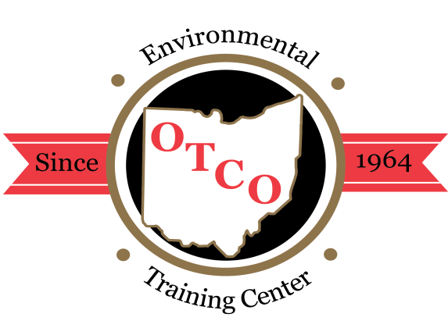
OTCO’S 2020 WORKSHOPS

Overview: The Regional Workshops are designed for individuals involved in the operations, maintenance, or management of water or wastewater facilities. These workshops will focus on current issues in the water and wastewater field around the state focusing on operations, maintenance, laboratory, management, water quality, backflow, GIS/GPS and asset management; presented by public & private water supply staff and consultants.

Who Should Attend: managers, superintendents, treatment operators, inspectors, and engineers who are interested in gaining a better understanding of the ever-advancing technology in the water and wastewater treatment process. These workshops can be used to fulfill the requirements for Ohio EPA licensed operator’s required contact hours.
Water Supply / Wastewater Certification: Class A, I, II, III, & IV
WW Collection & Water Distribution Systems Certification Class I & II

CANCELLATIONS
Cancellations received five days prior to the event will receive a full refund; otherwise, a $25.00 service charge may apply. Substitutions are permitted; however, NO REFUND FOR THOSE WHO REGISTER AND FAIL TO ATTEND.
REGISTRATION FORM
You may register by mail, fax, email, or online. After your registration has been processed, a confirmation will be sent to you either by fax or email.

CLICK HERE to register on-line:
OTCO STUDENT ID #
OHIO EPA CORE ID #
FIRST NAME
LAST NAME
TITLE
EMPLOYER
MAILING ADDRESS
BILLING ADDRESS
CITY STATE ZIP
BUS. TELEPHONE ( ) - EXT
FAX ( ) - (for confirmations)
EMAIL ADDRESS
Please check & initial if information needs to be updated in OTCO Training Tracking System.
CHECK / MONEY ORDER #
Please invoice my company#

Charge to my credit card account:

Visa MasterCard Discover AMEX

Billing Zip Code (For security purposes)
CARD NUMBER:
NAME ON CARD
EXP. DATE / CCV CODE:

Total: $
SEND REGISTRATION OR PAYMENT TO:
OPERATOR TRAINING COMMITTEE OF OHIO, INC.
3972 Indianola Avenue * Columbus, OH 43214 * (614) 268-6826
Fax (614) 268-3244 or Email: otco@otco.org or www.otco.org

NOTE: DUE TO THE COVID-19 PANDEMIC THERE WILL BE NO IN-PERSON TRAININGS UNTIL AFTER JANUARY 1, 2021. ALL WORKSHOPS ARE NOW OFFERED AS INTERACTIVE WEBINARS.

Please check which workshop and date(s) you are attending:

Compliance Webinar: October 6th & 7th
12.0 OEPA Water & Wastewater CTH’s Available both days
2 Day Registration – $330
1 Day Registration – $170 Oct. 6th Only Oct. 7th Only

Port Clinton Wastewater Webinar: Oct. 20, 2020
6.0 OEPA Wastewater CTH’s Available both days
Registration – $150

Port Clinton Water Webinar: Oct. 21, 2020
6.0 OEPA Water CTH’s Available both days
1 Day Registration – $150

Water Distribution Webinar: Nov. 4th & 5th
12.0 OEPA Water CTH’s Available
2 Day Registration – $330
1 Day Registration – $170 Nov. 4th Only Nov. 5th Only

Warsaw Webinar: November 19, 2020 = $150.00
6.0 OEPA CTH’s Available per day (Water & Wastewater)

Rudolph Webinar: Dec. 9th & 10th = 12.0 Contact hours
12.0 OEPA CTH’s Available both days
2 Day Registration – $275
1 Day Registration – $150 Dec. 9th Only Dec. 10th Only

Procrastinator’s Webinar: Dec. 15th & 16th = 12.0 Contact hours
12.0 OEPA Water & Wastewater CTH’s Available both days
2 Day Registration – $330
1 Day Registration – $170 Dec. 15th Only Dec. 16th Only

