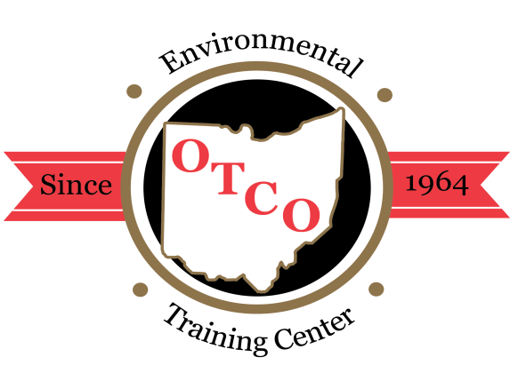
OTCO’S 2021 REGIONAL WORKSHOPS

Overview: The Regional Workshops are designed for individuals involved in the operations, maintenance, or management of water or wastewater facilities. These workshops will focus on current issues in the water and wastewater field around the state focusing on operations, maintenance, laboratory, management, water quality, backflow, GIS/GPS and asset management; presented by public & private water supply staff and consultants.

Who Should Attend: managers, superintendents, treatment operators, inspectors, and engineers who are interested in gaining a better understanding of the ever-advancing technology in the water and wastewater treatment process. These workshops can be used to fulfill the requirements for Ohio EPA licensed operator’s required contact hours.
Water Supply / Wastewater Certification: Class A, I, II, III, & IV
WW Collection & Water Distribution Systems Certification Class I,II

CANCELLATIONS
Cancellations received five days prior to the event will receive a full refund; otherwise, a $25.00 service charge may apply. Substitutions are permitted; however, NO REFUND FOR THOSE WHO REGISTER AND FAIL TO ATTEND.
REGISTRATION FORM
Registration fee for the Regional Workshops includes lunch. A $25 late fee may be applied to registrations at the door. You may register by mail, fax, email, or online. After your registration has been processed, a confirmation will be sent to you either by fax or email.

CLICK HERE to register on-line.

OTCO STUDENT ID #
OHIO EPA CORE ID #
FIRST NAME
LAST NAME
TITLE
EMPLOYER
MAILING ADDRESS
BILLING ADDRESS
CITY STATE ZIP
BUS. TELEPHONE ( ) - EXT
FAX ( ) - (for confirmations)
EMAIL ADDRESS
Please check & initial if information needs to be updated in OTCO Training Tracking System.
CHECK / MONEY ORDER #
Please invoice my company#

Charge to my credit card account:

Visa MasterCard Discover AMEX

Billing Zip Code (For security purposes)
CARD NUMBER:
NAME ON CARD
EXP. DATE / CCV CODE:

Total: $
SEND REGISTRATION OR PAYMENT TO:
OPERATOR TRAINING COMMITTEE OF OHIO, INC.
3972 Indianola Avenue * Columbus, OH 43214 * (614) 268-6826
Fax (614) 268-3244 or Email: otco@otco.org or www.otco.org

Please check which workshop and date(s) you are attending:
Marysville Wastewater Webinar: Feb. 10, 2021 = $165.00
6.0 CTH’s Available per day (Wastewater)

Marysville Water Webinar: Feb. 11, 2021 = $165.00
6.0 CTH’s Available per day (Water)

Marietta Wastewater Webinar: March 24, 2021 = $165.00
6.0 CTH’s Available per day (Wastewater)

Marietta Water Webinar: March 25, 2021 = $165.00
6.0 CTH’s Available per day (Water)

Elyria Wastewater Webinar: April 21, 2021 = $165.00
6.0 CTH’s Available per day (Wastewater)

Elyria Water Webinar: April 22, 2021 = $165.00
6.0 CTH’s Available per day (Wastewater)

Wooster Wastewater Webinar: May 19, 2021 = $165.00
6.0 CTH’s Available per day (Wastewater)

Wooster Water Webinar: May 20, 2021 = $165.00
6.0 CTH’s Available per day (Water)

Warren Wastewater Webinar: June 16, 2021 = $165.00
6.0 CTH’s Available per day (Wastewater)

Warren Water Webinar: June 17, 2021 = $165.00
6.0 CTH’s Available per day (Water)

Wapakoneta WW Webinar: July 21, 2021 = $165.00
6.0 CTH’s Available per day (Wastewater)

Wapakoneta Water Webinar: July 22, 2021 = $165.00
6.0 CTH’s Available per day (Water)

New Philadelphia WW Webinar: Aug. 11, 2021 = $165.00
6.0 CTH’s Available per day (Wastewater)

New Philadelphia Water Webinar: Aug. 12, 2021 = $165.00
6.0 CTH’s Available per day (Water)

Jefferson Wastewater Webinar: Sept. 22, 2021 = $165.00
6.0 CTH’s Available per day (Wastewater)

Jefferson Water Webinar: Sept. 23, 2021 = $165.00
6.0 CTH’s Available per day (Water)

Fairfield Wastewater Webinar: Oct. 13, 2021 = $165.00
6.0 CTH’s Available per day (Wastewater)

Fairfield Water Webinar: Oct. 14, 2021 = $165.00
6.0 CTH’s Available per day (Water)

Warsaw Wastewater Webinar: Nov. 17, 2021 = $165.00
6.0 CTH’s Available per day (Wastewater)

Warsaw Water Webinar: Nov. 18, 2021 = $165.00
6.0 CTH’s Available per day (Water)

Rudolph Wastewater Webinar: Dec. 8, 2021 = $165.00
6.0 CTH’s Available per day (Wastewater)

Rudolph Water Webinar: Dec. 9, 2021 = $165.00
6.0 CTH’s Available per day (Water)

