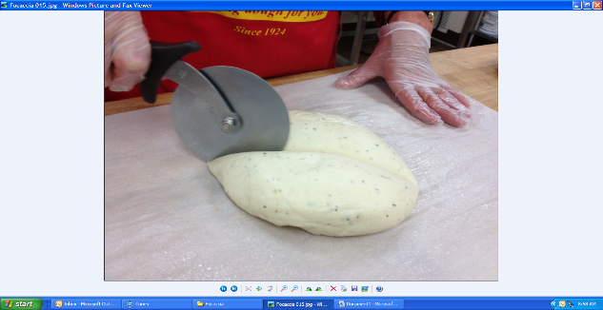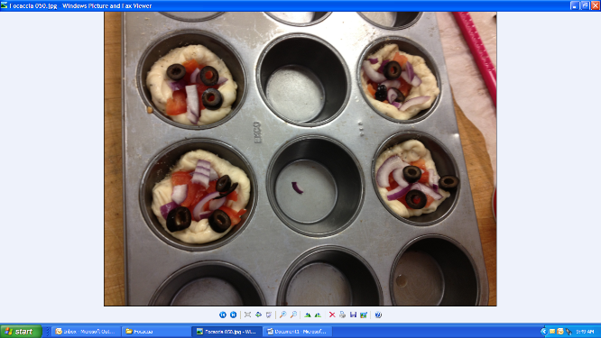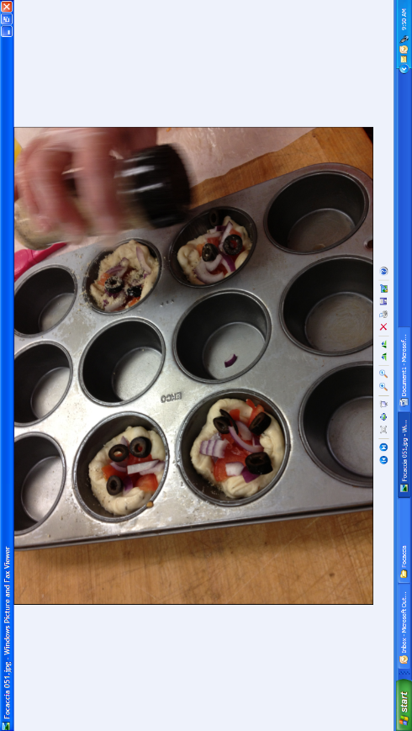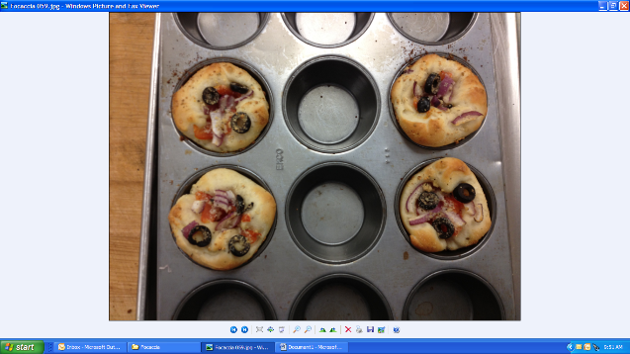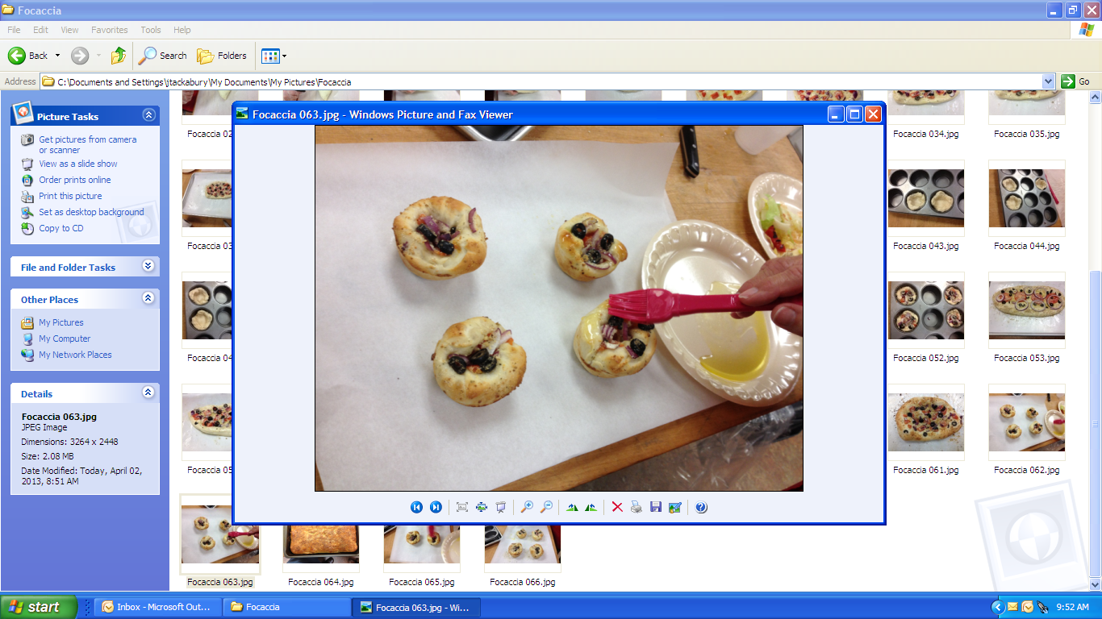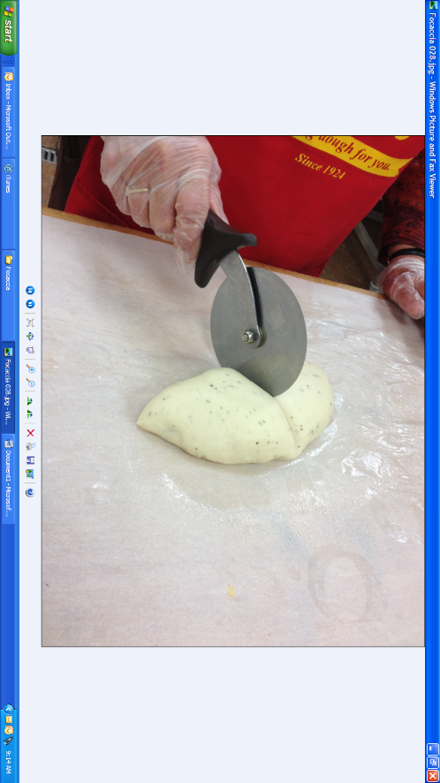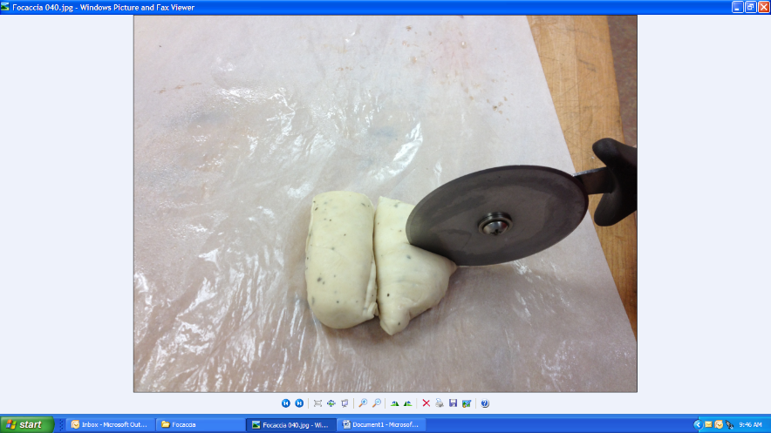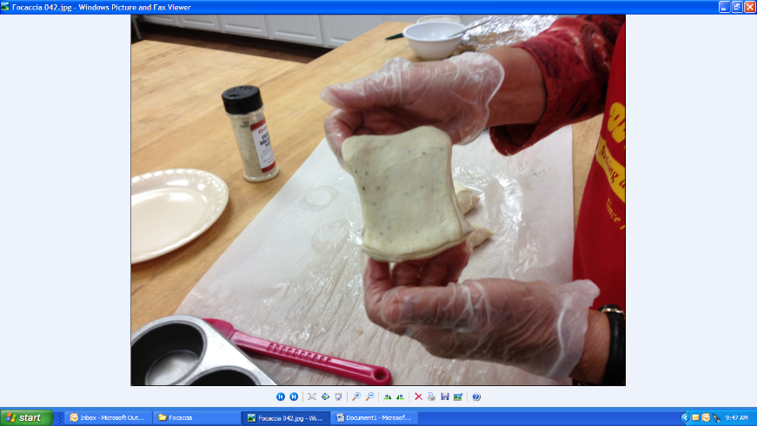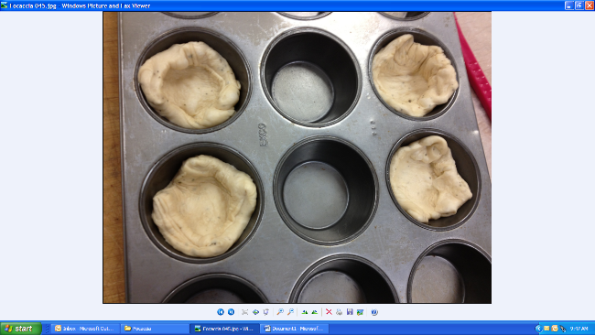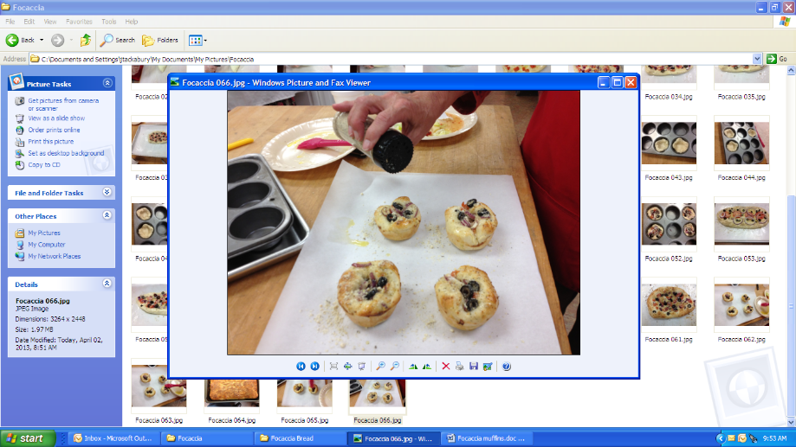

**Dough Ball Made into Focaccia Mini Appetizers**

* Thaw frozen dough ball in cooler overnight. Remove thawed dough ball from plastic bag (figure 1) and divide it in quarters as shown in figures 2 & 3.
* Now cut each quarter in fours, giving 16 pieces per dough ball as shown in figure 4.
* Stretch each piece into a 3 x 3 inch square and place into a **PRE-OILED** muffin tray (figures 5 & 6).
* Brush dough with olive oil.
* Place your desired toppings inside the dough
* Proofing activates the yeast in the dough and will give it lift. For best results place in a proof box for approximately 30-40 minutes or until dough is near the top of the muffin tray. Cover the pan, set in a warm spot until it grows.
* **Baking**- Place the proofed Focaccia muffin into a **PRE-HEATED** 350° oven and bake for 20-30 minutes or until product is golden brown. Please note, oven times and temperatures vary. (Figure 9)
* **Topping-** Once baking is finished, brush the top generously with olive oil.