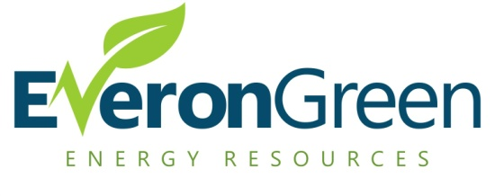
Everon Green Energy Resources, LLC is an all inclusive energy resources company specializing in temporary & permanent power for your projects in deregulated areas. Here is what we know:
- You get a new project, and temporary power is needed.
- The electrician on the project needs to set up a “t-pole” for temporary power.
- The t-pole will need to be inspected and green tagged in order for the local utility to place a meter in.
- The utility understands that an order for electricity will have to be run through a local electricity provider, a common practice is for Oncor to refer temporary power to TXU Energy.
- TXU Energy charges somewhere in between 13.5 – 14.5 cents per kilowatt for electricity needed during your build out.
- This high temporary power cost is something that your company has already budgeted for in your project bid.

Here is what we can do for you:
- When you win a bid for a new project, contact Everon Green Energy Resources. We have 10 years of experience in working with the local utilities and retail electricity providers.
- As a broker we can provide the same results for you, at a fraction of the cost. Instead of 13.5 – 14.5 cents per kilowatt, how would you like to pay 50% - 60% less per kilowatt?
- This not only helps you come under budget, but potentially helps you win more bids on projects in the future.
- When you call us, all we need to know is the information about location of your project, and who will be responsible for paying the electric bill during the project.
Now we know what your question must be; how much is this service going to cost us? The answer is nothing. Yes, our service to you is absolutely 100% free always. We are paid by our agreements that we have with the retail electricity providers.
So here are the key takeaways:
- Call Everon Green for your next project, and provide the little information we discussed.
- Pay 50% - 60% less for the electricity during your project.
- Come under budget, whether you are at the beginning of your bid, or in the middle of the project.
- Potentially win more bids and increase profitability as your electricity costs have decreased.
Give us a call today, as we are ready to take on your project, and put some Green back in your pocket!
P.S. Call Everon today about our referral program

