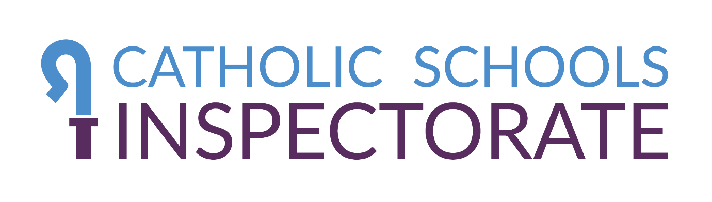
Application to become a registered inspector for the Catholic Schools Inspectorate: Privacy Notice
This privacy notice explains how your personal information will be collected, shared and used if you choose to apply to be a registered inspector for the Catholic Schools Inspectorate.
The Catholic Schools Inspectorate is the name given to the work carried out by Catholic dioceses collectively to support a national inspection framework for denominational inspections. The national framework is administered by the Catholic Education Service (CES) on behalf of Catholic dioceses.
The application process involves you submitting an application form to the CES. Your completed form will then be processed by the CES and shared with the Diocese to which you are applying (your Sponsoring Diocese). Your Sponsoring Diocese will then assess your suitability to be put forward for training as an inspector. If your application is approved and you successfully complete the training, the CES will include your details on the central register of inspectors and issue you with a licence to inspect.
This privacy notice contains information about how both the CES and your Sponsoring Diocese will collect, share and use your information. In this notice, the terms we or us are used to describe either the CES or your Sponsoring Diocese, as appropriate.

About us
The CES is an agency of the Catholic Bishops’ Conference of England and Wales, but it is not a legal entity in English law. The legal entity responsible for the collection and use of personal information by the CES is the Catholic Trust for England and Wales.
If you have any questions about this privacy notice, including any requests to exercise your legal rights, please contact us using the details set out below.
Email: karen.oconnor@cbcew.org.uk
Post: Karen O’Connor, Data Protection Officer, CBCEW, 39 Eccleston Square, London SW1V 1BX
Telephone: 020 7901 4896

The data we collect about you
In this notice, we use the term personal data to mean any information relating to an identified or identifiable individual. It does not include data where the identity has been completely removed (anonymous data).
We may collect, use, store and share different kinds of personal data about you which we have grouped together as follows:
- Application data: the data you provide to us when you complete your application form.
- Reference data: the data collected about you from your referees.
- Eligibility data: the data collected from other sources, including the Disclosure and Barring Service, to check that you are eligible to be a licensed inspector.
- Training data / records: the data collected in relation to your attendance at training and your successful completion of such training, if appropriate.
- Inspection data: details of the inspections that you carry out during the term of your licence.
The information collected during the application process will include information about your religious beliefs and information about criminal convictions and offences, which will be used to undertake our eligibility checks. Depending on your particular circumstances, we may also collect other special categories of personal data about you.

How we use your personal data
We will only use your personal data when the law allows us to. Most commonly, your personal data will be used in the following circumstances:
- Where it is necessary for our legitimate interests, and your interests and fundamental rights do not override those interests. This means the interests of the CES in creating and maintaining a register of licensed inspectors to carry out inspections of Catholic educational institutions on behalf of Catholic dioceses, and the interests of your Sponsoring Diocese in ensuring your suitability for the role. We make sure we consider and balance any potential impact on you and your rights before we process your personal data for our legitimate interests.
- Where we need to comply with a legal obligation on us.
Generally, we do not rely on consent as a legal basis for processing your personal data. If we do require your consent to process your personal data, we will ask you for it. You have the right to withdraw this consent at any time by contacting us.

Purposes for which we will use your personal data
We have set out below, in table format, a description of all the ways we plan to use your personal data, and which of the legal bases we rely on to do so. We have also identified what our legitimate interests are where appropriate.
Organisation responsible | Purpose/Activity | Type of data | Lawful basis for processing
CES | To register you as a new applicant;  To carry out initial eligibility checks; and  To share your information with your Sponsoring Diocese. | Application Data  Eligibility Data | Necessary for our legitimate interests (to manage the application process on behalf of Sponsoring Dioceses and to ensure that the Sponsoring Dioceses can comply with their safeguarding obligations).
Sponsoring Diocese | To obtain and receive references from third parties; and  To arrange and conduct interviews of those applicants who have passed the initial eligibility checks. | Application Data  Reference Data | Necessary for our legitimate interests (to ensure the suitability of applicants to be licensed to inspect)  Necessary to comply with the Sponsoring Diocese’s legal obligations in respect of safeguarding.
CES | To arrange appropriate training for applicants;  To maintain records of training; and  To provide successful proof of training for applicants and issue a licence to inspect. | Application Data  Training Data / Records | Necessary for our legitimate interests (to ensure all licensed inspectors have attended and successfully completed appropriate training).
Sponsoring Diocese | To obtain appropriate enhanced DBS checks; and  To confirm appropriate public liability insurance. | Eligibility Data | Necessary to comply with legal obligations in respect of safeguarding.  Necessary for the legitimate interests of the Sponsoring Diocese (to ensure appropriate insurance cover).
CES | To issue a licence to inspect;  To maintain a register of licensed inspectors; and  To share details of licensed inspectors with dioceses. | Application Data  Training Data / records  Inspection data | Necessary to comply with legal obligations in respect of safeguarding.  Necessary for our legitimate interests (to ensure the register is accurate and up to date).

Disclosures of your personal data
As set out in the table above, your personal data will be shared between the CES and your Sponsoring Diocese. The CES will also share your personal data with other dioceses to fulfil our functions and maintain the register of licensed inspectors. We do not intend to share your data with other third parties, unless required to do so by law.

International transfers
We will not transfer your personal data outside the UK.

Data security
We have put in place appropriate security measures to prevent your personal data from being accidentally lost, used or accessed in an unauthorised way, altered, or disclosed. In addition, we limit access to your personal data to those employees, agents, contractors and other third parties who have a genuine need to know. They will only process your personal data on our instructions, and they are subject to a duty of confidentiality.
We have put in place procedures to deal with any suspected personal data breach and will notify you and any applicable regulator of a breach where we are legally required to do so.

How long we retain personal data
If your application is successful, we will generally retain personal data about you for as long as you remain on the register.
If your application is unsuccessful, we will retain your Application Data for three months from the date your application is rejected or the completion of any appeals process, whichever is sooner. However, we may retain some information about you on a list of unsuccessful candidates, together with the reasons for any rejection. This is to ensure that you do not make repeated applications. If we decide that you should be permanently excluded from the register (for example because of serious safeguarding concerns), we may retain the reasons for your exclusion.

Your legal rights
Under certain circumstances, you have rights under data protection laws in relation to your personal data. You have the right to:
- Request access to your personal data. This enables you to receive a copy of the personal data we hold about you and to check that we are lawfully processing it.
- Request correction of the personal data that we hold about you. This enables you to have any incomplete or inaccurate data we hold about you corrected, though we may need to verify the accuracy of the new data you provide to us.
- Request erasure of your personal data.
- Object to processing of your personal data.
- Request restriction of processing of your personal data.
- Request the transfer of your personal data to you or to a third party in a structured, commonly used, machine-readable format.
If you wish to exercise any of the rights set out above, please contact us. You will not have to pay a fee. However, we may charge a reasonable fee or refuse to act if your request is clearly unfounded, repetitive or excessive.
We may need to request specific information from you to help us confirm your identity and ensure your right to access your personal data (or to exercise any of your other rights). This is a security measure to ensure that personal data is not disclosed to any person who has no right to receive it.
We try to respond to all legitimate requests within one month. Occasionally it could take us longer than a month if your request is particularly complex or you have made a number of requests. In this case, we will notify you and keep you updated.
You also have the right to make a complaint at any time to the Information Commissioner's Office (ICO), the UK regulator for data protection issues, if you are dissatisfied with how we have handled your personal data. You can do so by visiting www.ico.org.uk/complaints. We would, however, appreciate the chance to deal with your concerns before you approach the ICO so please contact us in the first instance.

Changes to this privacy notice
We keep our privacy notice under regular review and will inform you of any significant changes. This version was last updated on 21 May 2021.

