|  |  |  |  |  |  |
| --- | --- | --- | --- | --- | --- |
|  |  | |  | | --- | | The Sip and Sew Newsletter | | Issue Date | | |
|  |  |  |
| Located at 1555 12th ST SE. Salem, OR. 97302 right next door to Fitts Seafood. |  |  |

Welcome to our first newsletter! We are always looking for ways to improve our shoppe as well as our presence in the community. So, with that being said please give us feedback on how we are doing along with ways that we can improve. We have already received great feedback from a lot of folks and have been adopting some of them, so keep them coming in!

**The Coffee Shoppe**

As most of you know we have a fully functional coffee bar. Some have asked why the combination, and all we have had to say is why not! In a group setting look around at how many people have coffee in their hands.

We can make pretty much any coffee drink you would like. If you want it or can describe it, we will try and make it for you. If you don’t see it just ask!! Our current menu is on our website, or available to see when you come in and try some delicious coffee. We also have some comfy chairs to sit and relax and visit with friends, so come on in and try some of our coffee.

Sip & Sew Column

One of the feedback items we thought about is opening the shop to promotions that will bring customers in for coffee and socializing with one another. We thought about it and have come up with what we are calling “Sip and Sew-cialize Saturdays”. We will run this special for the month of February. We have started the classes this month, so from 9 to 12:30 there will be classes going on. After 12:30 the classroom is available for open sew. With this promotion all drinks will be only $3.00. That is any coffee drink, any size through February on Saturday’s during this promotion. We hope to see you here!! Hearing the purring of your sewing machine and the chitter chatter is such an amazing sound. It is also such a great time for a newer quilter to bond with a more experienced quilter. 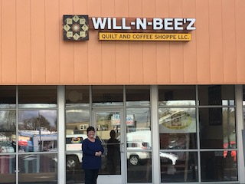

# Welcome to Will~n~Bee’z.

Mary’s Corner

Hello to all my Quilting friends. It has been such an amazing first few months at the Shop, and I owe it to all of you. We knew we were headed in the right direction, but you have just confirmed it for us. The holidays were a time to get in and get our feet wet, and now we are looking forward to classes, Groups, and open sew. We are adding to our inventory with new fabrics, patterns, and a few notions here and there.

Our goal is to connect quilters to other quilters so that we can share what we know and to bring “Quilting” out of the shadows and get more people involved. Quilts make the most personal treasures, and I know that you all agree with me.

Thank you so much for starting this journey with us. We are looking forward for what is to come.

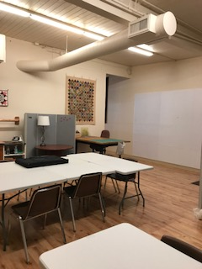

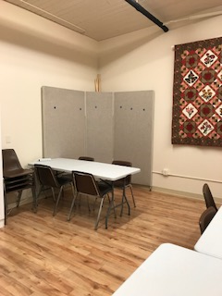

### Upcoming Classes

*Come in or email us to sign up and pay for your class and get the information that you will need.*

*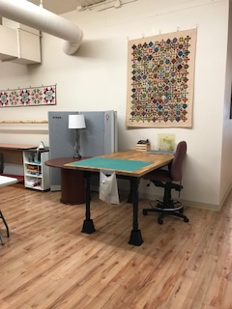****February 10th- 10-12:30pm***

***Introduction to Sewing/Quilting***

*Cost- 25.00*

*This class is for the newest sewing/quilters. You will learn the very basics of quilting and sewing. You will learn about fabrics, and colors as well. You will go away knowing the tools and terminology to get you started on your next project, or your first project.*

***February 17th & 24th- 10-12:30pm***

***Beginning Quilting***

*Cost- $50.00*

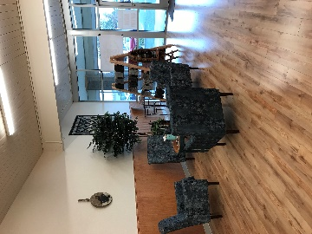*This class will review some things that were taught in the 1st class, and if you were unable to make that class you will learn these basics. By the second class you will go away with a small split rail quilt top. Lots of hands on experience*.

So much more to come…

Stay tuned!!!

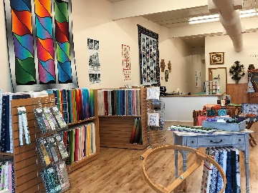

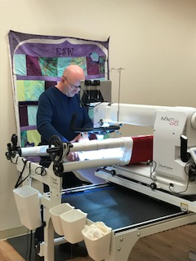Welcome to the Longarm section of the newsletter. We are so pleased to offer longarm services to our community! When we opened the shop this past Nov. we purchased a HQ Infinity 26 from Whitlock’s in Salem. Since then we have kept it quilting  
 “a-long”.

### The Longarm of the Shoppe

by Jeff Williams

In December, I had the opportunity to quilt my largest quilt to date. The top measured 132”x138”. It was a Lonestar pattern that was hand quilted in 1952. The gentleman that brought the quilt in had plans to give it to his sister for Christmas. He vividly remembered hand stitching the pieces of fabric together with his mother and various other family members around the living room table in the evening’s in the early 50’s. The quilt has been stored away in suitcases unfinished since his mother passed away a few years back. When I met with him we decided a medium stipple in the diamonds would look nice. I added 5 8-point stars in the square areas of the quilt, and then in the Lonestar I did some stitch in the ditch to quilt it down. I was able to straighten out the center star to keep puckering to a minimum. Being hand sewn, it was “a little” out of square. However, the quilt turned out very nice and the clients were very pleased.

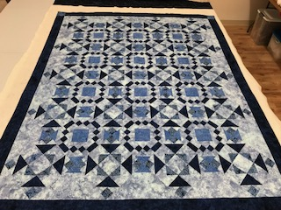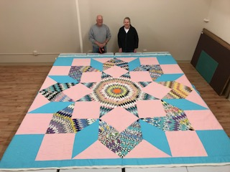The beginning of the year has turned out awesome. We have met so many more people and made new friends. We have had some repeat customers already at this point, and they have been very pleased. We look forward to providing a quality long-arm service to this quilt community as well. Thank you for coming in and visiting our shop.

