**SKIN INFORMATION:**

Name:______________________________________________ Today’s Date:______________________

Address:__________________________________________ City/State/Zip:________________________

Insurance:______________________________________________ Date of birth: ___________________

Phone:____________________________ Email:_____________________________________________

**Main Complaints/Reason for Visit:** _________________________________________________________________________________________________________________________________________________________________________________________________________________________________________________________________________________

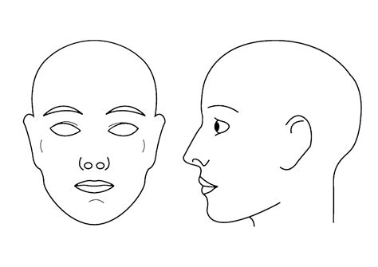

**Have you had a skin consultation or skin service before?** Y or N

**Have you used any of the following within the past month?**

Retinoic Acid Hydroquinone Glycolic Acid/Salicylic Acid Acne Medication

**Please circle any of the following that are true for you:**

Carcinomas/Melanoma/Cancer (current) Acne Eczema Psoriasis Hormonal Imbalance

Chemo or Radiation treatment (current) Rosacea Cold Sores Pregnant (current)/Lactating

**Are you taking any medications?** N or Y Please list current medications below: __________________________________________________________________________________________________________________________________________________________________________

**Please circle any of the following allergies:**

Aloe Sun/sunscreen Shellfish Pollen Lactose/Dairy Soy Fragrances Wheat/Gluten Aspirin Latex Eggs Nuts Other _______________________________________

Please describe your current skin care regimen: __________________________________________________________________________________________________________________________________________________________________________

I have voluntarily elected to undergo this treatment/procedure after the nature and purpose of this treatment has been explained to me, along with the risks and hazards involved. Although it is impossible to list every potential risk and complication, I have been informed of possible benefits, risks, and complications. I also recognize there are no guaranteed results and that independent results are dependent upon age, skin condition, and lifestyle and that there is the possibility I may require further treatments of the treated areas to obtain the expected results at an additional cost. I have read and understand the post-treatment home care instructions. I understand how important it is to follow all instructions given to me for post-treatment care. In the event that I may have additional questions or concerns regarding my treatment or suggested home product/post-treatment care, I will consult the esthetician immediately. I have also, to the best of my knowledge, given an accurate account of my medical history, including all known allergies or prescription drugs or products I am currently ingesting or using topically. I have read and fully understand this agreement and all information detailed above. I understand the procedure and accept the risks. All of my questions have been answered to my satisfaction and I consent to the terms of this agreement. I do not hold the esthetician, whose signature appears below, or Blue Q Health and Wellness responsible for any of my conditions that were present, but not disclosed at the time of this skin care procedure, which may be affected by the treatment performed today.

Client Name (signature) __________________________________ Date________________________

Esthetician (signature) ___________________________________ Date________________________

Although every precaution will be taken to ensure your safety and wellbeing before, during and after your LED and/or Microcurrent treatment, please be aware of the following information and possible risks. Please initial:

* ___ I understand there are certain contraindications that would preclude me from receiving LED treatments, including epilepsy, medications causing light sensitivity, open wounds, pregnancy, and thyroid conditions.
* ___ I understand there are other precautions that should be considered before receiving LED therapy treatments and may require a doctor’s release and/or I assume any risk involved.
* ___ I understand that reactions are rare, but may include nausea, dizziness, weakness, and possible skin reactions including redness and/or other irritations.
* ___ I understand that some clients report slight tingling sensations, flashing of the optic nerve, and/or a metallic taste in the mouth during the LED and microcurrent procedure.
* ___ I understand there are certain contraindications that would preclude me from receiving microcurrent treatments, including autoimmune disorders, diabetes, embolism, epilepsy, melanoma, metal implants including plates/pins/screws, open wounds, pacemaker use, phlebitis, pregnancy, thrombosis, and varicose veins.
* ___ I understand that the use of Botox®, Juvederm®, Restylane®, and any other injectable must be disclosed prior to microcurrent treatment.
* ___ I understand that microcurrent treatments involve conducting mild electrical currents through the body, and that this brings some inherent risk.
* ___ I understand that reactions are rare, but may include nausea, dizziness, weakness, and possible skin reactions including redness and/or other irritations.
* ___ I understand that while the goal of this treatment is to improve the vitality of the skin, no specific guarantees of the result can or have been made.
* ___ I understand that it is imperative to my health that I disclose all of the information requested in the Client Profile/Health History.
* ___ I have cited all conditions and circumstances regarding my health history, medications being taken, and any past reactions to products or medications.
* ___ I understand that additional conditions could occur or be discovered during the procedure which could affect my ability to tolerate the procedure.

**___ I consent to “before and after” photographs for the purpose of documentation, potential advertising and promotional purposes.**