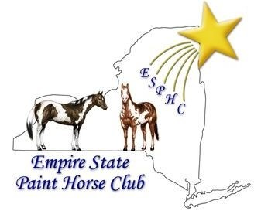
2026 EMPIRE STATE PAINT HORSE CLUB
MEMBERSHIP APPLICATION

2026 ESPHC General Membership entitles members to all club activities voting privileges, and the recording of ESPHC show points for the current year from when membership payment is received until the end of the current year.

All owners MUST be members of ESPHC to receive year-end awards; points accrue after membership has been paid.

NAME:

ADDRESS: _PHONE:

E-MAIL: APHA Membership #:

I have read and agree to follow the Bylaws of the Garden State Paint Horse Club Bylaws are available on www.gsphc.com

INDIVIDUAL $25.00 (1 vote) FAMILY $35.00 (1 Vote) YOUTH $10.00 (no vote)

FAMILY MEMBERSHIPS are for spouses and children under eighteen (18) living in the same household.
Spouse/Youth Name | APHA Membership # | Youth – Age as of January 1 & DOB

