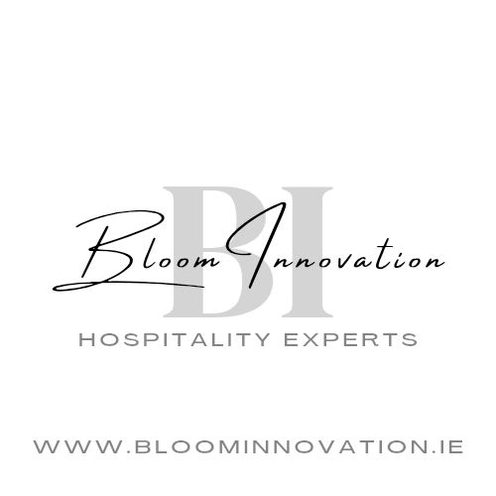

BRINGING INCREDIBLE DISHES & CREATIONS, TO DESTINATIONS ALL OVER IRELAND

Our hospitality catering showpieces travel to events nationwide allowing us to service events to the highest standard. Catering for bespoke food events, BBQs, Christmas parties, corporate events as well as match days, concerts, and film productions.

Gourmet Canapés
Menu

Mediterranean Mixed Vegetable Crostini
Smoked cheddar & Parma ham Arancini, Meaux mustard aioli
Kenmare smoked salmon, buttermilk wholemeal scone, lemon & saffron
Roasted Mediterranean vegetable tartar, sourdough
Chicken tandoori skewer, preserved lemon, coriander
At Tolas goats cheese tart, onion purée
Roast rare beef, truffle Yorkshire pudding, and horseradish
Cashel blue, shortcrust, candied walnut
Bruschetta- Green pesto red onion cherry tomato and basil
Brie, Bacon & Cranberry Crostini
Mini Garlic Breads with Pulled Pork & Guacamole
Smoked Salmon & Dill Cream
Tangy Thai Prawn Skewers
Smoked Chicken Filo Tartlets
Hummus & Cucumber Twirls

