Pioneer Family Recognized
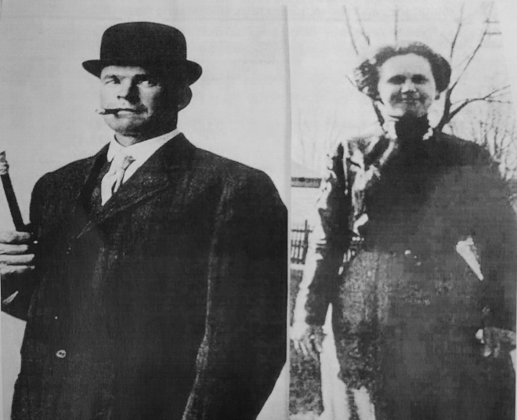
Daniel and Laura Hatley
Danield Hatley first arrived in 1914 to clear the land and establish their 400 acre farm on Hatley Road. He ordered a building package from Sears & Roebuck which was shipped by train to McGee. After building the home, his wife Laura joined him on the farm. Their family grew to include seven children; Wilbur, Edwin, Alice, Ruah, Thelma, Alva (Jerry) and Cleo. They attended the Perrin School. Descendants still live in, and serve our community; they also still own a portion of the original farm with a rustic cabin. The family will be presented with the Historical Proclamation August 29th at the Annual Pioneer Picnic held at the Veterans Memorial Park.
Treasurer Sibole Recommends
Garfield Treasurer Terri Sibole suggests that property owners Sign Up for free alerts when a document is recorded in Kalkaska County land records that match your name. A free notification will be sent by phone, text or email within 48 hours. Property owner information is kept confidential and used only for notification purposes. Go to www.propertyfraudalert.com to enroll; there is no cost. Questions? Contact JoAnn DeGraff, Kalkaska County Register of Deeds in person, or call (231) 258-3315.
New Cell Tower Approved
Garfield Township approved the erection of a 99’ tower in the area of Shively and Sharon Road, Verizon will be the service on the tower..
Annual Pioneer Picnic Date Set
Saturday August 29th is the Annual Community Picnic. Activities will include the Garfield Historical Society (GHS) Pioneer Family Recognition at the Museum followed by playground dedication, Community Picnic.
Garfield FD Needs Auxiliary
GFD is seeking volunteers to serve in the Auxiliary. Duties would include planning fundraisers, assisting with special events, providing food service during long emergency call outs. If interested in serving, please contact Fire Chief Charles Kitchen (231) 384-0096.
Playground Finally Finished
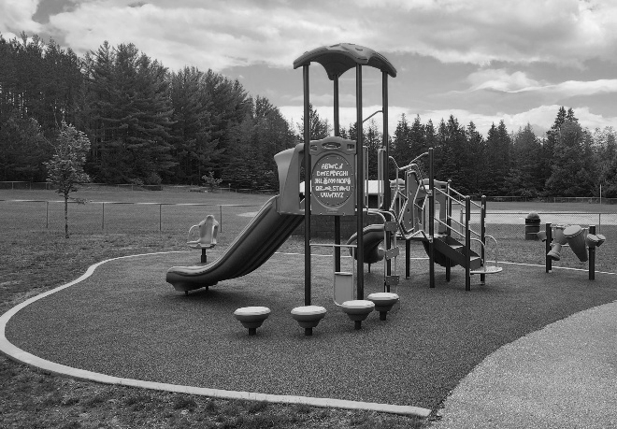
Veterans Memorial Park
Blazers Conference Champs
The Kalkaska HS Blue Blazers won the Northern Shores Conference Baseball Championship; their first in many years.
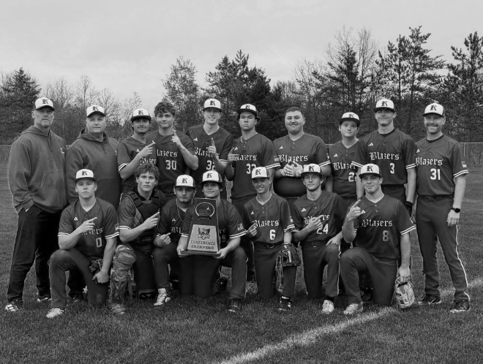
Kalkaska High School Baseball Team 2026

Watch for the Signs Soon

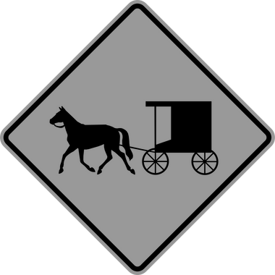
Signs are planned for Puffer and Lund Roads
DEPUTY CHIEF BOGUMIL
Recently graduated from a five month Leadership Program held at Camp Grayling Michigan. Officer Bogumil has 54 years of combined service with Detroit Police, Kalkaska Sheriff and Garfield Police Department.
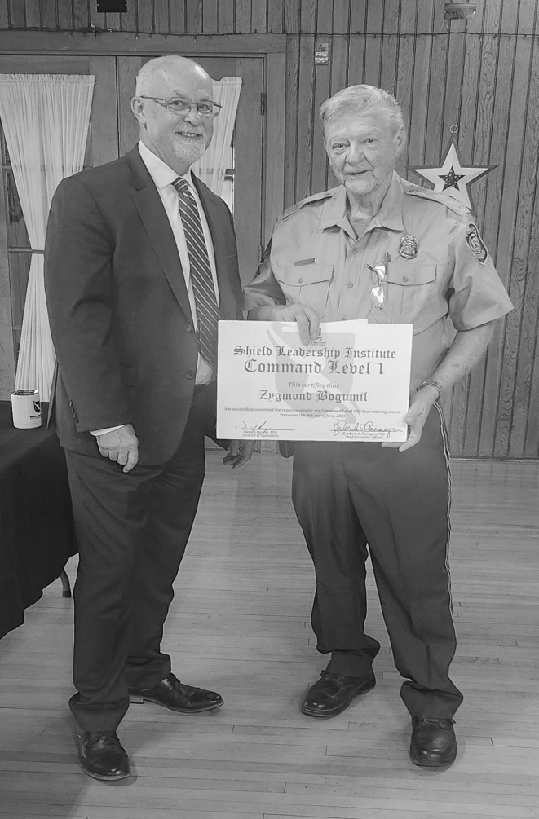
Summer Work Crew Members
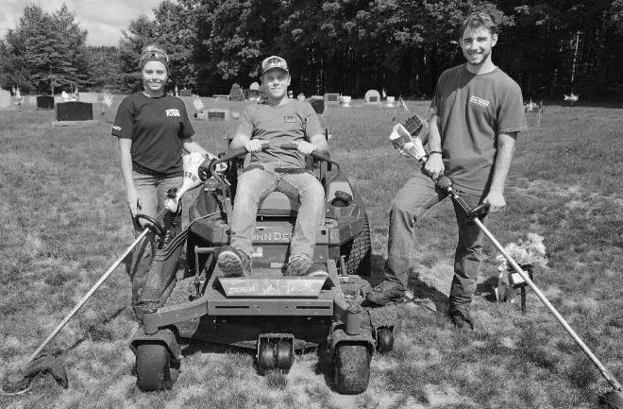
Groundkeepers Emily, Nate and Aidan are busy with Cemetery, Parks, Town Hall and Fire Dept.
It’s That Time of Year Again
Not our County Roads, but M-66 (Veterans Highway) is going to be resurfaced very soon; the signs and barrels are already out and about, so let’s help them help us. Give them a little safety space and a “Thumbs Up” for the good work that they do for us every single day.
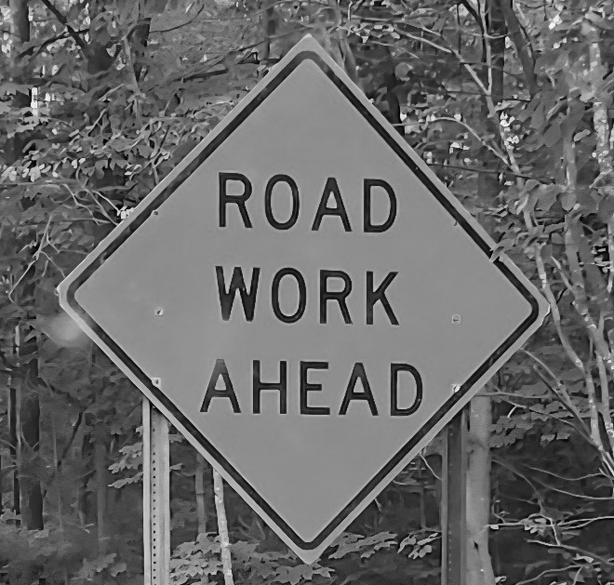
M-66 Resurfacing Project
Garfield Police Milestone
Garfield Police Department (GPD) was first organized in 1976. It has operated continuously for 50 years. There have been a number of officers who have served with the Department over the years; some started their careers here and many have finished out their careers with GPD. All consider their time with the agency a great opportunity to Serve, Protect and Defend the residents of our Community. A special recognition will be presented at Pioneer Picnic.

