JULIE COUCHERON, piano
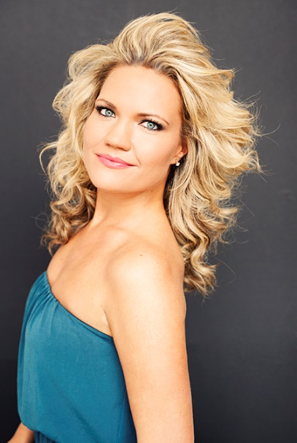

Born in Oslo, Norway, Ms. Coucheron began playing the piano at age four. She earned her Bachelor and Master’s Degree with honors from the Royal Academy of Music in London. At the age of 32, Ms. Coucheron has established an international career, winning awards and prizes in Italy, Germany, UK and in the United States.

Ms. Coucheron has worked with musicians such as Claude Frank, Emanuel Ax, Chee-Yun Kim, Christopher O’Riley, Steve Miller Band, Yo-Yo Ma, and Elton John, and has toured Europe, America, South America and Asia, performing in halls like Verizon Hall, Wigmore Hall, the Kennedy Center and Carnegie Hall.

Ms. Coucheron has performed with the Norwegian Radio Symphony Orchestra, Oslo Philharmonic; Jena Symphony Orchestra, Atlanta Symphony Orchestra, Atlanta Philarmonic and the Ukrainian Symphony Orchestra in Kiev.
Ms. Coucheron regularly performs at festivals such as the Oslo Chamber Music Festival, Bergen International Music Festival, Amelia Island Music Festival, Madison Chamber Music Festival, Juneau Jazz and Classics and at La Jolla Summer Fest. She is Artistic Director of the Fjord Cadenza festival in Norway ,the Kon Tiki Chamber Music Festival in Oslo, Norway and Georgian Chamber Players in Atlanta, GA.
In addition, Ms. Coucheron also performed during the 2003 Winter Olympic Games in Salt Lake City, Utah, and at the 2012 Summer Olympic Games in London.

Ms. Coucheron enjoys a close collaboration with her brother, the Concertmaster of the Atlanta Symphony, David Coucheron, and together they have released two recordings, ‘Debut’ and ‘David and Julie’ on the Naxos label.

In addition to her busy concert schedule, Ms. Coucheron is a sought after teacher and pedagogue. In August 2014, she was appointed Assistant Professor at Kennesaw State University in Atlanta, Georgia, one of the top 50 state schools in the United States.
Ms. Coucheron has given masterclasses and taught at schools such as the New England Conservatory, Emory University and Mercer University.

Ms. Coucheron enjoys a various and wide range of styles and repertoire emerging from her highly trained classical background to the more contemporary and popular music. Recent collaborations include performances with the Steve Miller Band and Elton John.

