**HEADS' CORNER**



 020 8449 2423

* [office@underhill.barnetmail.net](mailto:office@underhill.barnetmail.net)

 www.underhillschool.org

Hi everyone,

It has been another busy week here at Underhill. The children have been showing fantastic ‘I-Canuary’ attitudes and have been collecting lots of pink heart stickers!

Both our girls’ and boys’ football teams have played this week and we are so proud of all of them. The girls won with a convincing scoreline of 7-0 despite it being the first match for many players. Well done girls! The boys unfortunately didn’t win their match however the resilience and team work demonstrated by all of them was truly remarkable and we are equally as proud of them; they are true sportsmen.

On Tuesday next week, we have the Barnet Inclusion Advisory Team coming into school to see how we are supporting all children to achieve their very best. We are looking forward to showing them how much progress the chhidlren are making and how engaged they all are in their learning. We will update you on this visit next week.

Have a great weekend!

Jennie Reed and Nicola Hayles

Jennie Reed and Nicola Hayles

**NOTICES AND NEWS**

**OUTSTANDING DEBTS**

Please could we ask and remind parents that all school costs for dinners, nursery, after school club and breakfast club and all late charges need to be settled promptly or paid in advance on school money. It is not sustainable for us as a school to have a large amount of overdue debt as this restricts the money we have to spend on learning resources for your children. Thank you for your support with this.

**UNIFORM**

It looks so wonderful to see the children in their smart new uniforms but we are starting to see quite a few children who are not wearing the correct uniform and in particular who are coming in wearing trainers (when it is not PE day) or leggings. So here is a reminder of what the children should be wearing:

Our uniform list is:

**Boys Girls**

Black sweatshirt\cardigan with school logo Black sweatshirt\cardigan with school logo

Yellow polo shirt with school logo Yellow polo shirt with school logo

Black trousers (not leggings or joggers) Black skirt\pinafore\trousers (not leggings/joggers)

Black or white socks Black shoes Black tights or white socks

Black shoes

Black book bag with logo (optional) Black book bag with logo (optional)

**PE Kit**

Yellow T shirt with logo Yellow T shirt with logo

Black PE shorts Black PE shorts

Black joggers Black joggers

Trainers Trainers

**PARENTS EVENING MEETINGS YEARS 1-6**

**9TH FEBRUARY 3.40PM – 7.00PM and 10TH FEBRUARY 3.40PM – 5.00PM**

Parent Evening meetings will take place again via telephone call with your child’s class teacher. The phone calls are an opportunity to discuss your child’s learning and progress so far this year and each phone consultation will last a maximum of ten minutes.

Please don’t forget to book your slot from the email you have been sent as soon as possible.

**NURSERY AND RECEPTION**

Nursery and Reception parents will have a different meeting with their teachers and if your child is eligible for one now, you would have had a text message.

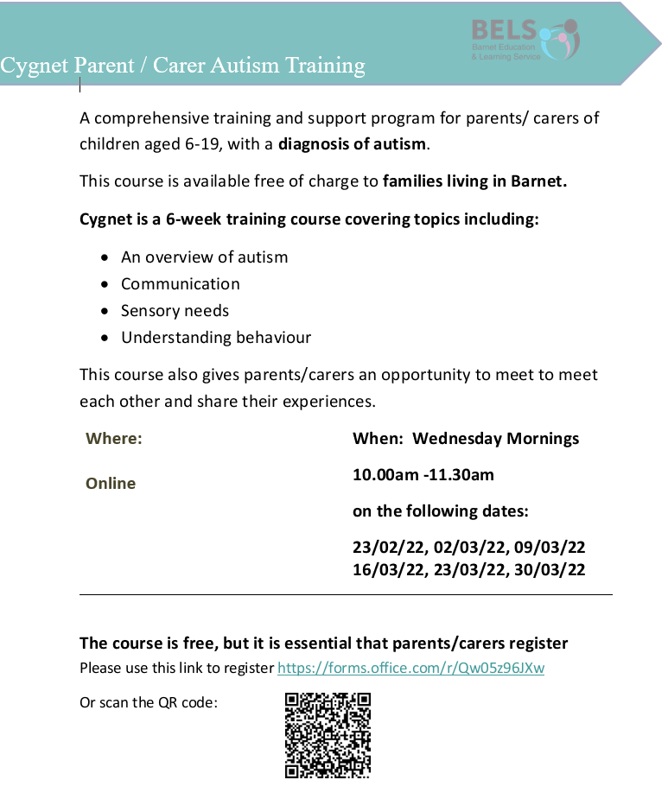

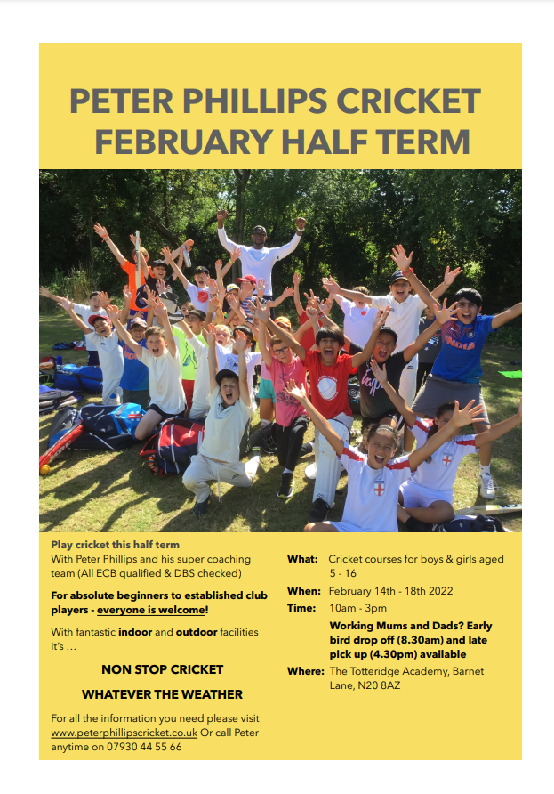

**DATES FOR YOUR DIARY**

**Wednesday 9th February-Parents Evening 3.40pm-7.00pm**

**Thursday 10th February-Parents Evening 3.40pm-5.00pm**

**Monday 14th February- Friday 18th February Half term**

**Thursday 31st March-last day of the term for Nursery**

**Friday 1st April-School finishes at 2pm**

|  |  |
| --- | --- |
| Beech | 92.55 |
| Maple | 92.31 |
| 1 Oak | 90.87 |
| 1 Willow | 93.59 |
| 2 Chestnut | 93.07 |
| 2 Palm | 98.19 |
| 3 Cedar | 86.27 |
| 3 Hornbeam | 91.32 |
| 3 Yew | 84.06 |
| 4 Cherry | 89.90 |
| 4 Larch | 92.81 |
| 4 Pine | 95.64 |
| 5 Holly | 94.72 |
| 5 Laurel | 92.10 |
| 5 Sycamore | 92.55 |
| 6 Ash | 96.07 |
| 6 Elm | 94.28 |
| 6 Hawthorn | 97.04 |

4

2

3

**House attendance**

Balmoral – 91.11

Windsor – 90.76

Holyrood – 92.06

Sandringham – 95.04

Balmoral – 94.06

1

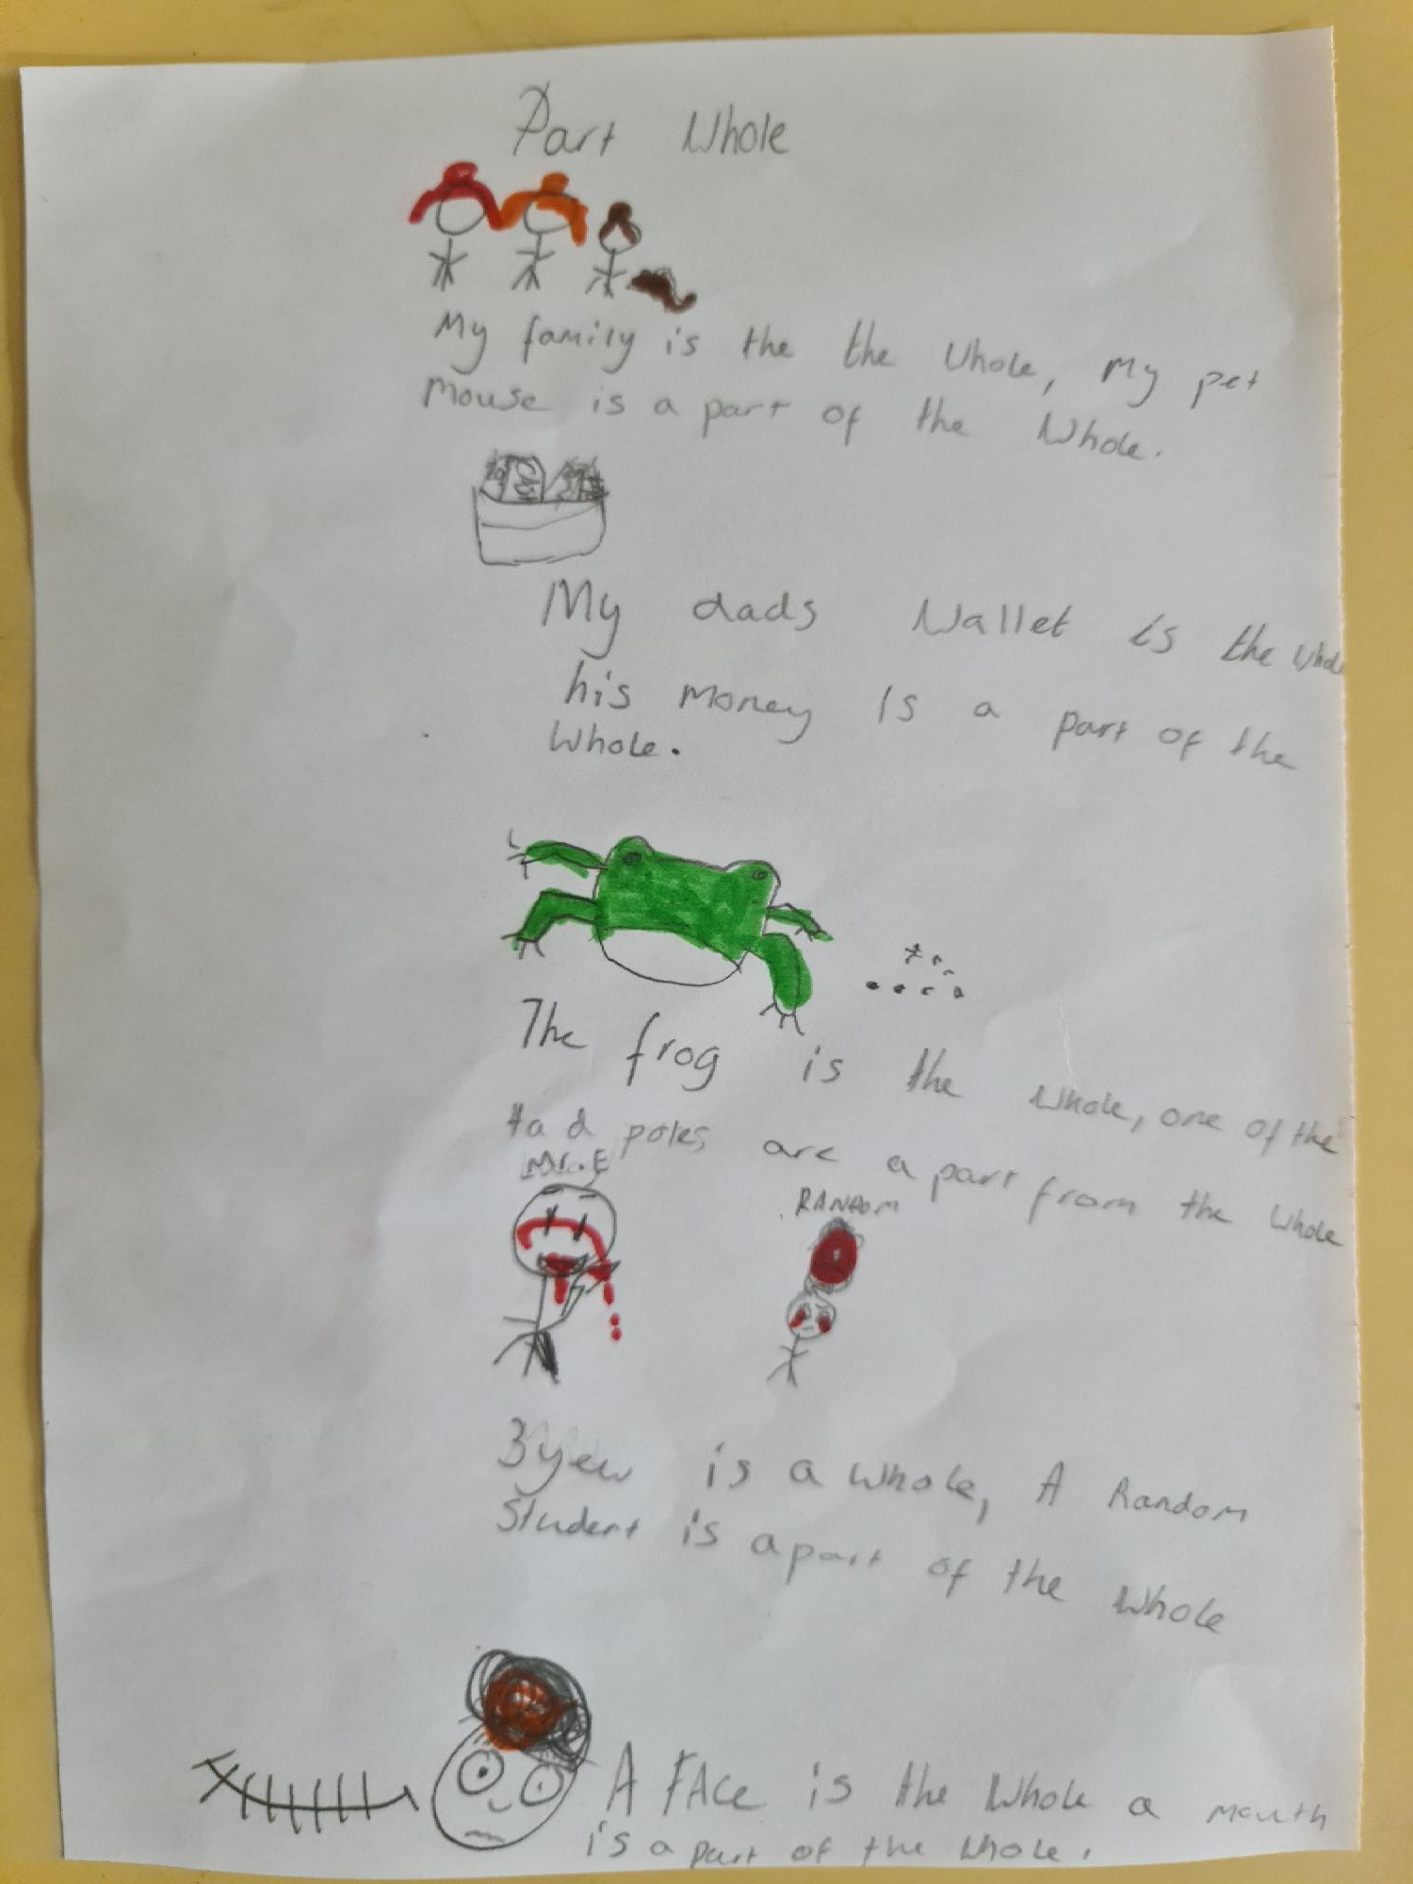



Would you like to improve your English speaking, reading, writing and listening skills? We will be starting ESOL - English for speakers of other languages​ in January 2022, Wednesday mornings 9.15am -11.15am. Please contact us at info@underhillcc.barnetmail.net or text 07511 273 564 to book your place. We are unable to offer creche facilities.

This is the link for the autumn term timetable.

<https://be801be7-27ae-403d-b550-25d9901a126c.filesusr.com/ugd/9779ab_e6b1abf05ecf467e811c62c74d94069d.pdf>

|  |
| --- |
|  |

