**HEADS' CORNER**



 020 8449 2423

* [office@underhill.barnetmail.net](mailto:office@underhill.barnetmail.net)

 www.underhillschool.org

Hi everyone,

We wanted to say a huge thank you for your support and understanding this week as we know that it is incredibly challenging when we have to move to remote learning with very little notice. Unfortunately, we still have a very large number of staff at home for Covid related reasons but we are trying to ensure that this impacts the children’s education as little as possible.

On Tuesday this week we had some visitors from the local authority and other Barnet schools, who came to look at the way we support children with their learning. They were really impressed by the way all children focused on their learning and also at the great progess evident in the books. The children, as always, were excellent Underhill ambassadors and were very keen to talk to our visitors about their learning. We are very proud headteachers!

Have a lovely weekend,

Jennie Reed and Nicola Hayles

Jennie Reed and Nicola Hayles

**NOTICES AND NEWS**



**PARENTS EVENING MEETINGS YEARS 1-6**

**9TH FEBRUARY 3.40PM – 7.00PM and 10TH FEBRUARY 3.40PM – 5.00PM**

Please remember to book your Parent Evening meetings if you haven’t done so already. The phone calls are an opportunity to discuss your child’s learning and progress so far this year and each phone consultation will last a maximum of ten minutes.

**NURSERY AND RECEPTION**

Nursery and Reception parents will have a different meeting with their teachers and if your child is eligible for one now, you would have had a text message.

**GIRL’S FOOTBALL**

The Underhill girls played last Monday their second football match against Northside. For some of them it was their first game ever and they were very nervous, but they played amazingly, showing that they are a very strong team.

The game kicked off with a goal from Hazel just a few minutes in, which helped the team gain confidence to bring the second win of the season for Underhill.  The first goal was followed by 6 more from Daniella (1), Maggie (1), Hazel (2), Willow (2) and Chichi (1).

Due to Covid they have not had many opportunities to play, but the girls have started off the season with two brilliant performances showing skill, team play and effectiveness.

Go on Underhill!

Player of the match : Willow

Judit Belastegui



**CANTEEN NEWS**

In order to celebrate the Chinese New Year ISS our caterers will be offering the children who have school dinners a **CHINESE NEW YEAR** lunch on Thursday 3rd February 2022. Please see the menu for next Thursday. We hope the children enjoy their lunch.

**CLUBS**

**EARLY BIRD TENNIS CLUB**

If you are interested in your child learning and playing Tennis there are still some spaces:

The club runs **every Tuesday morning from 7.45am.**

It is open to **years 2 to 6.**

**A free taster session is available by emailing the address below.**

To sign up please email Luke Barker at lukebarkerbltc@gmail.com with:

1. Childs name.

2. Year and class.

3. Parents contact details.

4. Permission to be added to a WhatsApp group.

5. Medical concerns.

6. Emergency contact.

The club will run up to Easter holidays!



**YOGA**

If you wish to sign your child up for Yoga there are still some spaces, please see the form below with the details

**DATES FOR YOUR DIARY**

**Wednesday 9th February-Parents Evening 3.40pm-7.00pm**

**Thursday 10th February-Parents Evening 3.40pm-5.00pm**

**Monday 14th February- Friday 18th February Half term**

**Thursday 31st March-last day of the term for Nursery**

**Friday 1st April-School finishes at 2pm**

|  |  |
| --- | --- |
| Beech | 92.35 |
| Maple | 88.94 |
| 1 Oak | 86.79 |
| 1 Willow | 92.22 |
| 2 Chestnut | 89.95 |
| 2 Palm | 85.33 |
| 3 Cedar | 80.34 |
| 3 Hornbeam | 98.04 |
| 3 Yew | 72.41 |
| 4 Cherry | 91.86 |
| 4 Larch | 93.16 |
| 4 Pine | 89.67 |
| 5 Holly | 89.19 |
| 5 Laurel | 87.76 |
| 5 Sycamore | 90.66 |
| 6 Ash | 100.00 |
| 6 Elm | 92.45 |
| 6 Hawthorn | 76.07 |

4

2

3

**House attendance**

Balmoral – 85.08

Windsor – 92.28

Holyrood – 86.47

Sandringham – 90.50

Balmoral – 94.06

1

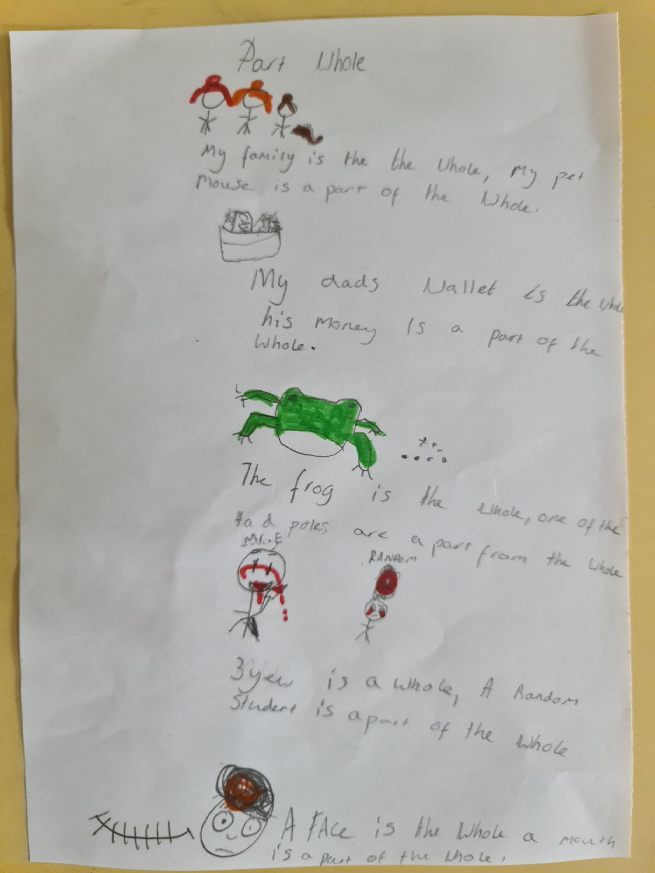



Would you like to improve your English speaking, reading, writing and listening skills? We will be starting ESOL - English for speakers of other languages​ in January 2022, Wednesday mornings 9.15am -11.15am. Please contact us at info@underhillcc.barnetmail.net or text 07511 273 564 to book your place. We are unable to offer creche facilities.

This is the link for the autumn term timetable.

<https://be801be7-27ae-403d-b550-25d9901a126c.filesusr.com/ugd/9779ab_e6b1abf05ecf467e811c62c74d94069d.pdf>

|  |
| --- |
|  |

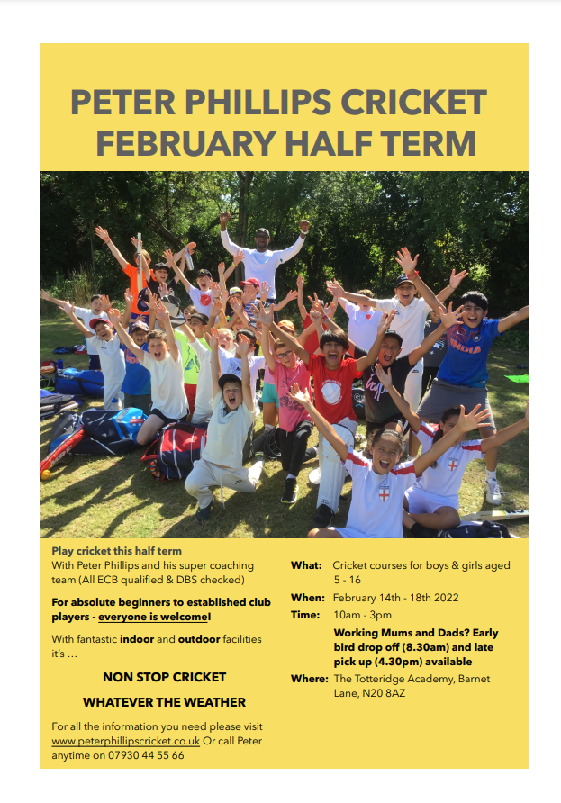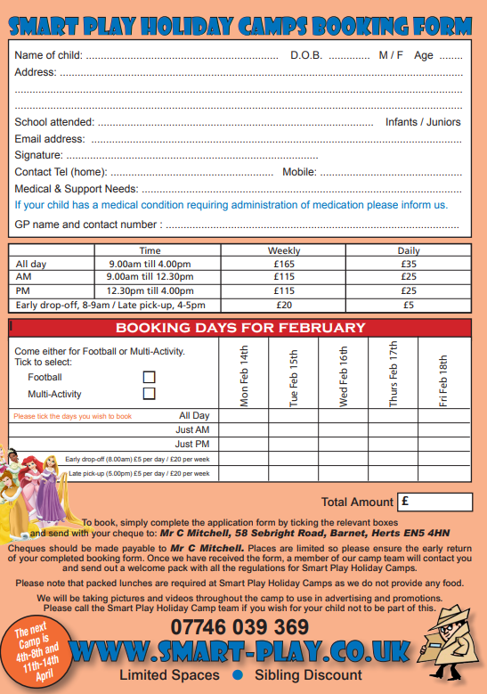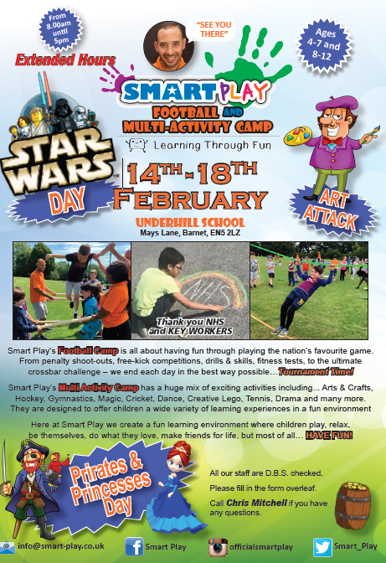

**HALF TERM HOLIDAY CLUB INFORMATION**