Underhill School and Children’s Centre

Recommended Reading List

Year 6+

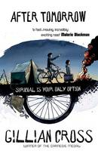 |  | After Tomorrow  Gillian Cross  What if you woke up tomorrow and everything had changed? Money is worthless. Your friends are gone. Armed robbers roam the streets. No one is safe. For Matt and his little brother, Taco, that nightmare is a reality. Their only hope of survival is to escape through the Channel Tunnel. But danger waits on the other side...Stay or go. What would you do?

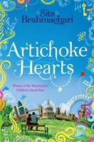 |  | Artichoke Hearts  Sita Brahmachari  Twelve-year-old Mira comes from a chaotic, artistic and outspoken family where it's not always easy to be heard. As her beloved Nana Josie's health declines, Mira begins to discover the secrets of those around her, and also starts to keep some of her own. She is drawn to mysterious Jide, a boy who is clearly hiding a troubled past and has grown hardened layers - like those of an artichoke - around his heart. As Mira is experiencing grief for the first time, she is also discovering the wondrous and often mystical world around her. An incredibly insightful, honest novel exploring the delicate balance, and often injustice, of life and death - but at its heart is a celebration of friendship, culture - and life. Winner of the 2011 Waterstone's Children's Book Prize.

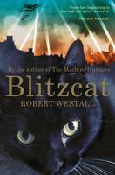 |  | Blitzcat  Robert Westall  She made her way down the cliff, and on to the beach. At the edge of the waves, she stopped, shaking her wet paws. She knew that somewhere ahead was her person, but far, far away. She miaowed plaintively; stood staring at the moving blur of uncrossable sea. She led the way to safety, out of the blazing hell of blitzed Coventry. People touched her for luck; feared her as an omen of disaster. Wherever she went, she changed lives ...From her beginning to her end she never wavered. She was the Blitzcat. Blitzcat by Robert Westall is the Smarties Prize-winning book about one brave cat's experiences during World War Two.

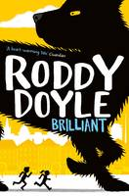 |  | Brilliant  Roddy Doyle  When Uncle Ben's Dublin business fails, it's clear to Gloria and Raymond that something is wrong. He just isn't his usual cheerful self. So when the children overhear their granny saying that the Black Dog has settled on Ben's back and he won't be OK until it's gone, they decide they're going to get rid of it. Gathering all their courage the children set out on a midnight quest to hunt down the Black Dog and chase it away. But they aren't the only kids on the mission. Loads of other children are searching for it too, because the Black Dog is hounding lots of Dublin's adults. Together - and with the help of magical animals, birds and rodents - the children manage to corner the Black Dog ...but will they have the courage and cleverness to destroy the frightening creature?

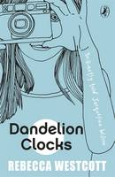 |  | Dandelion Clocks  Rebecca Westcott  Dandelion Clocks by Rebecca Westcott will be loved by fans of Jacqueline Wilson, Cathy Cassidy or Annabel Pitcher. Liv takes us on a journey through her life from Thirteen Weeks Before to Six Months After . We discover Liv's passion for photography, her brother's obsession with sticking to the rules, the stupidity of Moronic Louise at school, and how the family copes as Mum's terminal illness takes hold...Guided by Mum's own childhood diaries, Liv finds a new way to live. This book is real, funny, utterly touching and absolutely heartwarming. Despite the sadness at the heart of the story, every reader will laugh and keep on turning the pages, charmed by Liv and her mum. A brilliantly told, ultra modern story about a significant six months in eleven year old Olivia's life - it should be sold with a large box of tissues! (Jacqueline Wilson).

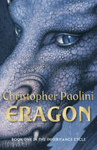 |  | Eragon  Christopher Paolini  One boy ...One dragon ...A world of adventure. When Eragon finds a polished stone in the forest, he thinks it is the lucky discovery of a poor farm boy; perhaps it will buy his family meat for the winter. But when the stone brings a dragon hatchling, Eragon soon realizes he has stumbled upon a legacy nearly as old as the Empire itself. Overnight his simple life is shattered and he is thrust into a perilous new world of destiny, magic and power. With only an ancient sword and the advice of an old storyteller for guidance, Eragon and the fledgling dragon must navigate the dangerous terrain and dark enemies of an Empire ruled by a king whose evil knows no bounds. Can Eragon take up the mantle of the legendary Dragon Riders? The fate of the Empire may rest in his hands...

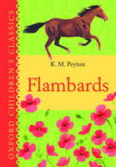 |  | Flambards: Oxford Children's Classics  K. M. Peyton  Christina is sent to live with her uncle in his country house, Flambards, and knows from the moment she arrives that she'll never fit in. Her uncle is fierce and domineering and her cousin, Mark, is selfish - but despite all this, Christina discovers a passion for horse-riding and finds a true friend in Will. What Christina has yet to realize, though, is the important part she has to play in the future of this strange household...

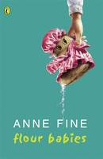 |  | Flour Babies  Anne Fine  Let it be flour babies. Let chaos reign. When the annual school science fair comes round, Mr Cartwright's class don't get to work on the Soap Factory, the Maggot Farm or the Exploding Custard Tins. To their intense disgust they get the Flour Babies - sweet little six-pound bags of flour that must be cared for at all times.

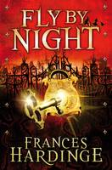 |  | Fly by Night  Frances Hardinge  A breathtaking adventure story, set in reimagined eighteenth-century England. As the realm struggles to maintain an uneasy peace after years of cival war and tyranny, a twelve-year-old orphan and her loyal companion, a grumpy goose, are about to become the unlikely heroes of a radical revolution. Mosca Mye is on the run, heading for the city of Mandelion. There she finds herself living by her wits among cut-throat highwaymen, spies and smugglers. With peril at every turn, Mosca uncovers a dark plot to terrorize the people of Mandelion, and soon merry mayhem leads to murder ...With an unforgettable cast of characters and an inspiring message at its heart -- sometimes the power of words can change the world!

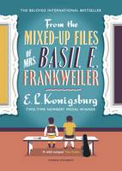 |  | From the Mixed-Up Files of Mrs. Basil E. Frankweiler  E.L. Konigsburg, Nathan Burton  New York City girl Claudia, a mere month shy of being a twelve-year-old, has resolved to run away from home with her younger brother, Jamie. She knows that she could never pull off the classic spur-of-the-moment departure without a destination (inevitably involving having to eat outside with the insects, and cupcakes melting in the sun); so she plans everything to perfection, including their destination: the grand, elegant, beautiful, all-encompassing Metropolitan Museum of Art. However, no sooner have Claudia and Jamie settled into their new home, than they are caught up in the mystery of an angel statue bought by the museum for the bargain price of $225. Is it in fact an as yet undiscovered work by Michelangelo, worth millions? Claudia is determined to find out, and her quest leads her to the remarkable, secretive Mrs. Frankweiler, who sold the statue to the museum - and to some equally remarkable discoveries about herself. Since its first appearance nearly 50 years ago, The Mixed-up Files of Mrs. Basil E. Frankweiler has gained a place in the hearts of generations of readers - and has rightly become one of the most celebrated and beloved children's books of all time.

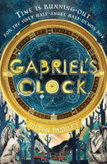 |  | Gabriel's Clock  Hilton Pashley  Jonathan is half-angel, half-demon, and the only one of his kind. But he has no idea of his true identity, and now a rogue archdemon wants him for his own sinister purpose...With the aid of a group of unlikely new friends, Jonathan races to find the mysterious Gabriel's Clock, which has the power to start a war between Heaven and Hell that could engulf them all. Gabriel's clock is ticking ...and time is running out.

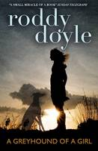 |  | Greyhound of a Girl  Roddy Doyle  12 year old Mary's beloved grandmother is near the end of her life. Letting go is hard - until Granny's long-dead mammy appears. Her ghost has returned to help her dying daughter say goodbye to the ones she loves. But first she needs to take them all on a road trip to the past. A GREYHOUND OF A GIRL is a perfectly-pitched funny and tender tale about four generations of an Irish family, and the special bonds between mothers and daughters. It will entrance readers from 10 to adult.

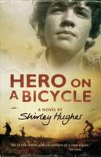 |  | Hero on a Bicycle  Shirley Hughes  In extraordinary circumstances, people are capable of extraordinary things...It is 1944 and Florence is occupied by Nazi German forces. The Italian resistance movement has not given up hope, though - and neither have Paolo and his sister, Constanza. Both are desperate to fight the occupation, but what can two siblings do against a whole army with only a bicycle to help them?

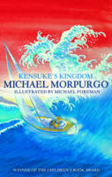 |  | Kensuke's Kingdom  Michael, M. B. E. Morpurgo  Kensuke's Kingdom is a true children's classic by Michael Morpurgo, the creator of War Horse. I heard the wind above me in the sails. I remember thinking, this is silly, you haven't got your safety harness on, you haven't got your lifejacket on. You shouldn't be doing this ...I was in the cold of the sea before I could even open my mouth to scream. Washed up on an island in the Pacific, Michael struggles to survive on his own. With no food and no water, he curls up to die. When he wakes, there is a plate beside him of fish, of fruit, and a bowl of fresh water. He is not alone ...From the author of War Horse (now a major motion picture directed by Steven Spielberg) comes a stunning children's story - loved by kids, teachers and parents alike. Michael Morpurgo has written more than forty books and won the Whitbread Award, the Smarties Award, the Circle of Gold Award, the Children's Book Award and has been short-listed for the Carnegie Medal four times. Reviewed as 'A dazzling adventure' by The Times.

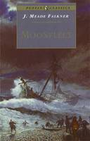 |  | Moonfleet  John Meade Falkner  Everyone in the tiny village of Moonfleet lives by the sea one way or another, so it's no surprise when young John Trenchard gets involved in the smuggling trade. Forced to flee England with a price on his head, John little guesses the adventures and trials he will have before he sees Moonfleet again or the change in his fortunes when he does.

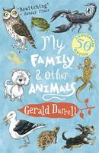 |  | My Family and Other Animals  Gerald Durrell  Sometimes it's pretty hard to tell them apart...my family and the animals, that is. I don't know why my brothers and sisters complain so much. With snakes in the bath and scorpions on the lunch table, our house, on the island of Corfu, is a bit like a circus. So they should feel right at home...

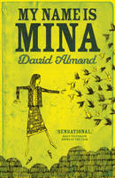 |  | My Name is Mina  David Almond  There's an empty notebook lying on the table in the moonlight. It's been there for an age. I keep on saying that I'll write a journal. So I'll start right here, right now. I open the book and write the very first words: My name is Mina and I love the night. Then what shall I write? I can't just write that this happened then this happened then this happened to boring infinitum. I'll let my journal grow just like the mind does, just like a tree or a beast does, just like life does. Why should a book tell a tale in a dull straight line? And so Mina writes and writes in her notebook, and here is her journal, Mina's life in Mina's own words: her stories and dreams, experiences and thoughts, her scribblings and nonsense, poems and songs. Her vivid account of her vivid life. In this stunning book, David Almond revisits Mina before she has met Michael, before she has met Skellig. Shortlisted for the 2012 Carnegie Medal.

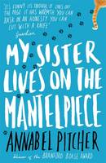 |  | My Sister Lives on the Mantelpiece  Annabel Pitcher  Ten-year-old Jamie Matthews has just moved to the Lake District with his Dad and his teenage sister, Jasmine for a 'Fresh New Start'. Five years ago his sister's twin, Rose, was blown up by a terrorist bomb. His parents are wrecked by their grief, Jasmine turns to piercing, pink hair and stops eating. The family falls apart. But Jamie hasn't cried in all that time. To him Rose is just a distant memory. Jamie is far more interested in his cat, Roger, his birthday Spiderman T-shirt, and in keeping his new friend Sunya a secret from his dad. And in his deep longing and unshakeable belief that his Mum will come back to the family she walked out on months ago. When he sees a TV advert for a talent show, he feels certain that this will change everything and bring them all back together once and for all.

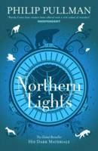 |  | Northern Lights  Philip Pullman  Without this child, we shall all die. Lyra Belacqua and her animal daemon live half-wild and carefree among scholars of Jordan College, Oxford. The destiny that awaits her will take her to the frozen lands of the Arctic, where witch-clans reign and ice-bears fight. Her extraordinary journey will have immeasurable consequences far beyond her own world...

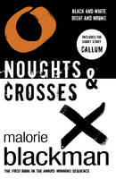 |  | Noughts and Crosses Book 1  Malorie Blackman  Sephy is a Cross - a member of the dark-skinned ruling class. Callum is a nought - a 'colourless' member of the underclass who were once slaves to the Crosses. The two have been friends since early childhood. But that's as far as it can go. Against a background of prejudice, distrust and mounting terrorist violence, a romance builds between Sephy and Callum - a romance that is to lead both of them into terrible danger ...

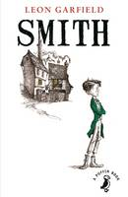 |  | Smith  Leon Garfield  London street urchin Smith is 12 years old, and an experienced pick-pocket. One day on Ludgate Hill, he robbed an old gentleman, and one minute later watched him silently murdered by two men, who chased him for the document he had stolen but could not understand. Smith artfully dodges the two men and winds up in the odd company of a wealthy blind man, who takes Smith into his home and provides him with an education. But this new comfort is lost when Smith himself is suspected of the very murder he witnessed

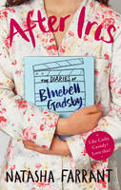 |  | The After Iris The Diaries of Bluebell Gadsby  Natasha Farrant  Being a combination of conventional diary entries and transcripts of videos shot by the author on the camera she was given for her 13th birthday, and beginning at the end of summer. Bluebell Gadsby is 13 but that's the least of her problems. Both her parents seem more interested in their careers than the family, leaving Blue and her three siblings as well as their three pet rats (who may or may not be pregnant), in the care of Zoran the au pair. The enigmatic Joss moves in next door and Blue thinks she might be falling in love, until he takes out her older sister Flora instead (who, incidentally, is trying to make a statement by dying her hair bright pink but no one takes the blindest bit of notice). Blue thinks and feels very deeply about life but can't really talk to anyone about it, because no one in the Gadsby family wants to address the real problem - that Blue's twin sister, Iris, died a year ago, and they are all just trying to hide their grief in busyness...So Blue turns to her diary and her unique way of seeing the world through her camcorder to express herself. A tender, funny, smart and ultimately heartwarming story.

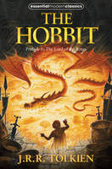 |  | The Hobbit  J. R. R. Tolkien  The Hobbit is the unforgettable story of Bilbo, a peace-loving hobbit, who embarks on a strange and magical adventure. A timeless classic. Bilbo Baggins enjoys a quiet and contented life, with no desire to travel far from the comforts of home; then one day the wizard Gandalf and a band of dwarves arrive unexpectedly and enlist his services -- as a burglar -- on a dangerous expedition to raid the treasure-hoard of Smaug the dragon. Bilbo's life is never to be the same again. Seldom has any book been so widely read and loved as J.R.R. Tolkien's classic tale, 'The Hobbit'.

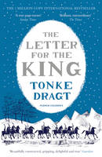 |  | The Letter for the King  Tonke Dragt  A young messenger. A secret mission. A kingdom in peril. When sixteen-year-old Tiuri answers a desperate call for help, he finds himself on a perilous mission that could cost him his life. He must deliver a secret letter to the King who lives across the Great Mountains - a letter upon which the future of the entire realm depends. It means abandoning his home, breaking all the rules and leaving everything behind - even the knighthood that he has dreamed of for so long. The fate of a kingdom depends on just one person...He must trust no one. He must keep his true identity secret. Above all, he must never reveal what is in the letter.

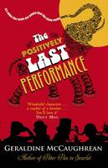 |  | The Positively Last Performance  Geraldine McCaughrean  The performances at The Royal Theatre are extraordinary. You'd have to see them to believe them! But that's the problem. Nobody can see them. Except Gracie, that is. Newly arrived in her favourite seaside town and its beautiful old theatre, Gracie's quickly making friends. There's Mikey the Mod who wears a parka and drives a scooter, Miss Melluish whose skirt is missing, and Frank Stuart, the maker of mechanical elephants. But the old theatre is under threat. Will Gracie and her friends be able to save their home, or is the curtain set to fall on their very last performance? 'Everybody should read Geraldine McCaughrean' Philip Reeve

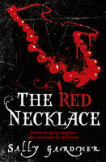 |  | The Red Necklace  Sally Gardner  The story of a remarkable boy called Yann Margoza; Tetu the dwarf, his friend and mentor; Sido, unloved daughter of a foolish Marquis; and Count Kalliovski, Grand Master of a secret society, who has half the aristocracy in thrall to him, and wants Yann dead. Yann is spirited away to London but three years later, when Paris is gripped by the bloody horrors of the Revolution, he returns, charged with two missions: to find out Kalliovski's darkest deeds and to save Sido from the guillotine. With a tangle of secrets, a thread of magic and a touch of humour, the follies of the aristocracy and the sufferings of ordinary people are unfolded as their lives move relentlessly towards the tragic and horrific days of the Terror. THE RED NECKLACE is not only a tremendous adventure story but a vibrant and passionate picture of Paris in turmoil and of a large cast of memorable characters.

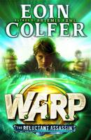 |  | The Reluctant Assassin  Eoin Colfer  It all began with the FBI and WARP (Witness Anonymous Relocation Programme). Hiding witnesses in the past to protect the future - until now. Riley is a Victorian orphan, hurtled into the twenty-first century and on the run from his evil master. Albert Garrick, the terrifying assassin-for-hire pursuing Riley through time, along with. Chevie Savano, the FBI's youngest and most impulsive special agent. As Garrick relentlessly hunts them down, Riley and Chevie face a desperate race to stay alive and stop Garrick from returning to his own time - armed with knowledge and power that could change the world forever.

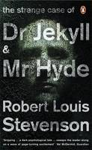 |  | The Strange Case of Dr Jekyll and Mr Hyde  Robert Louis Stevenson  Everyone has a dark side. Dr Jekyll has discovered the ultimate drug. A chemical that can turn him into something else. Suddenly, he can unleash his deepest cruelties in the guise of the sinister Hyde. Transforming himself at will, he roams the streets of fog-bound London as his monstrous alter-ego. It seems he is master of his fate. It seems he is in complete control. But soon he will discover that his double life comes at a hideous price.

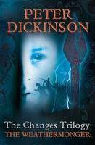 |  | The Weathermonger  Peter Dickinson  Long-awaited new editions of Peter Dickinson's cult classics England in the future - but an England that is less rather than more civilised. This is the time of The Changes - a time when people, especially adults, have grown to hate machines and returned to a more primitive lifestyle. It is a time of hardship and fear...When 16-year-old Geoffrey, a weathermonger starts to repair his uncle's motorboat, he and his sister Sally are condemned as witches. Fleeing for their lives, they travel to France - where they discover that everything is normal. Returning to England, they set out to discover why the country is under this mysterious spell. Only discovering the origin of the deadly magic will allow them to set the people free of its destructive influence. Peter Dickinson began writing the books after he'd had a nightmare. The trilogy is not sequential; rather, each book explores a different aspect of England during the time that simply became known as The Changes.

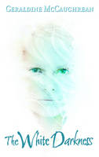 |  | The White Darkness  Geraldine McCaughrean  Captain Titus Oates, hero of the Antarctic, has been dead for nearly a century. But not in Sym's head. In there, he is her constant companion, her soul mate, her adviser. It is as if he walked out of the Polar blizzard and into her mind. In fact, if it were not for Titus, life might be as bleak a place as the Antarctic wilderness. When she is taken on a mystery expedition by her eccentric uncle Victor, Sym can't believe her luck. Destination Antarctica-the very place she's always wanted to visit. But Victor has other plans, more sinister than Sym could possibly imagine. Stranded in the most isolated part of the world with her trust in someone she comes to realize is a madman, she must find a way to avoid a gruesome fate. But what should a teenage girl do? Could it be that Titus, the one who perished in that very place, will be the means of her survival?

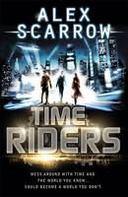 |  | TimeRiders  Alex Scarrow  Liam O'Connor should have died at sea in 1912. Maddy Carter should have died on a plane in 2010. Sal Vikram should have died in a fire in 2029. Yet moments before death, someone mysteriously appeared and said, 'Take my hand ...' But Liam, Maddy and Sal aren't rescued. They are recruited by an agency that no one knows exists, with only one purpose - to fix broken history. Because time travel is here, and there are those who would go back in time and change the past. That's why the TimeRiders exist: to protect us. To stop time travel from destroying the world ...

