Underhill School and Children’s Centre

Recommended Reading List

Year 1
If your child is a competent reader or has read all these titles then try the books from the Year 2 or 3 list
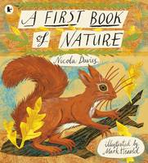 |  | A First Book of Nature  Nicola Davies  From beachcombing to stargazing, from watching squirrels, ducks and worms to making berry crumble or a winter bird feast, this is a remarkable book - part poetry, part scrapbook of recipes, facts and fragments - and a glorious reminder that the natural world is on our doorstep waiting to be discovered. Mark Hearld's pictures beautifully reproduce the colours of the seasons on woodfree paper, and Nicola Davies' lyrical words capture the simple loveliness that is everywhere, if only we can look.

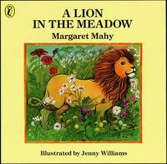 |  | A Lion in the Meadow  Margaret Mahy  What would you do if you knew there was a lion in the meadow, but your mother wouldn't believe you and gave you a matchbox with a dragon to scare the away the lion...and in fact the dragon was there too?

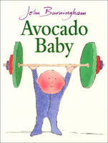 |  | Avocado Baby  John Burningham  The Hargraves want their new baby to grow up big and strong. But the puny mite will hardly eat a thing. One day Mrs Hargraves finds an avocado in the fruit bowl and the baby gobbles it up. Soon, the strangest things start to happen...

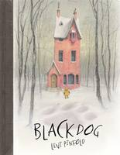 |  | Black Dog  Levi Pinfold  A black dog appears outside the Hope family's home. As each member of the household sees it and hides, the dog grows bigger and bigger. Only Small, the youngest Hope, has the courage to face the Black Dog. When it chases her through the forest she shows no fear, so it grows smaller and smaller. Finally, back to the size of a normal hound, the Black Dog is welcomed into the Hope household as their newest addition.

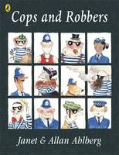 |  | Cops and Robbers  Allan Ahlberg  This is a new Puffin edition of Allan Ahlberg's best-selling Cops and Robbers classic picture book, with a brand new cover! The robbers of London town plan a desperate crime one Christmas Eve - to steal all the toys they can lay their hands on! Fortunately, the robbers meet their match in brave office Pugh who leaps into action and arrests the villains - all except Grandma Swagg who manages to get away. Look out for these other classics by Allan Ahlberg: Kicking a Ball; The Baby's Catalogue; Burglar Bill; Each Peach Pear Plum; The One and Only Two Heads; Son of a Gun; The Little Worm Book; Two Wheels Two Heads; Funny Bones; A Pair of Sinners; Happy Families; Peepo!; The Ha Ha Bonk Book; Help Your Child to Read; Ten in a Bed; Please Mrs Butler; Daisy Chains; Yum Yum; Playmates; Foldaways; Woof; The Cinderella Show; The Jolly Postman; The Jolly Christmas Postman; The Jolly Pocket Postman; The Clothes Horse and Other Stories; The Mighty Slide; Starting School; Heard it in the Playground; The Bear Nobody Wanted; It was a Dark and Stormy Night; The Giant Baby; Baby Sleeps; Blue Buggy; Doll and Teddy; See the Rabbit; Please Mrs Butler; The Better Brown Stories; and The Boyhood of Burglar Bill.

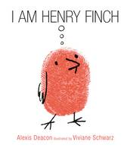 |  | I am Henry Finch  Alexis Deacon, Viviane Schwarz  From award-winning picture book makers Alexis Deacon and Viviane Schwarz comes an enlightening new story about courage and making a difference. For budding philosophers of all ages, this is the uplifting story of Henry Finch the loveable little bird who strives for greatness, gets it all a bit wrong, then makes it right again in a very surprising way - truly becoming great.

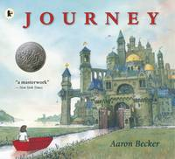 |  | Journey  Aaron Becker  The winner of the prestigious Caldecott Honor, and described by the New York Times as 'a masterwork', Aaron Becker's stunning, wordless picture book debut about self-determination and unexpected friendship follows a little girl who draws a magic door on her bedroom wall. Through it she escapes into a world where wonder, adventure and danger abound. Red marker pen in hand, she creates a boat, a balloon and a flying carpet which carry her on a spectacular journey ...who knows where? When she is captured by a sinister emperor, only an act of tremendous courage and kindness can set her free. Can it also guide her home and to happiness? In this exquisitely illustrated book, an ordinary child is launched on an extraordinary, magical journey towards her greatest and most rewarding adventure of all...

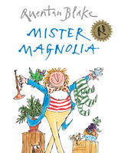 |  | Mister Magnolia  Quentin Blake  Mr Magnolia has only one boot. He has an old trumpet that goes rooty-toot - And two lovely sisters who play on the flute - But Mr Magnolia has only one boot. In this wittily rhyming picture book, Mr Magnolia has a full and happy life except for one serious omission - a boot. But one day, he receives a mysterious parcel, and at last Mr Magnolia can splash in the puddles with everyone else!

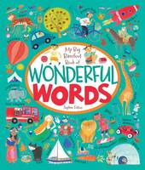 |  | My Big Barefoot Book of Wonderful Words  Sophie Fatus  Each scene is teeming with people, places and things. But what makes this book really different is that each of the narrative, real world scenes is followed and further developed by an abstract, interactive one.

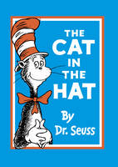 |  | The Cat in the Hat  Dr. Seuss  This classic book in a fantastic new format will make the perfect gift for Dr Seuss fans! When the Cat in the Hat steps in on the mat, Sally and her brother are in for a roller-coaster ride of havoc and mayhem! The Cat in the Hat is now available for the first time in picture book format. When Sally and her brother are left alone, they think they're in for a dull day - until the Cat in the Hat steps in on the mat, bringing with him mayhem and madness! This is the classic book that every child should have the joy of reading.

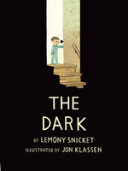 |  | The Dark  Lemony Snicket  Laszlo is afraid of the dark. The dark lives in the same house as Laszlo but mostly it spends its time in the basement. It doesn't visit Laszlo in his room. Until one night it does. With emotional insight and poetic economy, Lemony Snicket and Jon Klassen bring to light a universal and empowering story about conquering fear. Join a brave boy on his journey to meet the dark, and see why it will never bother him again.

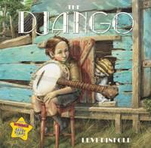 |  | The Django  Levi Pinfold  Winner of the prestigious 'Best Emerging Illustrator Award' from Booktrust, Levi Pinfold has created a wonderfully moving story of a young boy dogged by the attentions of his imaginary friend 'Django' who keeps getting him into trouble. Finally, the young boy has to banish his friend, but he misses him terribly. When his father gives Jean a banjo, he rediscovers the infectious enthusiasm for music that was the Django's special gift to him.

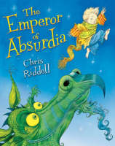 |  | The Emperor of Absurdia  Chris Riddell  Welcome to Absurdia: a strange and wonderful land where nothing is quite what it seems. Trees are birds, umbrellas are trees, and the sky is thick with snoring fish. Join one small boy as he tumbles out of bed into a crazy dreamland of wardrobe monsters, dragons -- and amazing adventure. This gloriously rich and beautiful picture book comes from a uniquely talented artist at the height of his powers. With a story to enchant the youngest reader, and pictures to gasp and pore over whatever your age, it is an extraordinary achievement and one to savour.

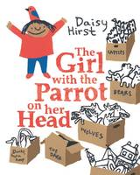 |  | The Girl with the Parrot on Her Head  Daisy Hirst  A beautifully bold and fresh new picture book, this hopeful and endearing story about moving house, making new friends and playing imaginative games is told with simple wit and charm, and offers a touching exploration of feelings. When she moves house, Isabel loses her best friend for ever. She is angry and lonely and decides it's better to be by herself. But after a time she faces a new problem that leads her to make a brilliant new friend...

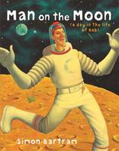 |  | The Man on the Moon  Simon Bartram  The everyday story of an ordinary man? Well, sort of. Bob is the man on the moon, and he has a very special job, looking after the moon, cleaning it up, showing visitors around and selling souvenirs.

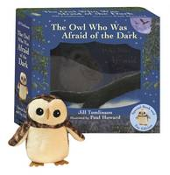 |  | The Owl Who Was Afraid of the Dark: Book and Toy  Jill Tomlinson  This beautiful gift box set includes the classic picture book and an adorable, soft and fuzzy plush toy of Plop, the baby barn owl. The timeless picture book starring Plop, a beautiful baby barn owl: he is fat and fluffy, with big, round eyes and soft, downy feathers. In fact, Plop is perfect in almost every way, except for just ONE thing ...Plop is afraid of the dark! And then one night he discovers that perhaps the dark isn't quite so scary and dangerous as he feared, as he learns to embrace the dark and its wonders. A comforting story filled with gentle humour and Paul Howard's warm and soothing illustrations, Jill Tomlinson's The Owl Who Was Afraid of the Dark has been enjoyed for decades by children who want to snuggle down with a good read. Perfect for story-led play, children can re-enact the tale as they learn not to be afraid the dark. The cute soft toy can also be played with separately

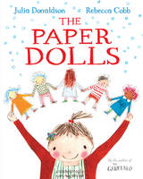 |  | The Paper Dolls  Julia Donaldson  A string of paper dolls go on a fantastical adventure through the house and out into the garden. They soon escape the clutches of the toy dinosaur and the snapping jaws of the oven-glove crocodile, but then a very real pair of scissors threatens. A stunning, rhythmical story of childhood, memory and the power of imagination from the author of THE GRUFFALO, and new illustrating talent Rebecca Cobb.

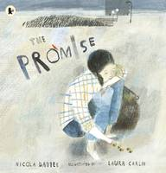 |  | The Promise  Nicola Davies  On a mean street in a mean city, a thief tries to snatch an old woman's bag. But she finds she can't have it without promising something in return - to plant them all . When it turns out the bag is full of acorns, the young thief embarks on a journey that changes her own life and the lives of others for generations to come.

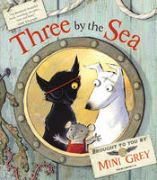 |  | Three by the Sea  Mini Grey  In a house by the sea there happily live a dog, a cat and a mouse. Well, happily enough until a stranger knocks on the door one night, offering them each a special free gift. Who is this mysterious salesman blowing into their little world and turning it upside-down? And can their happy home survive his trouble-making gifts?

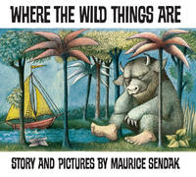 |  | Where the Wild Things Are  Maurice Sendak  One night Max puts on his wolf suit and makes mischief of one kind and another, so his mother calls him 'Wild Thing' and sends him to bed without his supper. That night a forest begins to grow in Max's room and an ocean rushes by with a boat to take Max to the place where the wild things are. Max tames the wild things and crowns himself as their king, and then the wild rumpus begins. But when Max has sent the monsters to bed, and everything is quiet, he starts to feel lonely and realises it is time to sail home to the place where someone loves him best of all.

