Underhill School and Children’s Centre

Recommended Reading List

Year 2
If your child is a competent reader or has read all these titles then try the books from the Year 3 list. Alternatively if these books are a little challenging try books from the Year 1 list.
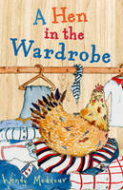 |  | A Hen in the Wardrobe  Wendy Meddour  Ramzi's dad is acting very strangely. He climbs trees in the middle of the night, and even goes into Ramzi's wardrobe looking for a hen. The trouble is, he's sleepwalking because he's homesick for his native Algeria. So Ramzi, Dad and Mum go back to Dad's Berber village in the desert region of North Africa, and Ramzi meets his Berber grandmother and cousins, and even braves the scary Sheherazad. But can Ramzi help his dad and what will happen when they get back home again. This is a funny, heart-warming family story by an exciting new author, set in Britain and Algeria, with fascinating glimpses of traditional Berber culture and lots of colourful characters.

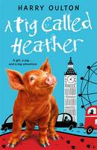 |  | A Pig Called Heather  Harry Oulton  Heather's best friend is a girl called Isla, who lives with her dad on a farm in Scotland. Their idyllic life together is shattered when a thunderstorm destroys the farm and forces Isla's dad to sell up and move to London - leaving Isla and Heather miles apart and utterly miserable. Then fate intervenes, turning Heather from an everyday pig into a national celebrity, and catapulting her to fame, fortune and, most excitingly of all...London. Armed only with her own pig-headedness, Heather embarks on a quest to track down her best friend. After all, how many girls with freckles can there be in London?

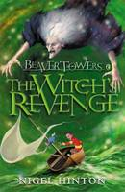 |  | Beaver Towers Witches Revenge The Witch's Revenge  Nigel Hinton  This is the second 'Beavor Towers' adventure. Once again Philip has been transported to the island to help his friends the beavers in their fight against the wicked witch, Oyin. But Oyin is planning a terrible revenge on the island's inhabitants.

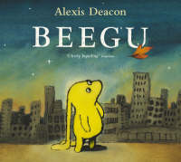 |  | Beegu  Alexis Deacon  Beegu is not supposed to be on Earth. She is lost. She is a friendly little creature, but the Earth People don't seem very welcoming at all. However, so far she has only met the BIG ones. The little ones are a different matter ...

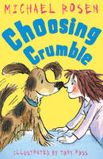 |  | Choosing Crumble  Michael Rosen  When Terri-Lee goes to the pet-shop she thinks she'll be choosing a dog - she doesn't expect the dog to be choosing her! But Crumble is no ordinary pet and he's got a few questions to ask: How many walks will you take me on? Do you like to dance? Will you tickle me? I like that a lot. Will Terri-Lee's dance moves and answers be enough to convince Crumble that she could be his owner?

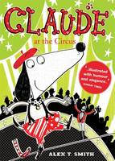 |  | Claude at the Circus  Alex T. Smith  A walk in the park leads to a walk on a tightrope when Claude joins a circus, throws custard pies, and becomes the star of the show!

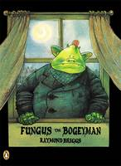 |  | Fungus the Bogeyman  Raymond Briggs  Life in Bogeydom is full of snot, smells, slime, scum and other unspeakable things, and Bogeymen live under the ground revelling in all the nastiness imaginable. Briggs has created a whole new world in this sophisticated cartoon-strip picture book for older children which will entice the most reluctant of readers into books.

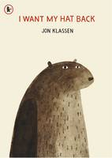 |  | I Want My Hat Back  Jon Klassen  In his bestselling debut picture book, the multiple award-winning Jon Klassen, illustrator of This Is Not My Hat and Sam and Dave Dig a Hole, tells the story of a bear who's hat has gone. And he wants it back. Patiently and politely, he asks the animals he comes across, one by one, whether they have seen it. Each animal says no (some more elaborately than others). But just as it he begins to lose hope, lying flat on his back in despair, a deer comes by and asks a rather obvious question that suddenly sparks the bear's memory and renews his search with a vengeance...Told completely in dialogue, this quirky, hilarious, read-aloud tale plays out in sly illustrations brimming with visual humour and winks at the reader who will be thrilled to be in on the joke.

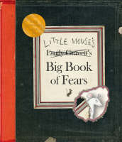 |  | Little Mouse's Big Book of Fears  Emily Gravett  Young children will identify with the little mouse who uses the pages of this book to document his fears - from loud noises and the dark, to being sucked down the plughole. Packed with details and novelty elements including flaps, die-cuts and even a hilarious fold-out map, this is an extraordinary picture book. Winner of the Kate Greenaway Medal 2008 .

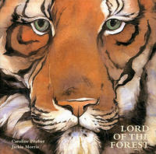 |  | Lord of the Forest  Caroline Pitcher  Little Tiger wonders who the Lord of the Forest can be in this miniature gift book edition. Children will want to read the story again and again with Caroline Pitcher's lyrical text and Jackie Morris's superlative portrayal of the forest and its inhabitants.

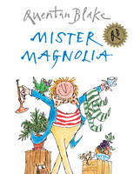 |  | Mister Magnolia  Quentin Blake  Mr Magnolia has only one boot. He has an old trumpet that goes rooty-toot - And two lovely sisters who play on the flute - But Mr Magnolia has only one boot. In this wittily rhyming picture book, Mr Magnolia has a full and happy life except for one serious omission - a boot. But one day, he receives a mysterious parcel, and at last Mr Magnolia can splash in the puddles with everyone else!

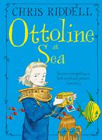 |  | Ottoline at Sea  Chris Riddell  Ottoline and Mr. Munroe do everything and go everywhere together. That is, until the day Mr. Munroe mysteriously disappears, leaving a strange clue written in string ...Armed with her Amateur Roving Collectors' travel pass, Ottoline sets off on a journey over, under and on top of the sea to find her hairy best friend - and bring him back home. Ottoline at Sea is the third enchanting Ottoline adventure from Kate Greenaway award winner, Chris Riddell. With his appealing illustration style, Riddell's humorous details make this a book to pore over and adore.

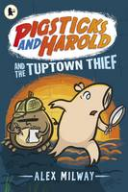 |  | Pigsticks and Harold and the Tuptown Thief  Alex Milway  There's a thief on the loose in Tuptown, and the annual Butterfly Ball will be cancelled unless someone is brought to justice. Luckily, Pigsticks has crime-fighting in his blood and a magnifying glass in his hand. Will Detective Pigsticks and his keen-eyes assistant Harold solve the crime? And can they do it in time to save the Butterfly Ball?

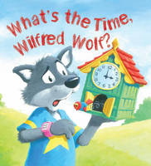 |  | Storytime: What's the Time, Wilfred Wolf?  Jessica Barrah  Wilfred Wolf can't tell the time, big hands and little hands are too confusing! Wilfred Wolf can't tell the time, he just eats and sleeps when he feels like it! When Wilfred gets invited to a party, he's faced with a problem - how will he know when it's time to go? This sweet story teaches the importance of time telling and the need for helpful and supportive friends. Part of the series Storytime. Beautifully illustrated, QED Storytime introduces young children to the pleasures of reading and sharing stories. Discussion points for parents and teachers are also included.

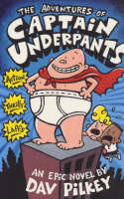 |  | The Adventures of Captain Underpants  Dav Pilkey  When naughty George and Harold hypnotise their headteacher, they accidentally create the greatest superhero in the history of their school -- Captain Underpants! His true identity is so secret that even HE doesn't know who he is...but he's fighting for truth, justice, and all things pre-shrunk and cottony!! If you're a naughty villain like the diabolical Dr Diaper, watch out! Captain Underpants has wedgie-power on his side, and he's coming your way

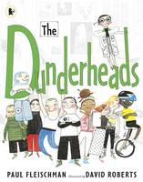 |  | The Dunderheads  Paul Fleischman  What’s in a name? Meet the Dunderheads, an unlikely band of kids with extraordinary hidden talents! 'Never', shrieked Miss Breakbone, 'have I been asked to teach such a scraping together of fiddling, twiddling, time-squandering, mind-wandering, doodling, dozing, don't-knowing DUNDERHEADS'! Miss Breakbone, the school mistress, hates kids. She shouts, she confiscates, she makes kids cry. But one day she goes too far. She confiscates the one-eyed cat that Junkyard is going to give his mum for her birthday. So the children pool their many weird and wonderful talents to break into Breakbone's house and get Junkyard's cat back for him.

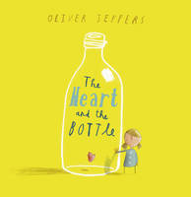 |  | The Heart and the Bottle  Oliver Jeffers  Award-winning picture book star Oliver Jeffers explores themes of love and loss in this life-affirming and uplifting tale. Once there was a girl whose life was filled with wonder at the world around her...Then one day something happened that made the girl take her heart and put it in a safe place. However, after that it seemed that the world was emptier than before. But would she know how to get her heart back? In this deeply moving story, Oliver Jeffers deals with the weighty themes of love and loss with an extraordinary lightness of touch and shows us, ultimately, that there is always hope.

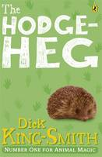 |  | The Hodgeheg  Dick King-Smith  Max is a hedgehog who lives with his family in a nice little home, but unfortunately on the wrong side of the road from the Park, with its beautiful lily pond, and more importantly its juicy slugs, worms and snails! The busy road is a dangerous barrier but Max notices that humans seem to cross it quite easily. If they can, why can't hedgehogs? So Max sets out on a quest to find a safe way to reach the Park. His first attempt ends in a nasty bump on the head, and Max finds when he tries to speak his words are all mixed up. He is now a Hodgeheg, not a hedgehog, but he is still determined to fulfill his mission. After some careful detective work, Max eventually discovers the best way to cross the road - with the help of the lollipop lady, of course!

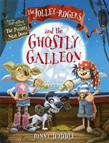 |  | The Jolley-Rogers and the Ghostly Galleon  Jonny Duddle  Ahoy there shipmates! Climb aboard with a new fiction series from Jonny Duddle featuring the crew from The Pirates Next Door. Join Jim Lad and Matilda as they sail the seven seas (and the coast of Dull-on-Sea) in search of adventure and pirate loot. Every full moon, a mysterious ship is seen off the coast of Dull-on-Sea. Then, the day after, gold and jewellery are missing from the homes, shops and museums of the town. Matilda needs the Jolley-Rogers' help to investigate. Can Matilda and Jim Lad retrieve the stolen booty from the mysterious ship before the moon fades? Or will they end up stuck on board with ghostly pirates until the next full moon?

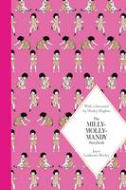 |  | The Milly-Molly-Mandy Storybook  Joyce Lankester Brisley  The stories of Milly-Molly-Mandy and her friends have charmed generations of children since their first publication in 1925. Perfect for reading aloud, these twenty-one stories will bring back happy memories for parents and grandparents and introduce younger readers to an enduringly popular heroine and her friends little-friend-Susan and Billy Blunt. Gloriously illustrated with the author's original line drawings and with a foreword by Shirley Hughes, this beautiful hardback edition of Joyce Lankester Brisley's The Milly-Molly-Mandy Storybook is a truly special gift to treasure.

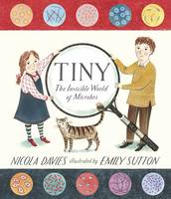 |  | Tiny The Invisible World of Microbes  Nicola Davies  There are living things so tiny millions could fit on a dot. Although they are invisible, they are everywhere and they multiply very quickly. They are vital for life on earth, and do all sorts of things - from giving us a cold and making yoghurt to wearing down mountains and helping to make the air we breathe. With charming illustrations by Emily Sutton, this friendly, clever book succeeds in conveying the complex science of micro-organisms simply and clearly, and opens up an exciting new avenue for young non-fiction.

