Underhill School and Children’s Centre

Recommended Reading List

Year 4
If your child is a competent reader or has read all these titles then try the books from the Year 5 list. Alternatively if these books are a little challenging try books from the Year 3 list.

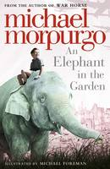 |  | An Elephant in the Garden  Michael, M. B. E. Morpurgo  A thrilling and moving novel about an extraordinary animal caught up in a very human war, for anyone who loved The Amazing Story of Adolphus Tips or The Butterfly Lion...By the award-winning former Children's Laureate and author of War Horse. Dresden, 1945. Elizabeth and Karli's mother works at the zoo, where her favourite animal is a young elephant named Marlene. Then the zoo director tells her that the dangerous animals - including the elephants - must be shot before the town is bombed. Unable to give Marlene up, their mother moves her into the back garden to save her...and then the bombs start to fall. Their home destroyed, the whole family must flee the bombed-out city and through the perilous, snow-covered landscape, all the while avoiding the Russian troops who are drawing ever closer. It would be hard enough to do, without an elephant in tow...

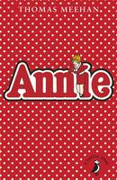 |  | Annie  Thomas Meehan  'Annie' began in 1924 as the heroine of a comic strip cartoon called Little Orphan Annie. Her adventures ran in newspapers in America for over 40 years before it was turned into a Broadway musical. It's 1933 and for as long as she can remember, 11 year old Annie has believed that her mother and father would come back to her New York City orphanage to get her. But mean Miss Hannigan the headmistress is making Annie's life a misery. So she runs away to find her parents - and along the way she rescues a friendly dog, meets millionaire Oliver Warbucks, and has a many scary and exciting adventures. Will kind-hearted Annie find a way to escape her hard-knock life? .

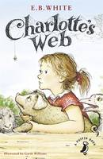 |  | Charlotte's Web  E. B. White  This is the story of a little girl named Fern who loved a little pig named Wilbur and of Wilbur's dear friend, Charlotte A. Cavatica, a beautiful large grey spider. With the unlikely help of Templeton the rat, and a wonderfully clever plan of her own, Charlotte saves the life of Wilbur, who by this time has grown up to be quite a pig.

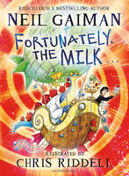 |  | Fortunately, the Milk ...  Neil Gaiman  You know what it's like when your mum goes away on a business trip and Dad's in charge. She leaves a really, really long list of what he's got to do. And the most important thing is DON'T FORGET TO GET THE MILK. Unfortunately, Dad forgets. So the next morning, before breakfast, he has to go to the corner shop, and this is the story of why it takes him a very, very long time to get back. Featuring: Professor Steg (a time-travelling dinosaur), some green globby things, the Queen of the Pirates, the famed jewel that is the Eye of Splod, some wumpires, and a perfectly normal but very important carton of milk. The award-laden, bestselling Neil Gaiman, author of The Ocean at the End of the Lane, Stardust, Neverwhere, The Graveyard Book and Coraline, brings his biggest ever publishing year to a spectacular conclusion with this gloriously entertaining novel about time-travel, dinosaurs, milk and dads.

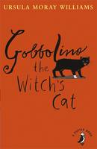 |  | Gobbolino the Witch's Cat  Ursula Moray Williams  Gobbolino by Ursula Moray Williams is the charming tale of a witch's cat who would rather be a kitchen cat. Gobbolino has one white paw and blue eyes and isn't wicked at all, so his mother doesn't like him. He escapes to look for a kitchen home but is distrusted everywhere he goes and blamed for mysterious happenings, such as the farmer's milk turning sour and the orphanage children's gruel turning into chocolate. A perfect story for A Puffin Book with charming black and white illustrations by the author, Ursula Moray Williams.

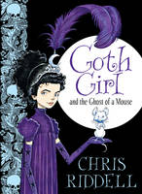 |  | Goth Girl and the Ghost of a Mouse  Chris Riddell  Ada Goth is the only child of Lord Goth. The two live together in the enormous Ghastly-Gorm Hall. Lord Goth believes that children should be heard and not seen, so Ada has to wear large clumpy boots so that he can always hear her coming. This makes it hard for her to make friends and, if she's honest, she's rather lonely. Then one day William and Emily Cabbage come to stay at the house, and together with a ghostly mouse called Ishmael they and Ada begin to unravel a dastardly plot that Maltravers, the mysterious indoor gamekeeper, is hatching. Ada and her friends must work together to foil Maltravers before it's too late!

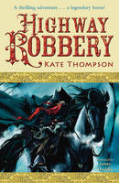 |  | Highway Robbery  Kate Thompson  'Hold the mare for me, lad. And when I come back I'll give you a golden guinea'. It's more money than the street urchin has ever dreamt of. But who is the rider, and why is there so much interest in his big black horse? And will the boy ever see the money he has been promised? There's highway robbery in the air, but it isn't always entirely clear just who is trying to rob who ...Stunningly illustrated and fast-paced, this story for younger readers brings to life the legend of the most famous highwayman of them - and his amazing horse.

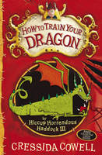 |  | How to Train Your Dragon  Cressida Cowell  Read the books that inspired the How to Train Your Dragon films! This book will be a hit with children and adults alike. THE STORY BEGINS in the first volume of Hiccup's How to Train Your Dragon memoirs...Hiccup Horrendous Haddock III was an awesome sword-fighter, a dragon-whisperer and the greatest Viking Hero who ever lived. But it wasn't always like that. In fact, in the beginning, Hiccup Horrendous Haddock III was the most put upon Viking you'd ever seen. Not loud enough to make himself heard at dinner with his father, Stoick the Vast; not hard enough to beat his chief rival, Snotlout, at Bashyball, the number one school sport and CERTAINLY not stupid enough to go into a cave full of dragons to find a pet...It's time for Hiccup to learn how to be a Hero. How to Train Your Dragon is now a major DreamWorks franchise starring Gerard Butler, Cate Blanchett and Jonah Hill and the TV series, Riders of Berk, can be seen on CBeebies and Cartoon Network. Read all of Hiccup's exploits in the How to Train Your Dragon series: How to Train Your Dragon, How to Be a Pirate, How to Speak Dragonese, How to Cheat a Dragon's Curse, How to Twist a Dragon's Tale, A Hero's Guide to Deadly Dragons, How to Ride a Dragon's Storm, How to Break a Dragon's Heart, How to Steal a Dragon's Sword, How to Seize a Dragon's Jewel and How to Betray a Dragon's Hero. Check out the brilliant website at www.howtotrainyourdragonbooks.com It's the place to go for games, downloads, activities and sneak peeks!

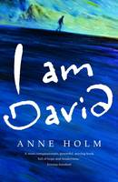 |  | I am David  Anne Holm  'You must get away tonight,' the man had told him. David escapes from the concentration camp where he has spent his entire life and flees across Europe. He is utterly alone - who can he trust? What will await him? And all the while, how can he be sure that they won't catch up with him ...This is the remarkable story of David's introduction to the world: sea, mountains and flowers, the colours of Italy, the taste of fruit, people laughing and smiling, all are new to David. David learns that his polite manner, his haunted eyes and his thin features are strange to other people. He must learn to fend for himself in this strange new world. This is The Boy in the Striped Pyjamas meets Jonathan Safran Foer for children. An incredible story of survival against all odds and self discovery.

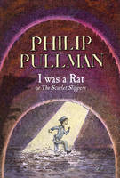 |  | I Was a Rat! Or, the Scarlet slippers  Philip Pullman  I WAS A RAT!' So insists Roger. Maybe it's true. But what is he NOW? A terrifying monster rampaging in the sewers? The Daily Scourge is sure of it. A money-spinning fairground freak? He is to Mr Tapscrew. A champion wriggler and a downy card? That's what Billy hopes. Or just an ordinary small boy, though a little ratty in his habits? Only three people believe this version of the story. Only one of them knows who Roger really is. And luckily a story about her can sell even more newspapers than one about a rat-boy ...

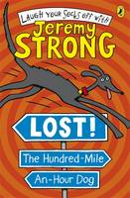 |  | Lost! The Hundred-Mile-An-Hour Dog  Jeremy Strong  From The Hundred-Mile-an-Hour Dog to karate princesses and hot cross bottoms, there's a Jeremy Strong story to suit every child's sense of humour. Jeremy's readers range from 7 to teen, perfect for fans of Roald Dahl and Andy Stanton. Streaker the dog is lost. And not just a bit lost, but really lost. It wasn't even her fault! She wanted to protect some pies from the PIE ROBBER and suddenly she's miles from home and two-legged Trevor AND she has to make friends with a cat. A CAT! But it gets a lot HAIRIER when they find themselves face-to-face with a baboon...Will Streaker ever see her beloved pups again? And more importantly, will she ever eat another donut again? Award-winning Jeremy Strong has written many wacky books for children aged 7-teen, including My Dad's Got an Alligator and My Brother's Famous Bottom . Most of which are illustrated by Nick Sharratt, who also illustrates for Jacqueline Wilson! The Hundred-Mile-An-Hour Dog is back causing more chaos and getting into more trouble in The Hundred-Mile-An-Hour Dog , Lost! The Hundred-Mile-An-Hour Dog , Wanted! The Hundred-Mile-An-Hour Dog , Christmas Chaos for the Hundred-Mile-An-Hour Dog and The Hundred-Mile-An-Hour Dog Goes for Gold - guaranteed to have you laughing your socks off!

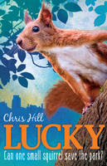 |  | Lucky  Chris Hill  When lost red squirrel Lucky finds himself in Albion Park, the native squirrels all around him are bigger, tougher, and much more \. grey. He needs all the luck he can find to fit in, and even more to pass the Squirrel Trial that will give him a permanent place in the park. But when Lucky discovers a plot that threatens their home, he'll need more than just good fortune on his side.

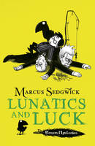 |  | Lunatics and Luck  Marcus Sedgwick  Join the wonderfully weird Otherhand family and their faithful guardian, Edgar the raven, and discover the dark secrets of Castle Otherhand. Solstice and Cudweed are appalled to find their father has appointed a new school master. But things get even worse when the grumpy, viciously mean teacher actually arrives. The Otherhand children are sure there's something more to him than meets the eye - the trouble is, who will believe them? No one it seems. Except, perhaps, Edgar. Winner of the 2011 Blue Peter Book Award for Most Fun Story With Pictures, LUNATICS AND LUCK is the third story in this hilarious six book mystery series (with a touch of goth-froth) for 9 year olds from bestselling author, Marcus Sedgwick with quirky black and white line illustrations from new talent, Pete Williamson. Dedicated website on Raven Mysteries: www.ravenmysteries.co.uk

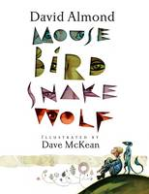 |  | Mouse Bird Snake Wolf  David Almond  The dream team of David Almond and Dave McKean bring us a complete story set in an incomplete world. The gods have created a world - they've built mountains, a sea and a sky - and now their days are filled with long naps in the clouds (and tea and cake). That's until Harry, Sue and Little Ben begin to fill the gaps of the world: with a mousy thing, a chirpy thing and a twisty legless thing. As the children's ideas take shape, the power of their visions proves to be greater than they, or the gods, could ever have imagined. This is a genius retelling of creation from an award-winning duo, fully illustrated in colour.

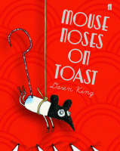 |  | Mouse Noses on Toast  Daren King  'I will have the colourful parrot soup,' the lady said, 'with extra beaky bits.' 'And I,' said her husband, 'will have mouse noses on toast.' The waiter flipped open his notebook and wrote this down. 'Would that be with whiskers, Sir, or without?' Hiding on the restaurant table, Paul Mouse's world has just turned upside down. Surely the man is making a joke? Isn't mouse noses on toast just a big myth? Gathering his friends - Sandra the Christmas tree decoration, Rowley Barker Hobbs, the sheepdog, and the Tinby, a kind of monster - Paul becomes determined to find the truth. So begins an adventure involving mouse activists, the prime minister, cheese addicts and a wildly insane Tinby. But what awaits them all at the mouse noses abbatoir...?

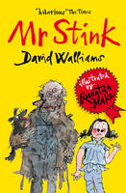 |  | Mr Stink  David Walliams  The second original, touching, twisted, and most of all hilarious novel for children from David Walliams, number one bestseller and fastest growing children's author in the country - beautifully illustrated by Quentin Blake. Mr Stink stank. He also stunk. And if it was correct English to say he stinked, then he stinked as well... It all starts when Chloe makes friends with Mr Stink, the local tramp. Yes, he smells a bit. But when it looks like he might be driven out of town, Chloe decides to hide him in the garden shed. Now Chloe's got to make sure no one finds out her secret. And speaking of secrets, there just might be more to Mr Stink than meets the eye...or the nose.

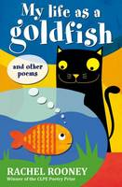 |  | My Life as a Goldfish And Other Poems  Rachel Rooney  Magic slips between the cracks in real life. One day you will step on it. A monster's lunch, a wolf boy, Monday mornings, monkeys, headlice, Christmas, making friends, goldfish - and lots more. Full of jokes, surprises and puzzles, but also sensitive and thought-provoking, this is a spellbinding new collection from the winner of the CLPE Poetry Award.

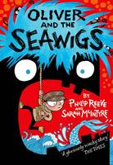 |  | Oliver and the Seawigs  Philip Reeve  A lively, gorgeously illustrated story from Dynamic Duo, Reeve and McIntyre! Along with his new friends, a grumpy old albatross, a short-sighted mermaid, and a friendly island called Cliff, Oliver goes off in search of his missing parents. But before he can put his rescue plan into action there's the evil Stacey de Lacey and an army of greasy, green sea monkeys to contend with ...

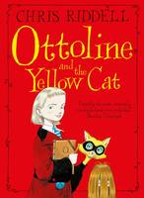 |  | Ottoline and the Yellow Cat  Chris Riddell  Introducing Miss Ottoline Brown, an exceptionally inquisitive Mistress of Disguise, and her partner in crime, Mr. Munroe. No puzzle is ever too tricky for the two of them to solve ...Ottoline lives in a stylish apartment in Big City with a small hairy creature called Mr. Munroe. Together they look after the Brown family's eclectic collections - and dabble in a spot of detective work. So they are the first to the scene of the crime when a string of high-society dog-nappings and jewel thefts hits Big City. Ottoline (who luckily has a diploma from the Who-R-U Academy of Disguise) and Mr. Munroe go undercover - and expose an ingenious scam masterminded by furry feline crook, the Yellow Cat. Ottoline and the Yellow Cat is a quirky mystery-adventure from star author/illustrator, Chris Riddell. Winner of the Nestle Prize, and crammed with black and white illustrations, Ottoline and the Yellow Cat is perfectly packaged and highly collectable.

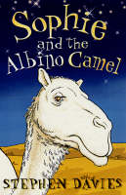 |  | Sophie and the Albino Camel  Stephen Davies  Sophie lives in Gorom-Gorom with her carnivorous-plant obsessed dad. Despite living there for two years and speaking the local language, Sophie finds it difficult to make friends. So when she meets Gidaado, a young griot (story-teller) she agrees to join him and his albino camel, Chobbal, on a journey to his village. It is not until they have set off that Sophie begins to realise just how dangerous the desert is - it's full of djinns that creep up behind you and jump on your head and make you go mad, not to mention the infamous Moussa ag Litni, a ruthless bandit who steals camels...

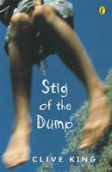 |  | Stig of the Dump  Clive King  Stig of the Dump by Clive King is 50 years old and the story of Barney and his best friend, cave-man Stig, is as fresh today as it was when first published. 'Stig's nice. He's my friend' Nobody believes Barney when he says he's discovered a boy living wild in the dump. But for Barney, Stif is totally real. They become great friends, learn each other's ways and embark on a series of exciting adventures. This story has wonderful appeal . (Guardian). Clive King was born in Richmond, Surrey in 1924. When he was a baby his family moved to a village called Ash, near Sevenoaks in Kent, which is the setting for Stig of the Dump. He went to local schools, then King's School, Rochester and Downing College, Cambridge. During the war he served in the Royal Navy Volunteer Reserve and later joined the British Council. He now lives in a cottage in Norfolk, and has three children and several grandchildren.

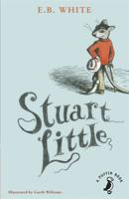 |  | Stuart Little  E. B. White  Stuart Little is no ordinary mouse. Born to a family of humans he lives in New York City with his parents, his older brother George and Snowball the cat. He's an adventurous and heroic little mouse. When his best friend, a beautiful little bird called Margalo disappears from her nest, Stuart is determined to track her down. He ventures away from home for the very first time in his life and finds himself embroiled in one exciting adventure after another, making new friends and meeting old ones along the way.

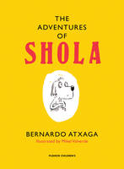 |  | The Adventures of Shola  Bernardo Atxaga, Mikel Valverde  Winner of the 2014 Marsh Award for Children's Literature Shola is a little dog with attitude. Frustratingly for her, she loves both comfort (mainly in the form of food) and adventure (in theory, at least), and spends much of her time trying to decide between the two. Whether she is faced with the possibility that she may really be a lion or the prospect of a boar-hunt, with eccentric American visitors or insufferable country bumpkins, Shola is not afraid to pursue her dreams ...up to a point. Lovingly and revealingly illustrated by Mikel Valverde, these four stories in one volume are a treasure-trove of amusement which cannot fail to cheer the reader.

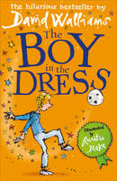 |  | The Boy in the Dress  David Walliams  The sparkling debut children's novel from David Walliams, number one bestseller and fastest growing children's author in the country, with sparkling new cover look to tie in with later books. Dennis was different. Why was he different, you ask? Well, a small clue might be in the title of this book...Charming, surprising and hilarious - The Boy in the Dress is everything you would expect from the co-creator of Little Britain. David Walliams's beautiful first novel will touch the hearts (and funny bones) of children and adults alike.

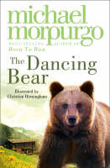 |  | The Dancing Bear  Michael, M. B. E. Morpurgo  A gentle and deeply moving story of a young girl and her bear, told with great charm by a master storyteller. High in the mountains, in a tiny village, an abandoned bear cub is adopted by a lonely orphan child. Soon they are inseparable, beloved by the whole village - safe, until the arrival of a glamorous film crew who need a dancing bear...

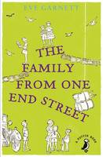 |  | The Family from One End Street  Eve Garnett  The Family from One End Street by Eve Garnett is the story of everyday life in the big, happy Ruggles family who live in the small town of Otwell. Father is a dustman and Mother a washerwoman. Then there's all the children - practical Lily Rose, clever Kate, mischievous twins James and John, followed by Jo, who loves films, little Peg and finally baby William. This is a truly classic book awarded the Carnegie Medal as the best children's book of 1937

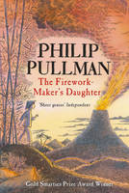 |  | The Firework-maker's Daughter  Philip Pullman  What Lila wants to be more than anything else in the world is ...a Firework-Maker! But firework-making is not just about being able to make Crackle-Dragons and Golden Sneezes. There is also one special secret: every Firework-Maker must make a perilous journey to face the terrifying Fire-Fiend! Not knowing that she needs special protection to survive the Fire-Fiend's flames, Lila sets off alone. Her friends, Chulak and Hamlet - the King's white elephant - race after her. But can they possibly reach her in time?

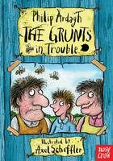 |  | The Grunts In Trouble  Philip Ardagh  Meet Mr and Mrs Grunt. Oh, go on. They're not that bad. No, actually, they ARE. Maybe worse, even. But Sunny, their sort-of son, is okay. They stole him from a washing line as a baby. He was hanging by his ears, which probably explains why they're so wonky (but not why he has sticky-up hair that NEVER lies flat, even if you pour glue into it or try taping it in place). Sticky around and you'll also meet Lord Bigg of Bigg Manor, Bigg-hater Larry Smalls, Mimi the Bigg Manor boot boy (yup, she's a girl) and...Well, you'll have to READ the book to find that out. But I should mention the bees. Did I warn you about the bees?!

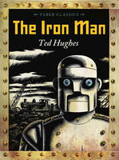 |  | The Iron Man  Ted Hughes  Mankind must put a stop to the dreadful destruction by the Iron Man and set a trap for him, but he cannot be kept down. Then, when a terrible monster from outer space threatens to lay waste to the planet, it is the Iron Man who finds a way to save the world.

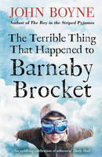 |  | The Terrible Thing That Happened to Barnaby Brocket  John Boyne  There's nothing unusual or different about the Brocket family - and they're keen to keep it that way. But when Barnaby Brocket comes into the world, it's clear he's anything but ordinary. To his parents' horror, Barnaby defies the laws of gravity - and floats. Soon, the Brockets decide enough is enough. The neighbours are starting to talk. They never asked for a weird, abnormal, floating child. Barnaby has to go...Betrayed and frightened, Barnaby floats into the path of a very special hot air balloon - and so begins a magical journey around the world, with a cast of extraordinary new friends.

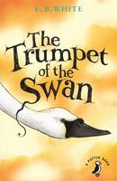 |  | The Trumpet of the Swan  E. B. White  The Trumpet Of The Swan is an uplifting story by E. B. White, author of Charlotte's Web in which wildlife and nature blend with fantasy to make a tender, humorous and unforgettable animal tale. Unlike other cygnets, Louis, the trumpeter swan, cannot utter a sound. But with the encouragement of his father, Louis sets out to overcome his problem. One way of doing this Louis decides, is to learn to read and write and so he sets off to Montana to find his friend Sam Beaver. Louis goes to school with him and learns to read and write, but when he returns to the lakes and falls in love with the beautiful Serena, he is upset that Serena can't read his sign, which says 'I love you'. Once again his parents are determined to help him find a new way of expressing himself and it is his father who dreams up the brilliant solution that will put Louis firmly on the path to success and fulfilment.

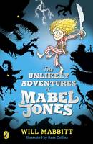 |  | The Unlikely Adventures of Mabel Jones  Will Mabbitt  The first book by brilliant new comic author, Will Mabbitt. When Mabel Jones unknowingly commits 'The Deed' she finds herself swiftly bundled into a sack and carried off to the pirate ship the Feroshus Maggot. Crewed by the strangest bunch of pirates you would ever want to meet and captained by the dreaded Idryss Ebeneezer Split (a wolf with a false leg carved from a human thighbone, a rusty cutlass sheathed in his belt and a loaded pistol tucked in his pants with no fear of the consequences), the Feroshus Maggot whisks Mabel Jones off on the adventure of a lifetime.

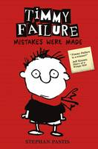 |  | Timmy Failure: Mistakes Were Made  Stephan Pastis  Perfect for fans of Wimpy Kid and Big Nate, Timmy Failure: Mistakes Were Made is the first book in the New York Times bestselling series. Listed as one of 100 Modern Children's Classics by The Sunday Times, it was also a Booktrust Best Book Awards winner. Meet Timmy Failure, founder of the best detective agency in town - Total Failure, Inc. With the help of his polar bear, Total, the clueless, comically self-confident Timmy already has plans for world domination. Plans that will make his mother rich and unpaid bills a thing of the past. And plans that will defeat Corrina Corrina, The One Whose Name Shall Not Be Uttered . But she's not going away. Riotously funny, Timmy Failure is sure to have readers in stitches.

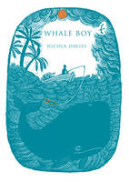 |  | Whale Boy  Nicola Davies  Michael, a young boy growing up on the tropical island of Rose Town, has been saving up for his own fishing boat for years. But when a terrible storm wrecks his home, Michael is forced to take a job working for a rich, mysterious newcomer named Spargo. Spargo asks Michael to search for one thing in the deep waters around Rose Town - whales...

