

Health Promotion Workshops
Underhill School & Children’s Centre, Mays Lane, Barnet, EN5 2LZ

To Register your Interest, please either:
Call: 020 8 449 2423 Ext 206 Or Email: info@underhillcc.barnetmail.net
Introduction to Solids
Suitable from 4-6 months

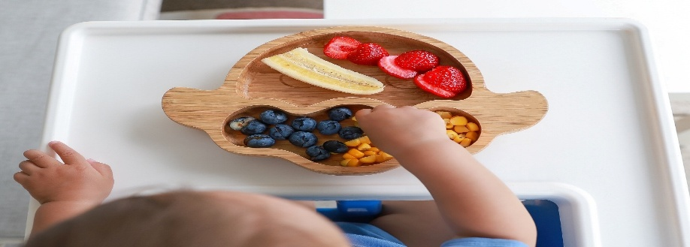
Tuesday 6th October 2026: 9.30-10.30 am
Toilet Training
Suitable from 18 months Plus


Tuesday 13th October 2026: 9.30-10.30 am

