PE Funding

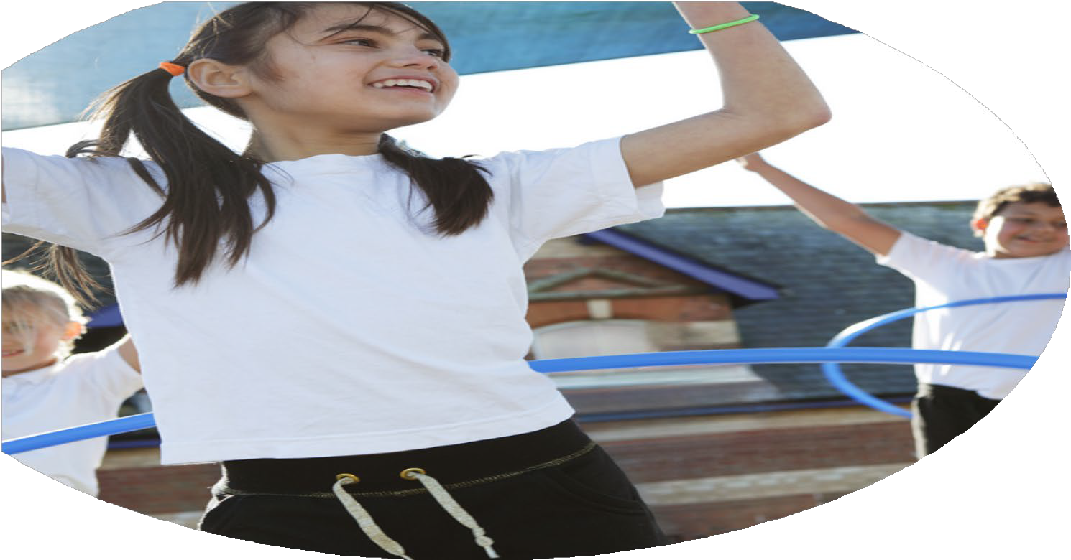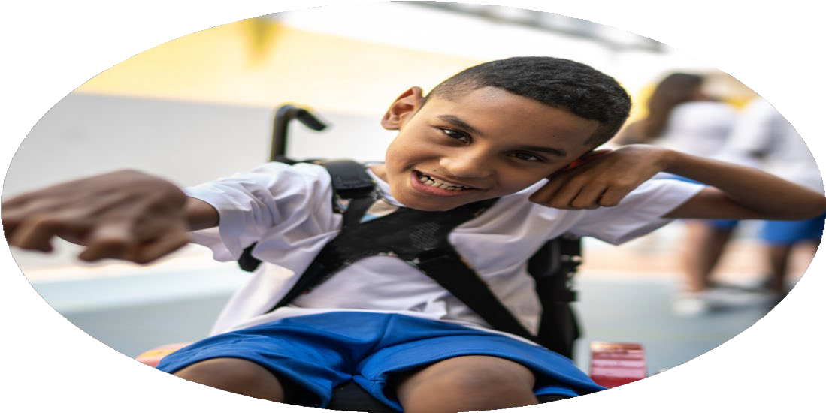

Evaluation Form

**Commissioned by**

**Created by**

Images courtesy of Youth Sport Trust

**PE Funding Evaluation Form**

|  |  |  |  |
| --- | --- | --- | --- |
| What went well? | How do you know? | What didn’t go well? | How do you know? |
| Upskilling staff has happened in all 3 areas of focused subject development (PESSPA). Children have also had the opportunity to work with a specialist and sporting links developed in the local community.  A broader range of clubs offered and new clubs introduced such as arco dance and boxing. Highest percentage yet of club participation (including protected children). Underhill funds a lot of clubs for children and staff volunteer their time to lead an enrichment.  Higher participation of BPSS competitive sports comps and inclusive festivals attended.  Numerous targeted clubs have been happening during lunchtime/after school and at weekends focusing on our **protected students**. | Staff are feeling confident and inspired in delivering lessons in these areas of PE. Children have also been able to develop their skills.  Every child has access to a wide range of free clubs. Confidence and self-esteem are prevalent throughout the school. Increased fitness levels and stamina displayed during class PE lessons.    Children want to achieve highly in school comps, proud to represent their school. SEND are accessing more sports.  Highest participation with these groups of children, children are flourishing and the gap is being closed by giving these children the opportunity. | Uptake on paid for clubs has reduced, as parents are depending more on the free clubs. The budget for this is not sustainable. | Registers and sign ups, causing some clubs to withdraw. |

|  |  |
| --- | --- |
| What are your plans for 2024/25? | How are you going to action and achieve these plans? |
| Intent | Implementation |
| * Understanding of skills, subject knowledge development. * Knowing our protected groups and PE targeted groups to run. * Open up the school out of hours more. Generating more money for the school and relationship with our wider community. * Target KS1- develop competitive Sports. * Swimming Year 6 top up sessions. * Audit of PE equipment. * National Sports Week opportunities for Underhill children to experience new sports. * Stretching our more able children to represent the school in borough comps. * Maintain and develop the range of activities in our club timetable. * Increase the number of physical activity opportunities at lunchtime. Training for play leaders. | * PPA team to know and understand how to deliver skills to the children. PE Inset booked via borough BPSS team. * Embedding more confidence with the team. * Children will have the opportunity to work with a sporting expert. * Creating opportunities for our protected group to be nurtured and stretched in clubs and lunchtime sessions/interventions. * Identify which areas of the curriculum play leaders can support units being taught by running lunchtime sessions. * To attend borough tournaments and festivals. Sensory circuit led by Sports Ambassadors. * Targeted children in year 6 to swim at QE Boys in Summer Term as a top up to meet national average. * Ensure we have a good range of equipment and update any equipment needed.   Enabling children to be more ambitious with the curriculum by; purchasing roll out gym mats, vault and athletics & netball equipment.   * A range of sports experts will lead workshops (NSW) and clubs for our children (protected being the focus). Pupil voice carried out prior to this. * Transport provided and children brought to borough tournaments and comps. * Increased participation of children being active. |

|  |  |
| --- | --- |
| What impact/intended impact/sustainability are you  expecting? | How will you know? What **evidence** do you have or  expect to have? |
| * Ensuring subject knowledge is up to date and PPA team are confident in all areas of teaching PE and in line with NC. * Interventions offer support to students who require more time to develop skills and give them strategies for developing resilience. Learning and skills being developed during sessions at lunchtime and during after school clubs. * Consistent lessons being taught, skills support lessons and N.C requirements. * Children to keep active and healthy. Provide children with a range of opportunities and experiences. Community local links developed. * Ensure a balance between paid and free clubs with no barrier to participate. Protected groups targeted eg girls football at lunchtime, SEND lunchtime group. | * Confident, more able children in their PE. Skills will be demonstrated and development shown throughout the unit. * Closing the gap with our protected groups. Improvement of skills and confidence. * Newsletters features * Participation registers. * Higher percentage of sign-ups to clubs by offering free clubs. * Parent feedback * Pupil voice |

|  |  |
| --- | --- |
| What **impact/sustainability** have you seen? | What **evidence** do you have? |
| * Children are continually being monitored and assessed during units in PE. Informs planning for next academic years. * Children and teachers will benefit from experts in sporting fields delivering workshops- providing CPD for adults and adapting lessons for our children. * Leadership skills being developed in class and with our sports ambassadors. Pupil lead in lesson and playground. * Rise in club intake and popularity. * More participation with local community sports groups | * Children’s skill and stamina developed. Higher percentage of WA/GD in unit assessments. * More inclusivity in sports in school and clubs. * Children leading in lunchtime sports, running sensory circuits and promoting school sporting activities. * Progress being made with age appropriate and range of equipment ordered. * Children are winning in team sports and presenting the borough in sports. (Netball, Basketball, Athletics). * Registers and range of clubs. High intake with our protected groups. * Higher intake in local sports clubs, links developed and they are offering discounted rates to our school. * Positive feedback from pupils and parents. |