THURSDAY 6TH FEB 7pm SKITTLES ‘OPEN’

Entry Free PRIZES

Food served 6pm – 9pm from the menu

**VALENTINES Day**

**Friday 14th February**

**SPECIAL OFFER ROSE CAVA FREIXENET £10**

**a bottle While stocks last**

 

**SATURDAY 8th FEBRUARY 9.00am to set up**

**SEE NOTICE BOARD TO BOOK** Or phone 01202766698

£5 a table (provided) £2.50 clothes rail (not provided)





Restaurant Opening Times

Mon 11am to 2pm Tues 11am to 2pm

Wed 10am to 2pm & 5pm to 8:30pm

Thurs 11 to 2pm.

Fri 11 to 2 & 5pm to 8:30pm

Sat 10am to 2pm & 5pm to 8:30pm

Sun 12.00 to 2pm

Telephone Chris on 07873389051

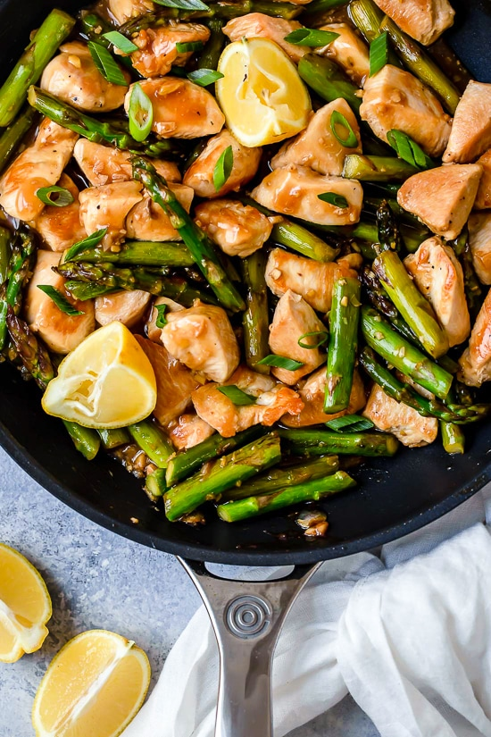

£6



2 BOTTLES OF BIERRA MORETTI, DESPERADOS OR CORONA FOR £5

While stocks last



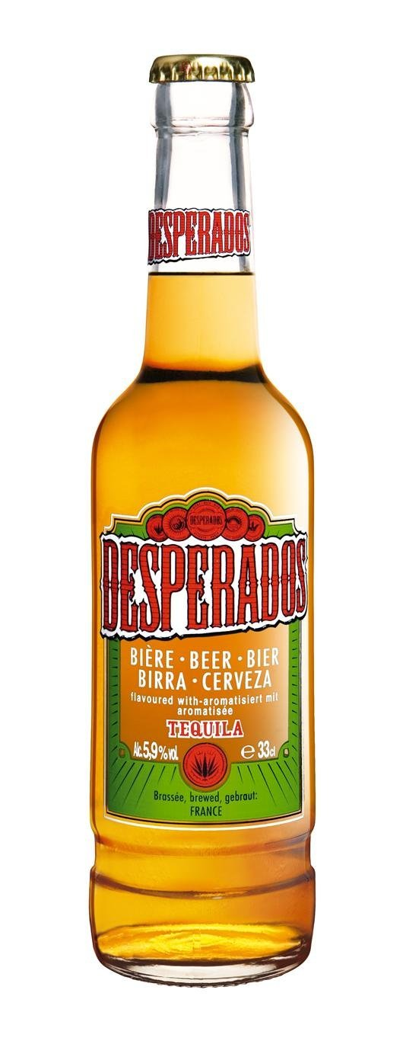

[](https://www.google.co.uk/url?sa=i&rct=j&q=&esrc=s&source=images&cd=&ved=2ahUKEwjts5X627nkAhVOcBQKHX9rAuwQjRx6BAgBEAQ&url=https://www.123rf.com/photo_81982839_minsk-belarus-july-10-2017-bottle-of-corona-extra-beer-isolated-on-white-one-of-the-top-selling-beer.html&psig=AOvVaw3X30bIX3KLNAXxiaLZomr8&ust=1567774084049852)

[](https://www.google.co.uk/url?sa=i&source=images&cd=&cad=rja&uact=8&ved=2ahUKEwj36L26yPjaAhWHOBQKHWNxDo0QjRx6BAgBEAU&url=http://www.gourmetislandcatering.com/salads/&psig=AOvVaw2Beby3Fi2UkQ3jJQXpTPTH&ust=1525953110186516)

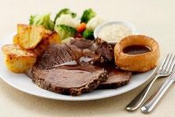



**Three Snooker Tables, Pool Table, Darts, Cards, Wide Screen TVs showing**

**SKY SPORTS & BT SPORTS in our air-conditioned Sports Bar**

Check out our website at www.westbourneconclub.com

NOTICE BOARD

**Birthday Parties, Anniversaries, Meetings, Lunches, Buffets, Wakes.**

The Club caterer provides a wide range of

Catering Services for all occasions.

Chris will be happy to discuss arrangements.

**BAR** Phone: 01202 761056

**CATERING** Chris Curtis 07873389051

Email: [wcc6alum@btconnect.com](mailto:wcc6alum@btconnect.com)

Visit our website at [www.westbourneconclub.com](http://www.westbourneconclub.com)

Phone: 01202 766698 (office hours only)

OPENING HOURS: Mon/Thurs 11.00 – 11.00, Wed 10.00 – 11.00,

Fri 11.00 – 11.30, Sat 11.00 – 12.00, Sun 11.00 – 10.30

ADULT LATIN AMERICAN & BALLROOM

DANCE CLASSES for beginners

Here in the club every Friday

9:30am – 10:30am  £7 per session

No partner required, please call Donna on 01202 243803

Or email her on [donnadiebelius@googlemail.com](mailto:donnadiebelius@googlemail.com) to book



SUNDAY LUNCH

Come in for a lovely roast with all the trimmings

Large size Small size

1 course £8.75 1 course £6.75

Order dessert for only £2.00

Booking highly recommended – Please See Chris for Bookings

THURSDAY 27th FEBRUARY

7pm for 7:30pm start

(Open to the public) Tickets £10

**SPIRITUAL MEDIUM & CLAIRVOYANT**

Dan has been from the age of 6 years a medium, fully

able to communicate with the spirit world and give messages



MAKE A NIGHT OF IT BY DINING

AT THE CLUB BEFORE THE SHOW -

C Chicken with asparagus & . mushroom in white wine sauce

Served at 6:30pm See Catering to pre book & pre pay by Monday 17th February

**Thursday 20th February**

**ABBA’S ANGELS**

**For a full on dose of 70's Nostalgia**

**TICKET MEMBER / IA £7 pp**

**ADVANCE TICKET GUEST £9 pp**

**Now on sale at the bar.**

Regular Weekly Social Events

|  |  |  |  |  |
| --- | --- | --- | --- | --- |
| **Mondays**  **Tuesdays**  **Wednesdays**  **Thursdays**  **Fridays**  **Saturdays**  **Sundays** | | **8.00pm**  **8.30pm**  **10.00am**  **3.00 – 5.00pm**  **8.30pm**  **3.00 – 5.00pm**  **9.00pm**  **8.30pm**  **8.30pm**  **10.00pm**  **1.45pm** | | **Cards: Also “League Poker” £5 buy in.**  **Bingo, cash prizes, Joe “90”,£80. Bottle draw, Play Your Cards Right**  **Club opens early.**  **Live music for dancing. “21” Bottle draw.**  **Quiz night. “Play your cards right”**  **Line dancing, beginners welcome.**  **Informal poker game 8:00pm monthly poker game – see notice board**  **Card Bingo, Membership Draw, Fresh Meat Draw, Bottle Draw, Reverse Forecast Draw, “Treasure Chest” Snowball – find the “right” key**  **Live music – see details below. £1 members & IA, £2 for guests**  **Bottle Draw. Then door entry ticket no. goes into “FREE” Prize draw, for Bottles of Wine**  **Sunday Money Draw; £100, £50, £25, £10, £10 & £5 (if all tickets sold),**  **Bottle Draw & Meat voucher draw.** |
| **SATURDAY EVENING ENTERTAINMENT 8.30 – 11.30pm Members & IA £1, Guests £2**  **ALSO SPECIAL EVENTS OVER THE NEXT FEW MONTHS**  **“MAIN” Bottle draw 10.00pm, then Door Entry ticket no. goes into ‘FREE’ Prize draw for Bottles of Wine** | | | | |
| **FEBRUARY** | | | | |  |  |
| **Saturday**  **Thursday**  **Saturday** | **1st**  **8th**  **15th**  **20th**  **22nd**  **29th** | | **OUTRAGE – 60’s band playing all the hits from that great era; Shadows, Searchers and others**  **ALTO DUO - experienced professionals, variety of music that will keep you on the dance floor**  **Dale Fender 4 piece band, one of our most requested groups**  **ABBA TRIBUTE - Abba’s Angels one of the UK’s premier Abba tributes. £7 members & IA, £9 guests. “MAIN” Bottle & “FREE” Bottle draws at 10.00pm.**  **KABOODLE – 4 piece classic rock & blues band, recommended by members**  **BANDASTIC - 4 piece band. Guaranteed to entertain you.** | |
| **MARCH** |  | |  | |
| **Saturday**  **Thursday**  **Saturday**  **Thursday**  **Saturday** | **7th**  **14th**  **19th**  **21st**  **26th**  **28th** | | **NIGHT SHIFT - 4 piece band, very popular – always in demand.**  **JURRASIC Rock ‘n’ Roll 4 piece band the music of the 50’s & 60’s**  **ELVIS TRIBUTE by Garry Foley, best ever tribute night: £7 members & IA, £9 guests.**  **‘MAIN’ Bottle draw at 10.00pm. Then free ‘Door Entry’ ticket draw.**  **NEW BEATS – 4 piece band, relive the 60s featuring songs from the Beatles, The Who,**  **The Hollies, Rolling Stones, Small Faces, The Kinks and more.**  **ANNUAL GENERAL MEETING 8pm**  **DANCE ON 3 piece band, dance all evening** | |
| **APRIL** |  | |  | |
| **Saturday**  **Thursday**  **Saturday** | **4th**  **11th**  **18th**  **23rd**  **25th** | | **BLUE CHORDS**  **HANDLE WITH CARE 5 piece covers band with an excellent reputation**  **OUTRAGE– 60’s band playing all the hits from that great era; Shadows, Searchers and others**  **MICHAEL JACKSON TRIBUTE by Gathan Cheema £5 members & IA £7 guests**  **‘MAIN’ Bottle draw 10.00pm. Then ‘Door Entry’ ticket draw.**  **ROY CHARLES Beautiful singer of hits from the 60s up to the present day, great for dancing.** | |

Dates and acts subject to change E & OE