THURSDAY 5TH MARCH 7pm SKITTLES EVENING

Free Entry -- PRIZES

Food served 6pm – 9pm from the menu

 

**SATURDAY 14th MARCH 9.00am to set up**

**SEE NOTICE BOARD TO BOOK** Or phone 01202766698

£5 a table (provided) £2.50 clothes rail (not provided)

Restaurant Opening Times

Mon 11am to 2pm Tues 11am to 2pm

Wed 10am to 2pm & 5pm to 8:30pm

Thurs 11 to 2pm.

Fri 11 to 2 & 5pm to 8:30pm

Sat 10am to 2pm & 5pm to 8:30pm

Sun 12.00 to 2pm

Telephone Chris on 07873389051

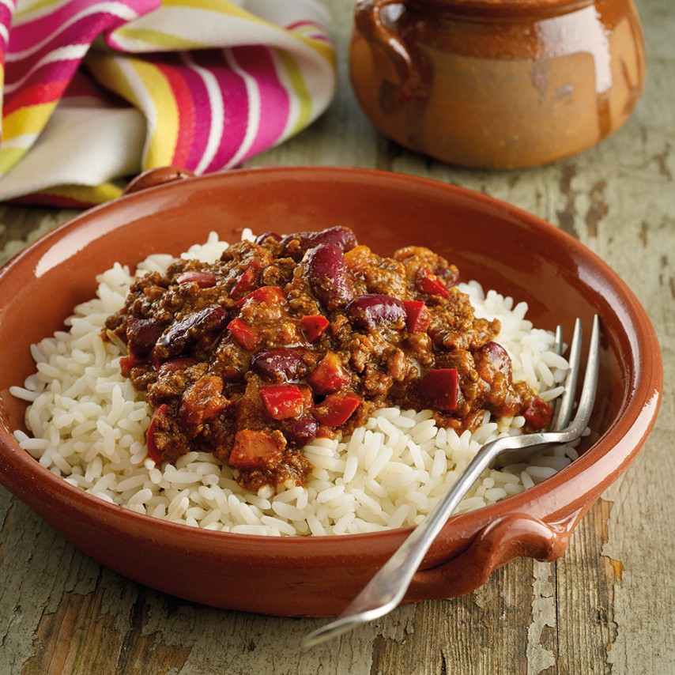

£6

BAR OFFER ….. February to end April

Buy 6 pints get the 7th pint FREE

Collect your card from the bar. One stamp per person per visit will be awarded with the purchase of one pint of the qualifying brand

CARLING, SAN MIGUEL, RUDDLES BEST

& BELHAVEN

2 BOTTLES OF BIERRA MORETTI, DESPERADOS OR CORONA FOR £5

While stocks last



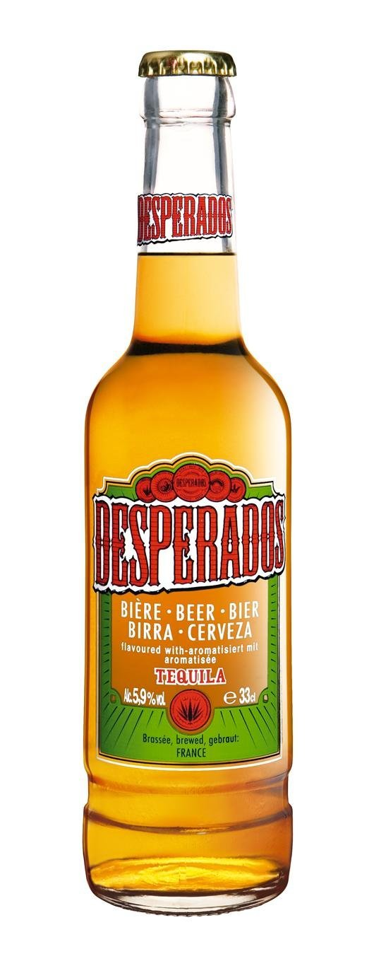

[](https://www.google.co.uk/url?sa=i&rct=j&q=&esrc=s&source=images&cd=&ved=2ahUKEwjts5X627nkAhVOcBQKHX9rAuwQjRx6BAgBEAQ&url=https://www.123rf.com/photo_81982839_minsk-belarus-july-10-2017-bottle-of-corona-extra-beer-isolated-on-white-one-of-the-top-selling-beer.html&psig=AOvVaw3X30bIX3KLNAXxiaLZomr8&ust=1567774084049852)

[](https://www.google.co.uk/url?sa=i&source=images&cd=&cad=rja&uact=8&ved=2ahUKEwj36L26yPjaAhWHOBQKHWNxDo0QjRx6BAgBEAU&url=http://www.gourmetislandcatering.com/salads/&psig=AOvVaw2Beby3Fi2UkQ3jJQXpTPTH&ust=1525953110186516)

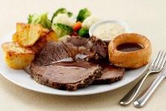

**Three Snooker Tables, Pool Table, Darts, Cards, Wide Screen TVs showing**

**SKY SPORTS & BT SPORTS in our air-conditioned Sports Bar**

Check out our website at www.westbourneconclub.com

NOTICE BOARD

**Birthday Parties, Anniversaries, Meetings, Lunches, Buffets, Wakes.**

The Club caterer provides a wide range of

Catering Services for all occasions.

Chris will be happy to discuss arrangements.

**BAR** Phone: 01202 761056 for event tickets

**CATERING** Chris Curtis 07873389051

Email: [wcc6alum@btconnect.com](mailto:wcc6alum@btconnect.com)

Visit our website at [www.westbourneconclub.com](http://www.westbourneconclub.com)

Phone: 01202 766698 (office hours only)

OPENING HOURS: Mon/Thurs 11.00 – 11.00, Wed 10.00 – 11.00,

Fri 11.00 – 11.30, Sat 11.00 – 12.00, Sun 11.00 – 10.30

ADULT LATIN AMERICAN & BALLROOM

DANCE CLASSES for beginners

Here in the club every Friday

9:30am – 10:30am  £7 per session

No partner required, please call Donna on 01202 243803

Or email her on [donnadiebelius@googlemail.com](mailto:donnadiebelius@googlemail.com) to book



SUNDAY LUNCH

Come in for a lovely roast with all the trimmings

Large size Small size

1 course £10.50 1 course £8.00

Order dessert for only £2.25

Booking highly recommended – Please See Chris for Bookings

**ANNUAL GENERAL MEETING.**

The Annual General Meeting of the Westbourne Conservative Club

will be held in the Main Lounge

of the Club at

## 8.00pm Thursday 26th March 2020



MAKE A NIGHT OF IT BY DINING

AT THE CLUB BEFORE THE SHOW -

C Chilli con carne with rice

Served at 6:30pm

See Catering to pre book & pre pay by Mon 16TH March

**Thursday 19TH March**

**Elvis tribute by Garry J Foley**

**TICKET MEMBER / IA £7 pp**

**ADVANCE TICKET GUEST £9 pp**

**Now on sale at the bar.**

**Or by phone 01202 761056**

Regular Weekly Social Events

|  |  |  |  |  |
| --- | --- | --- | --- | --- |
| **Mondays**  **Tuesdays**  **Wednesdays**  **Thursdays**  **Fridays**  **Saturdays**  **Sundays** | | **8.00pm**  **8.30pm**  **10.00am**  **3.00 – 5.00pm**  **8.30pm**  **3.00 – 5.00pm**  **9.00pm**  **8.30pm**  **8.30pm**  **10.00pm**  **1.45pm** | | **Cards: Also “League Poker” £5 buy in.**  **Bingo, cash prizes, Joe “90”,£80. Bottle draw, Play Your Cards Right**  **Club opens early.**  **Live music for dancing. “21” Bottle draw.**  **Quiz night. “Play your cards right”**  **Line dancing, beginners welcome.**  **Informal poker game 8:00pm monthly poker game – see notice board**  **Card Bingo, Membership Draw, Fresh Meat Draw, Bottle Draw, Reverse Forecast Draw, “Treasure Chest” Snowball – find the “right” key**  **Live music – see details below. £1 members & IA, £2 for guests**  **Bottle Draw. Then door entry ticket no. goes into “FREE” Prize draw, for Bottles of Wine**  **Sunday Money Draw: £100, £50, £25, £10, £10 & £5 (if all tickets sold),**  **Bottle Draw & Meat voucher draw.** |
| **SATURDAY EVENING ENTERTAINMENT 8.30 – 11.30pm Members & IA £1, Guests £2**  **ALSO SPECIAL EVENTS OVER THE NEXT FEW MONTHS**  **“MAIN” Bottle draw 10.00pm, then Door Entry ticket no. goes into ‘FREE’ Prize draw for Bottles of Wine** | | | | |
| **MARCH** | | | | |  |  |
| **Saturday**  **Thursday**  **Saturday**  **Thursday**  **Saturday** | **7th**  **14th**  **19th**  **21st**  **26th**  **28th** | | **NIGHT SHIFT - 4-piece band, very popular – always in demand.**  **JURRASIC Rock ‘n’ Roll 4-piece band the music of the 50’s & 60’s**  **ELVIS TRIBUTE by Garry Foley, best ever tribute night: £7 members & IA, £9 guests.**  **‘MAIN’ Bottle draw at 10.00pm. Then free ‘Door Entry’ ticket draw.**  **NEW BEATS – 4-piece band, relive the 60s featuring songs from the Beatles, The Who,**  **The Hollies, Rolling Stones, Small Faces, The Kinks and more.**  **ANNUAL GENERAL MEETING 8pm**  **DANCE ON 3-piece band, dance all evening** | |
| **APRIL** |  | |  | |
| **Saturday**  **Thursday**  **Saturday** | **4th**  **11th**  **18th**  **23rd**  **25th** | | **HUGH BUDDEN & BLUE CHORDS 50’s, 60’s, 70’s Soul, Blues, Rock, Pop & Country**  **HANDLE WITH CARE 5 piece covers band with an excellent reputation**  **OUTRAGE– 60’s band playing all the hits from that great era; Shadows, Searchers and others**  **MICHAEL JACKSON TRIBUTE by Gathan Cheema £5 members & IA £7 guests**  **‘MAIN’ Bottle draw 10.00pm. Then ‘Door Entry’ ticket draw.**  **ROY CHARLES Beautiful singer of hits from the 60s up to the present day, great for dancing.** | |
| **MAY** |  | |  | |
| **Saturday**  **Friday**  **Saturday**  **Thursday**  **Saturday** | **2nd**  **8th**  **9th**  **16th**  **21st**  **23rd**  **30th** | | **MAGIC - 6-piece band; our all-time favourites with Katie**  **75th Anniversary of VE Day with music by Paul Hammond 3-6pm**  **THE DEFECTORS 8-piece band, soul motown hits & classics, dance the night away**  **MIDNIGHT HOUR – 5-piece band, THE South’s leading show band here to entertain you.**  **ED SHEERAN TRIBUTE by Matt Fisher £5 members & IA £7 guests**  **‘MAIN’ Bottle draw 10.00pm. Then ‘Door Entry’ ticket draw.**  **HURRICANES 4-piece band, the South's leading R'n'R 60'S & 70'S club band**  **PAUL SPENCER DUO dance along to great music and singing** | |

Dates and acts subject to change E & OE