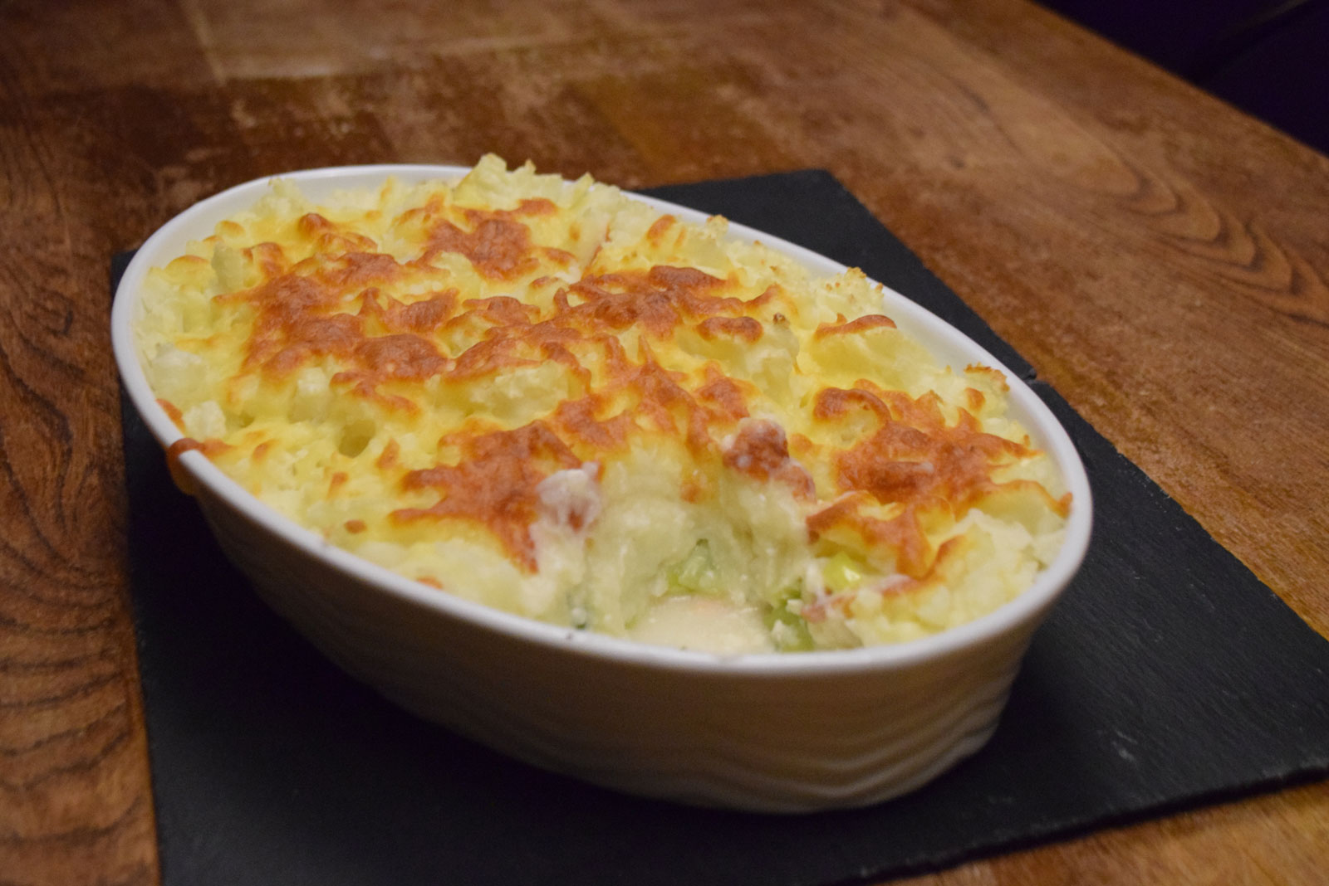





[](http://www.ferrymeadowsrailway.co.uk/?attachment_id=277)



GRAND CHRISTMAS DRAW

Prizes of cash & luxury goods –

see Notice Board for details.

Tickets on sale NOW

**Three Snooker Tables, Pool Table, Darts, Cards, Wide Screen TVs showing**

**SKY SPORTS & BT SPORTS in our air-conditioned Sports Bar**

Check out our website at www.westbourneconclub.com

[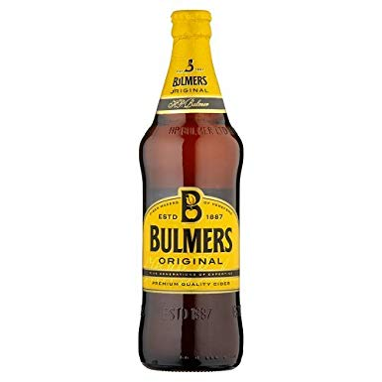](https://www.google.co.uk/url?sa=i&rct=j&q=&esrc=s&source=images&cd=&cad=rja&uact=8&ved=&url=https://www.amazon.co.uk/Bulmers-Original-Cider-Bottle-568ml/dp/B0051C1HA4&psig=AOvVaw3r9Q7b0pov7VE51YTUVt38&ust=1567774022384895)[](https://www.google.co.uk/url?sa=i&rct=j&q=&esrc=s&source=images&cd=&ved=2ahUKEwjts5X627nkAhVOcBQKHX9rAuwQjRx6BAgBEAQ&url=https://www.123rf.com/photo_81982839_minsk-belarus-july-10-2017-bottle-of-corona-extra-beer-isolated-on-white-one-of-the-top-selling-beer.html&psig=AOvVaw3X30bIX3KLNAXxiaLZomr8&ust=1567774084049852)

FRIDAYS 2 BOTTLES

OF CORONA FOR £5

SATURDAY & SUNDAYS

2 BOTTLES OF ORIGINAL

OR RED BERRY BULMERS FOR £5

NOTICE BOARD

**Birthday Parties, Anniversaries, Meetings, Lunches, Buffets, Wakes.**

The Club caterer provides a wide range of

Catering Services for all occasions.

Chris will be happy to discuss arrangements.

**BAR** Phone: 01202 761056

**CATERING** Chris Curtis 07801 374490

Email: [wcc6alum@btconnect.com](mailto:wcc6alum@btconnect.com)

Visit our website at [www.westbourneconclub.com](http://www.westbourneconclub.com)

Phone: 01202 766698 (office hours only)

OPENING HOURS: Mon/Thurs 11.00 – 11.00, Wed 10.00 – 11.00,

Fri 11.00 – 11.30, Sat 11.00 – 12.00, Sun 11.00 – 10.30

ADULT LATIN AMERICAN & BALLROOM

DANCE CLASSES for beginners

Here in the club every Friday

9:30am – 10:30am  £7 per session

No partner required, please call Donna on 01202 243803

Or email her on [donnadiebelius@googlemail.com](mailto:donnadiebelius@googlemail.com) to book



**New in -- CLUB COCKTAILS**

Kir Royal £5.50

Mini Prosecco & Chambord

Screwdriver £5.95

Oj, Vodka & Angostura bitter.

***Christmas Lunches***

Served From Monday 2nd until

Tuesday 24th December.

2 courses £12.00 3 courses £15.00

No Turkey on Sundays

TICKETS ON SALE FOR

**PERSUADERS - New Year’s Eve**

**Tickets Members & IA £15, Guests £17. On sale at the bar to Members only until 17th November.**

**Just Jeff - Christmas Eve**

**FREE to Members £1 guests on the door**

Children’s Christmas Party

Here in the club Saturday 14th December

from 3 – 5 in the afternoon. Games, party

food and a visit from Father Christmas.

Please put your child's name on the list

on the Notice Board.

[](http://www.google.co.uk/url?sa=i&rct=j&q=&esrc=s&source=images&cd=&cad=rja&uact=8&ved=2ahUKEwiHkIbZu8HdAhUQUhoKHXgyAL8QjRx6BAgBEAU&url=http://ukran.soochi.co/word-christmas/&psig=AOvVaw0XjEKLB070fuJ8x94nPI-2&ust=1537253935263796)

**SATURDAY 30th NOVEMBER 9.00am to set up**

**SEE NOTICE BOARD TO BOOK**

Or phone 01202766698

£5 a table (provided) £2.50 clothes rail (not provided)

[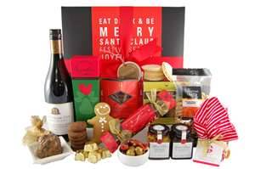](http://images.search.yahoo.com/images/view;_ylt=A0PDoS8DRa9Q7AcARr6JzbkF;_ylu=X3oDMTBlMTQ4cGxyBHNlYwNzcgRzbGsDaW1n?back=http://images.search.yahoo.com/search/images?_adv_prop=image&va=christmas+hampers&fr=b1ie7&tab=organic&ri=1&w=653&h=434&imgurl=gourmetbasket.com.au/products/Xmas%202012/Festive_Christmas_Hamper-653x434.jpg&rurl=http://gourmetbasket.com.au/christmas-hampers/festive-christmas-hamper&size=203.4+KB&name=Festive+%3cb%3eChristmas+%3c/b%3eHamper&p=christmas+hampers&oid=61e4295fd54128e219e6791ede2394a9&fr2=&fr=b1ie7&tt=Festive+%3cb%3eChristmas+%3c/b%3eHamper&b=0&ni=48&no=1&ts=&tab=organic&sigr=126bn5gsf&sigb=13bledqdp&sigi=12eo45lvk&.crumb=LGT1CVCScnG)

MAKE A NIGHT OF IT BY DINING

AT THE CLUB BEFORE THE SHOW -

Fish Parmentier with steamed

Vegetables £6

Served at 6:30pm

See Chris in Catering to pre book & pre pay

Telephone 07801374490 by Monday 11th November

**Thursday 14th & Thursday 21st Nov**

**Elvis tribute by Garry J Foley**

**TICKET MEMBER / IA £6 pp**

**ADVANCE TICKET GUEST £8 pp**

**Now on sale at the bar.**

Regular Weekly Social Events

|  |  |  |  |  |
| --- | --- | --- | --- | --- |
| **Mondays**  **Tuesdays**  **Wednesdays**  **Thursdays**  **Fridays**  **Saturdays**  **Sundays** | | **8.00pm**  **8.30pm**  **10.00am**  **3.00 – 5.00pm**  **8.30pm**  **3.00 – 5.00pm**  **9.00pm**  **8.30pm**  **8.30pm**  **10.00pm**  **1.45pm** | | **Cards: Also “League Poker” £5 buy in.**  **Bingo, cash prizes, Joe “90”,£80. Bottle draw, Play Your Cards Right**  **Club opens early for Free Art Classes. Join like-minded people & take up a hobby.**  **Live music for dancing. “21” Bottle draw.**  **Quiz night. “Play your cards right”**  **Line dancing, beginners welcome.**  **Informal poker game 8:00pm monthly poker game – see notice board**  **Card Bingo, Membership Draw, Fresh Meat Draw, Bottle Draw, Reverse Forecast Draw, “Treasure Chest” Snowball – find the “right” key**  **Live music – see details below. £1 members & IA, £2 for guests**  **Bottle Draw. Then door entry ticket no. goes into “FREE” Prize draw, for Bottles of Wine**  **Sunday Money Draw; £100, £50, £25, £10, £10 & £5 (if all tickets sold),**  **Bottle Draw & Meat voucher draw.** |
| **SATURDAY EVENING ENTERTAINMENT 8.30 – 11.30pm Members & IA £1, Guests £2**  **ALSO SPECIAL EVENTS OVER THE NEXT FEW MONTHS**  **“MAIN” Bottle draw 10.00pm, then Door Entry ticket no. goes into ‘FREE’ Prize draw for Bottles of Wine** | | | | |
| **NOVEMBER** | | | | |  |  |
| **Saturday**  **Thursday**  **Saturday**  **Thursday**  **Saturday** | **2nd**  **9th**  **14th**  **16th**  **21st**  **23rd**  **30th** | | **MAGIC - 6 piece band; our all time favourites with Katie**  **HURRICANES 4 piece band, the South's leading R'n'R 60'S & 70'S club band**  **ELVIS TRIBUTE by Garry Foley, best ever tribute night: £6 members & IA, £8 guests.**  **‘MAIN’ Bottle draw at 10.00pm. Then ‘Door Entry’ ticket draw. Yes we have Elvis twice this month**  **ROY CHARLES Beautiful singer of hits from the 60s up to the present day, great for dancing.**  **ELVIS TRIBUTE by Garry Foley, best ever tribute night: £6 members & IA, £8 guests.**  **‘MAIN’ Bottle draw at 10.00pm. Then ‘Door Entry’ ticket draw. Yes we have Elvis twice this month**  **PHIL SPENCER DUO dance along to great music and singing**  **BANDASTIC - 4 piece band. Guaranteed to entertain you.** | |
| **DECEMBER** |  | |  | |
| **Saturday**  **Thursday**  **Saturday**  **Christmas Eve**  **Boxing Day**  **Saturday**  **New Year’s Eve** | **7th**  **12th**  **14th**  **21st**  **24th**  **26th**  **28th**  **31st** | | **OUTRAGE – 60’s band playing all the hits from that great era; Shadows, Searchers and others**  **CLIFF RICHARDS XMAS PARTY TRIBUTE By Will Chandler £5 members & IA, £7 guests.**  **“MAIN” Bottle & “FREE” Bottle draws at 10.00pm**  **SUPER GROOVES - 4 piece band, hits from the 50s to current day.**  **ALTO DUO - experienced professionals, variety of music that will keep you on the dance floor**  **JUST JEFF – 50’s & 60’s music guitar & vocals, always a lovely evening’s entertainment.**  **Free to members & IA, £1 guests pay on the door.**  **CHRISTMAS “OUT ON THE FLOOR” 4pm-10pm Resident DJ's Dave Morris, plus guest DJ’s Members & IA £1, Non-members £5 Entry fee paid on the door**  **NEW BEATS - 4 piece band, relive the 60s featuring songs from the Beatles, The Who,**  **The Hollies, Rolling Stones, Small Faces, The Kinks and more.**  **THE PERSUADERS – 4 piece band playing for us at our New Year's Eve party. Tickets Members & I.A. £15, Guests £17. On sale to members only until 17th November, then open to all.** | |
| **JANUARY** |  | |  | |
| **Saturday**  **Thursday**  **Saturday** | **4th**  **11th**  **18th**  **23rd**  **25th** | | **STILL ROCKIN 5 piece band**  **DEFECTORS - 8 piece band, soul motown hits & classics, dance the night away**  **MIDNIGHT HOUR - 5 piece band, The South’s leading show band here to entertain you.**  **GEORGE MICHAEL TRIBUTE – “I’m Your Man” by Andrew Michaels £6 members & IA, £8 guests.**  **“MAIN” Bottle & “FREE” Bottle draws at 10.00pm.**  **MAGIC - 6 piece band; our all time favourites with Katie** | |

Dates and acts subject to change E & OE