Proposed Itineraries for 2027 Australian Stake Holy Lands Tour

Jordan: March 29-April 04 & Israel: April 03-15, 2027
New Pre-Tour Egypt Option: March 23-29, 2027
Jordan-Israel Tour Price: TBA
(All Itineraries include ﬂight dates)

The Hashemite Kingdom of Jordan Itinerary

March 29-April 04, 2027

Days 1 & 2. Monday-Tuesday: March 29-30, 2027
Locations: USA/AMMAN, Jordan. Bus transfer from Queen Alia International Airport to Grand Palace Amman Hotel. Meeting room after dinner at hotel. (In-ﬂight meals, D)

Day 3. Wednesday: March 31
Locations: 6:45 am Breakfast. Depart Hotel at 7:45 am to Citadel. Arrive at 8:00 am and begin tour. Depart at 9:15 am to Jordan National Museum. Arrive at 10:00 am and depart at 11:15 am. Arrive at Jabbok (Zarqa) River at 12:15 pm. Depart at 12:30 pm for Jerash Visitors Center (lunch en route). Arrive after lunch at Visitor’s Center and then begin tour 2:10 pm. Depart Jerash for Wadi al-Yabis (Awda Ottoman Flour Mill and ancient Olive Tree). Arrive at 3:00 pm, depart at 3:20 pm. Arrive Grand Palace Amman Hotel at 5:00 pm. Some may choose to go to downtown Suq or market. Dinner at 7:00 pm. (B, D)

Day 4. Thursday: April 01, 2027
Locations: 6:30 am breakfast. Luggage to lobby and bus at 7:10 am. Devotional at 7:25 am. Depart at 7:30 AM for Petra via Desert Hwy./Route 15/Route 45M. Stop at Qetyraneh Visitors Center and see Khan and a rest stop while traveling. View Shobak Castle and continue to Ayn Musa in Wadi Musa, arriving at 11:00 am. Depart at 11:10 am for Time Out Restaurant (Tourism St 71810, Wadi Musa), arriving at 11:20 am. Lunch and depart at 12:15 pm for Petra Visitor’s Center. Arrive at 12:20 pm for tour of Petra and Petra Museum until 5:00 pm. Depart for Petra Moon Resort Hotel and arrive at 5:15 pm. Dinner at 6:30 pm. (B, D)

Day 5. Friday: April 02, 2027
Locations: 7:00 am breakfast. Luggage out of rooms by 7:30 am. Departure from hotel at 8:00 am. After breakfast, bus to Wadi Aravah view and Wadi Rum Visitor’s Center. Go to Rum Planet Camp in Wadi Rum for a one-hour camel trek, Bedouin lunch meal (Zerbe) with guest lecture on Bedouin Lifestyle. Depart at 1:pm for Aqaba for short city bus tour. Arrive at 2:30 pm to the Aqaba Marine Reserve Park Visitor’s Center. Here rent snorkeling equipment and have time to snorkel at coral beach in Red Sea. The 7:00 pm dinner and overnight is at the Grand Tala Bay Resort with its swimming pool and private beach on the Red Sea. (B, L, D)

Day 6. Saturday: April 3, 2027
Location: 7:00 am breakfast. Luggage out of rooms by 7:15 am. Depart Grand Tala Bay Resort in Aqaba at 7:30 pm for the Museum at the Lowest Place on Earth (3G22+5WF, Gawr as-Saﬁ, Jordan) and Lot's Cave (Church of Saint Lot), arriving at 10:30 am. Depart after lunch at 12:30 pm for Al Karak Castle, arriving at 1:30 pm. Depart at 3:30 pm, traveling to the Dead Sea Spa and Resort. Arriving at the resort at 5:00 pm. Some may choose to ﬂoat in the Dead Sea. Dinner at 7:00 pm. (B, D)

Day 7. Sunday: April 4, 2027
Location: Dead Sea Spa Resort breakfast at 7:00 am. Luggage on the bus by 7:30 am. Depart by 7:45 am to Madaba Visitor’s Center. Arrive at 8:45 am. Tour St. George mosaic map (oldest map of Holy Lands), depart Madaba at 10 AM for Mosaic Factory Shop. Arrive at 10:15 am. Depart for Mount Nebo at 11:15 am. Stop at 11:30 am for lunch at a nearby restaurant and depart at 12:00 pm for “The Baptismal Site of Jesus Christ”, arriving at 12:40 pm. Depart Baptism site at 2:00 pm for King Hussein/Allenby Bridge Crossing, arriving at 2:30 pm. Depart border crossing at 4:30 pm for Hadera Resort by Jocob’s Hotels in Hadera, Israel. Arrive at the hotel at 6:20 pm. Dinner at 7:00 pm and meet with the Israel only tour group after dinner.

ISRAEL ITINERARY

Day 8. Monday April 05, 2027
Locations: Hadera, Caesarea Maritima National Park, Megiddo National Park, Mount Carmel, Muhkraqa Carmelite Monastery, Haifa, Baha'i Gardens Observatory, German Templer Cemetery, Tiberias, Ein Gev Holiday Resort. Full Day Bus & Guide. Breakfast at Hadera Resort and dinner at Ein Gev Holiday Resort. (B, D)

Day 9. Tuesday April 06, 2027
Locations: Ein Gev Holiday Resort, Mount Tabor (Taxis up mount), Nazareth Village (include tour at 10:45 AM followed by 1st Century lunch), Church of Annunciation, Sisters of Nazareth Chapel (tour appointment at 1:50 PM), Magdala Franciscan Excavations, Yigal Allon Centre, Ginosar, Israel, Boat on Sea of Galilee (appointment at 4:00 PM), Ein Gev Holiday Resort. Full Day Bus & Guide. Breakfast and dinner at Ein Gev Holiday Resort. (B, L, D)

Day 10. Wednesday April 07, 2027
Locations: Ein Gev Holiday Resort, Capernaum, Church of the Primacy of Peter, Mount of the Beatitudes, Dag Al Dan Restaurant for ﬁsh lunch, Tel Dan Nature Reserve, Hermon Nature Reserve (Caesarea Philippi), Syrian-Israel Border below Mount Bental, Susita (Hippos) National Park (optional, based on time), Ein Gev Holiday Resort. Full Day Bus & Guide. Breakfast and dinner at Ein Gev Holiday Resort. (B, L, D)

Day 11. Thursday April 08, 2027
Locations: Ein Gev Holiday Resort, Yardenit, Beit Shean National Park, Tel Shiloh Excavations (arrive at include private red heifer visit), Qasr el Yehud (Jesus Baptism), Tel es-Sultan, Jericho Oasis Hotel. Full Day Bus & Guide. Breakfast at Ein Gev Holiday Resort and dinner at Oasis Hotel, Jericho. (B, D)

Day12. Friday April 09, 2027
Locations: Oasis Hotel, Jericho, Masada National Park, Qumran National Park (lunch), Kalia Dead Sea Beach, Judean Wilderness (Wadi Qelt Overlook), Olive Tree or Grand Court Hotel, Jerusalem. Full Day Bus & Guide.
Breakfast at Oasis Jericho Hotel and dinner at Olive Tree or Grand Court Hotel, Jerusalem. (B, D)

Day 13. Saturday April 10, 2027
Locations: Sabbath in Jerusalem BYU Jerusalem Center, Orson Hyde Memorial Gardens, West Jerusalem and Israel Museum, view Knesset Building to visit National Menorah Memorial, Model City of 1st Century AD Jerusalem, Shrine of the Book, and Archaeological Museum. Full Day Bus & Guide. Breakfast and dinner at Olive Tree or Grand Court Hotel, Jerusalem. (B, D)

Day 14. Sunday April 11, 2027
Locations: Old City of Jerusalem, Temple Mount, Western Wall, & Bethlehem. Visit the four quarters of the Old City, including the Moslem, Jewish, Armenian, and Christian quarters. Begin at the Harem al Sharif (Temple Mount), Via Dolorosa (St Anne’s Church, Lithostratos, Holy Sepulcher), Shaban’s or Alibaba’s shop. Proceed to Jewish Quarter, Roofs of Shops, Cardo, Broad Wall, Hurva Synagogue square, Temple Menorah, Western Wall, Dung Gate. We then travel a few miles south of Jerusalem to Bethlehem and visit Catholic Shepherd’s Fields in Beit Sahur, Joseph’s Olive Wood shop, Manger Square, Church of the Nativity, Full Day Bus & Guide. Breakfast and dinner at Olive Tree or Grand Court Hotel, Jerusalem. (B, D)

Day 15. Monday April 12, 2027
Locations: Bethany, Bethphage, Mount of Olives, Gethsemane, Orson Hyde, Mount Zion, Zion’s Gate, David’s Tomb, Upper Room, St. Peter en Galicantu. Full Day Bus & no Guide. Breakfast and dinner at Olive Tree or Grand Court Hotel, Jerusalem. (B, D)

Day 16. Tuesday: April 13, 2027
Locations: (8:00 AM appointment) Garden Tomb, depart for options: Option 1 – West Jerusalem, Yad Vashem (Museum of the Holocaust), and Mt. Hertzl: The City of David Excavations (10 AM appointment), Hezekiah’s Water Tunnel, the Pool of Siloam, and the newly excavated tunnel to the Ophel excavations, Davidson Center, Jewish Quarter. Half-day Bus & no Guide. Breakfast and dinner at Olive Tree or Grand Court Hotel, Jerusalem. (B, D)

Days 17-18. Wednesday-Thursday: April 14-15, 2027
Locations: Check out of Olive Tree or Grand Court Hotel by noon: depart for Nicopolis (Emmaus; meeting arranged at 2:30 PM); Travel to Jaffa (Bus tour of Tel Aviv and walking tour of Jaffa, meet at St. George Restaurant for Farewell meal at 5:30 pm); transfer to Ben Gurion International Airport after dinner. Half-day Bus & no Guide. Breakfast at Olive Tree or Grand Court Hotel, Jerusalem. Fast Food lunch on own. (B, D, In-ﬂight meals)
Pre-Tour Egypt Option
March 23-29, 2027
Price: TBA
Day 1-2 (Tuesday-Wednesday, March 23-24) Depart for Cairo Egypt International Airport
Locations: Flights arrive in Cairo International Airport and the group transfers to the Steigenberger Giza Pyramids Hotel for dinner and overnight. We will meet as a group with Dann Hone. (Inflight meals, Dinner in Cairo.)
Day 3 (Thursday, March 25) Cairo, Memphis, Saqqara, Giza.
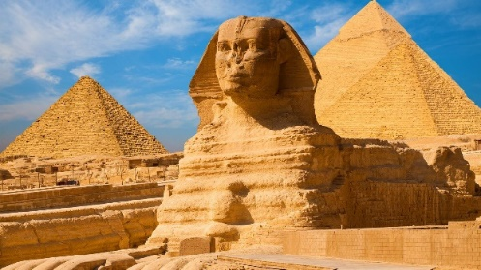
After breakfast our first visit is to Memphis (capital of the Pyramid Age) and Saqqara (Djoser's famous step pyramid); we'll then transfer to Giza. We begin with the world-famous Pyramids of Giza, classified among the Seven Wonders of the Ancient World. Here we'll stand in awe of their size and magnificent engineering. Then we will come face to face with the 5,000-year-old Sphinx. Some may choose to ride a camel with the Great Pyramids and Sphinx as a background. As time permits, we will include visits to a carpet factory, the Papyri Institute, and some may choose an optional evening light and sound show at Giza. A short distance away is our hotel near the Pyramids and the GEM [Grand Egyptian Museum]. (B, D)
Sphinx and Great Pyramids of Giza, Egypt
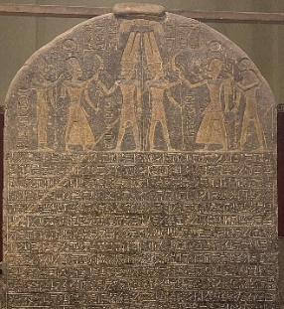
Day 4 (Friday, March 26) Egyptian Museum, Old Cairo, Citadel, Alabaster Mosque, Khan Khalili Bazaar
After breakfast, we have our heavy luggage stored at the Steigenberger Pyramids Hotel (we only take with us our carry-on luggage for an evening flight and two-day stay in Upper Egypt). Our first stop today is the famous Cairo Egyptian Museum near El-Tahrir Square in downtown Cairo. Here discoveries from the tombs and cities throughout Egypt are exhibited. The treasures of Tanis that rival the “King Tut” collections, the Narmer Pallet (earliest unification of Upper and Lower Egypt about 5,000 years ago), as well as many other fascinating exhibits from the various periods of ancient Egyptian history are on display. After lunch we will transfer to the National Museum of Egyptian Civilization (NMEC) in Old Cairo, which is a sweeping, multi-civilization complex exploring Egyptian heritage from prehistoric times to the modern era. It is world-renowned for housing the official Royal Mummies Hall featuring the mummies of 18 kings and 4 queens (such as Queen Ahmose Nefertari, Hatshepsut, Ramses II, and Thutmose III, plus 18 more Pharaonic mummies) resting in climate-controlled chambers. We will tour Old Cairo Coptic and Jewish communities, the Cairo Citadel, Mohammed Ali Alabaster Mosque, and pay a visit to the world-famous Khan Khalili Bazaar for shopping before heading once again to the Cairo International Airport at 4:30 PM. Arrive Cairo Airport at 5:00 PM and depart for Luxor at 6:25 PM. Arrive Luxor Airport at 7:30 PM. The flight to Luxor Airport in Upper Egypt is 317 miles south of Cairo. Transfer to the Luxor Steigenberger Hotel for a late dinner and overnight stay. (B, D)
The Victory Stele of Pharaoh Merneptah, who reigned from 1213 to 1203 BCE. It contains the first reference to the tribes of Israel.
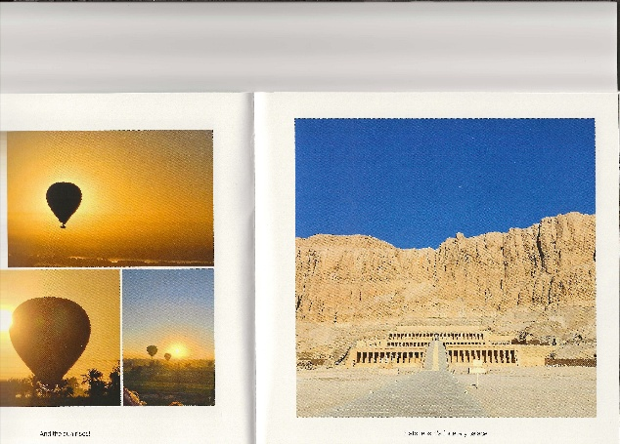
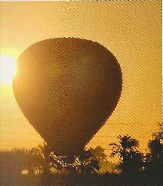
Day 5 (Saturday, March 27) East and West Bank of the Nile in Upper Egypt: Luxor, early morning Hot Air Balloon over West Bank (extra cost), the West Bank tombs and funerary temples, Luxor and Karnak Temples, Avenue of the Sphinx, Luxor Markets and Bazaars
Hatshepsut's Funerary Temple
The adventurous will have an early morning sack breakfast and cross the Nile for an optional hot-air balloon ride over the Nile West Bank. Others will depart the hotel later for crossing the Nile to join the hot air ballon adventurers. They all visit the fabulous tombs and funerary temples on the West Bank, including the elaborate tombs of Ramses V & VI and the famous Tomb of King Tutankhamen. We also visit and explore the Mortuary Temple of Hatshepsut, the Ramesseum, Medinet Habu, the Colossi of Memnon, and other sites. Crossing back across the Nile to Luxor, we will tour the famous temples of Luxor and Karnak (the largest religious building ever constructed). We will also walk a portion of the newly opened “Avenue of the Sphinx.” After dinner at the Luxor Steigenberger Hotel some may choose to have a carriage ride through the streets of Luxor, do some shopping before retiring overnight at our hotel. (B, D)
Balloon ride above Egyptian Temples, Nile West Bank, Upper Egypt
Day 6 (Sunday, March 28) Temple of Dendera, Life along the Nile, Flight to Cairo.
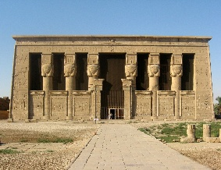
Our stay in upper Egypt is completed with a visit to the Temple of Dendera, where worship of the gods of Egypt is found as early as 3,000 B.C. The Temple of Dendera was one of the last completed temples and has the son of Julius Caesar and Cleopatra VII (famous Cleopatra of Shakespeare) and the Roman Commander Pompeii carved on wall reliefs. It is considered one of the best preserved and beautiful temples of Egyptian antiquity. Here we will review the ancient temple ceremonies before returning to Luxor for some shopping and our return flight to Cairo. We will return to the Steigenberger Pyramids Hotel, Giza for dinner and overnight. (B, D)
Temple of Dandara
Day 7 (Monday, March 29) The Grand Egyptian Museum (Gem) in Giza, Farewell Meal, Departure from Egypt
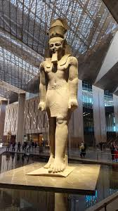
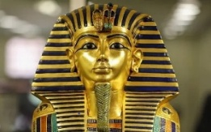
After breakfast, we check-out of our hotel and transfer to The Grand Egyptian Museum (GEM). The GEM is the finest and most extensive collection of ancient Egyptian civilization in the world. We will explore the over 100,000 treasures of Egyptian antiquity, including the famous King Tutankhamen (“King Tut”) exhibits housing over 5,398 pieces from King Tut’s Tomb. Here also we visit the Solar Boat Museum to see the funerary barge used 4500 years ago by Pharaoh Khufu (also known as Cheops, the second pharaoh of the Fourth Dynasty of the Old Kingdom of Egypt), Our visit to the GEM will help us review the history and see life as it existed at the time of the pharaonic dynasties. The ancient artifacts that span 5,000 to 7,000 years of Egyptian history are organized into four primary eras which include: Predynastic & Old Kingdom, Middle Kingdom, New Kingdom, Greco-Roman era. This evening after the final Farewell Dinner, we will head to the Cairo International Airport for our departure to Queen Alia International Airport outside Amman, Jordan to join other Australian Saints for our journeys in Jordan and Israel. (B, D)
The Golden Funerary Mask of King Tutankhamun (TUT)
The Statue of Rameses II in Lobby of the Grand Egyptian Museum (GEM)

