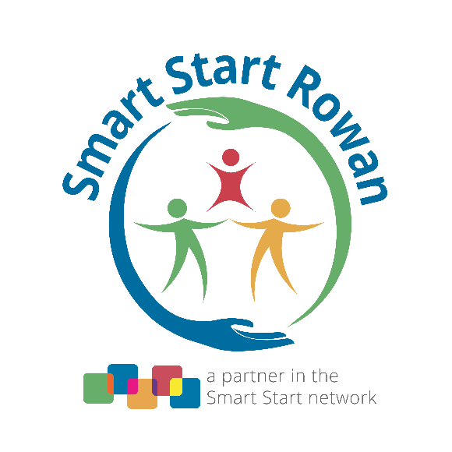

**Board Meeting Calendar**

**2025 – 2026**

***No Board Meeting in July Happy Summer***

**Monday, August 25, 2025 Board Meeting**

**Monday, September 22, 2025 Board Meeting**

**Monday, October 27, 2025 Board Meeting**

**Monday, November 17, 2025 Board Meeting**

***No Board Meeting in December Happy Holidays***

**Monday, January, 26, 2026 Board Meeting**

**Monday, February, 23, 2026 Board Meeting**

***No Board Meeting in March Champion Event***

**Monday, April 27, 2026 Board Meeting**

**\*Monday, May 18, 2026 Board Meeting**

***(one week early because of Memorial Day holiday)***

**Monday, June 22, 2026 Board Meeting**

Regular Board meetings begin with lunch and fellowship at 11:30 a.m., followed by the meeting at 12:00 p.m. All Board meetings will be at the Smart Start Rowan office, located at 1329 Jake Alexander Boulevard South, in Salisbury.

A virtual option for meeting attendance via **zoom.com** will be given upon request. **\*If you are a community member who would like to attend virtually, please contact** [**abrown@smartstartrowan.org**](mailto:abrown@smartstartrowan.org) **in order to receive access to the meeting.**