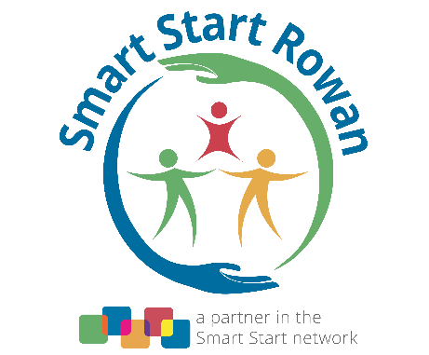
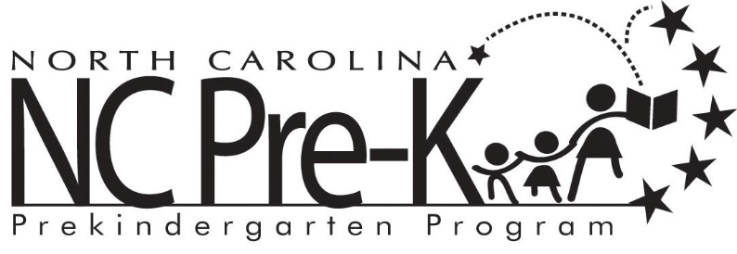

2022-2023 NC Pre-K County Planning Committee Meeting Schedule

July 20, 2022 at 3:00 pm*(2022-2023 NC Pre-K Site Selection)
August 24, 2022 at 3:00 pm*
October 26, 2022 at 3:00 pm* Cancelled
January 25, 2023 at 3:00 pm*
March 29, 2023 at 3:00 pm*
June 21, 2023, 3:00 pm* (2023-2024 NC Pre-K Site Selection)
*If you are a community member who would like to attend virtually, please contact amay@smartstartrowan.org in order to receive access to the meeting

