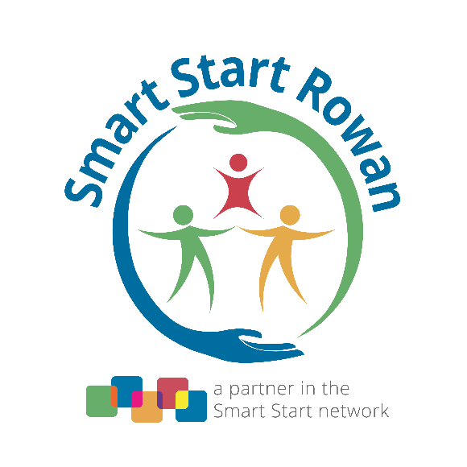
Board Meeting Calendar
2023 – 2024

No Board Meeting in July Happy Summer

Monday, August 28, 2023 Board Meeting
Monday, September 25, 2023 Board Meeting
Monday, October 23, 2023 Board Meeting
Monday, November 27, 2023 Board Meeting

No Board Meeting in December Happy Holidays

Wednesday, January, 31, 2024 Strategic Planning Session
at Trinity Oaks
(10:00 a.m. – 3:00 p.m.)

Monday, February, 26, 2024 Board Meeting
Monday, March 25, 2024 Board Meeting
Monday, April 22, 2024 Board Meeting
Monday, May 20, 2024 Board Meeting
Monday, June 24, 2024 Board Meeting

Regular Board meetings begin with lunch and fellowship at 11:30 a.m., followed by the meeting at 12:00 p.m. All Board meetings will be at the Smart Start Rowan office, located at 1329 Jake Alexander Boulevard South, in Salisbury.

A virtual option for meeting attendance via zoom.com will be given upon request. *If you are a community member who would like to attend virtually, please contact abrown@smartstartrowan.org in order to receive access to the meeting.

