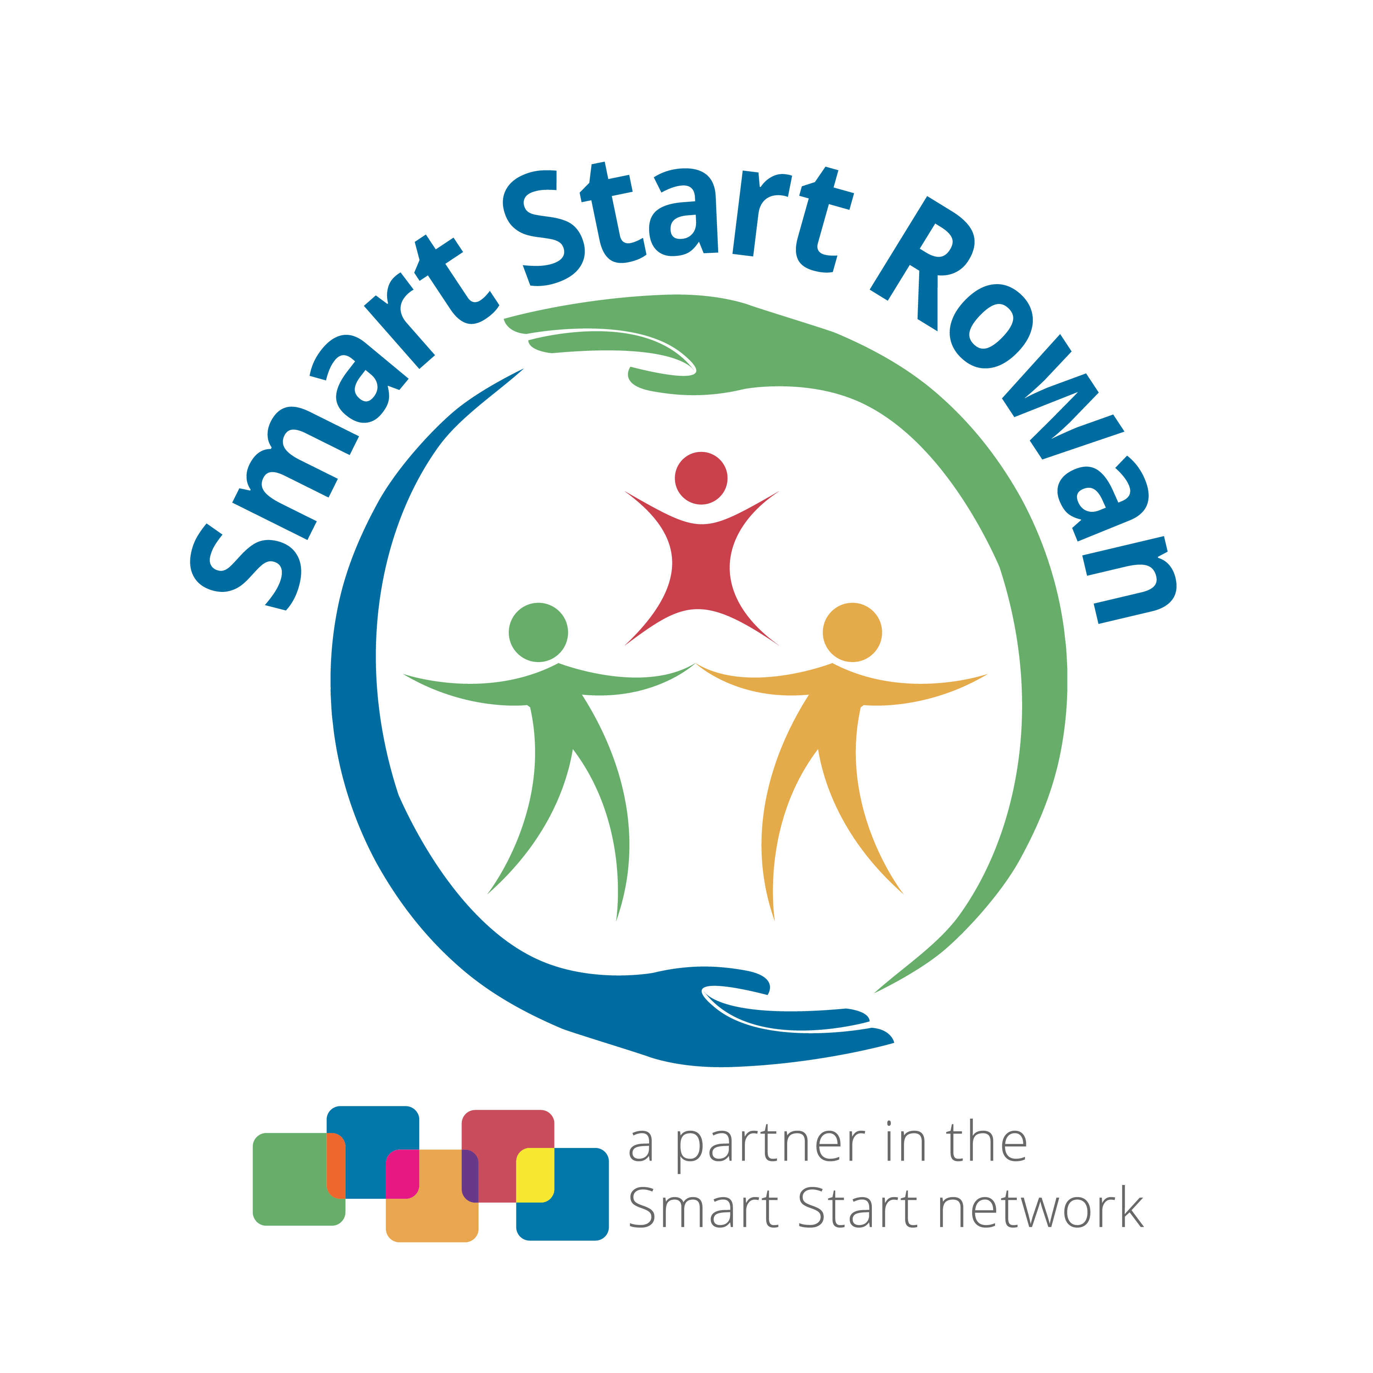
Strategic Plan for FY 2021-2022 Through FY 2023-2024

This document describes the Board of Directors’ Strategic Plan for Smart Start Rowan. It presents our vision, mission, and values; reviews our strengths, opportunities, and aspirations; and outlines the goals and potential action strategies to explore and implement over the next three years.

The Strategic Plan review occurred with the Board of Directors and staff on January 25, 2021. Due to the COVID-19 pandemic, a full Strategic Planning Session and data analysis was not done. However, the agency’s current Strategic Plan was reviewed and program implementation needs were discussed and considered, per recommendations set forth by the North Carolina Partnership for Children. Organizational values and the agency’s vision and mission statements, as well as strengths and opportunities, were discussed.
Vision Statement
Our vision for Rowan County is that every child will receive the education, nurturing, and support needed to provide the foundation for them to grow into healthy, productive citizens.

Mission Statement
Smart Start Rowan will collaborate to offer services that foster growth, encourage learning, and provide resources and support to community partners and families of children, prenatal through age five in Rowan County.

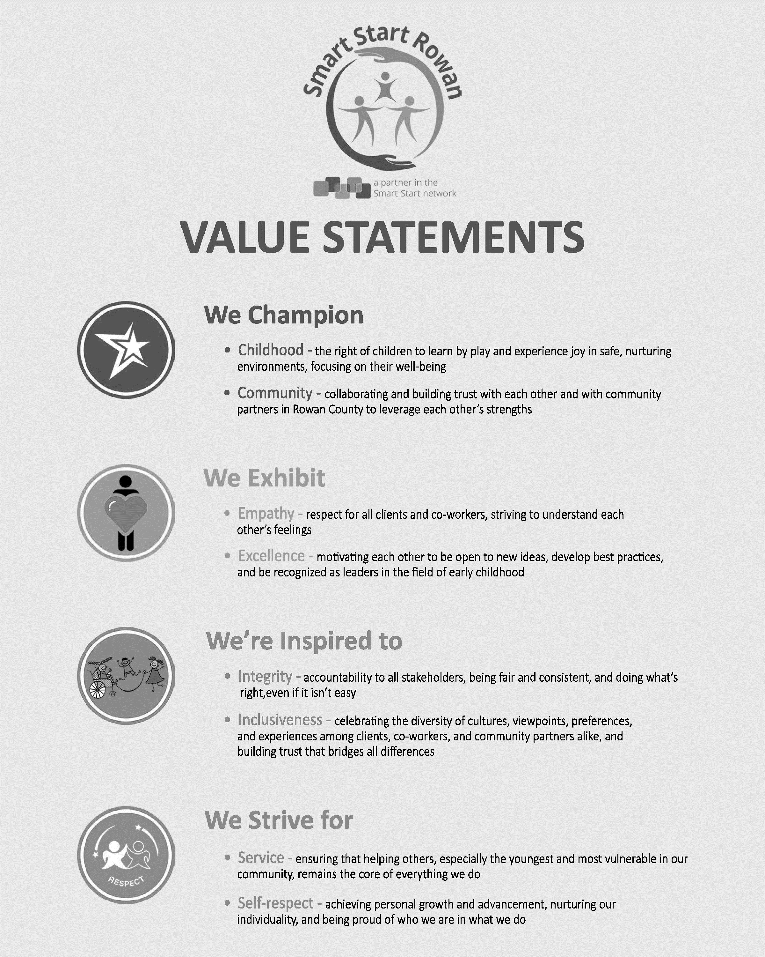

Review of Strengths & Opportunities
During the Strategic Plan review, the Board examined the agency’s Value Statements and were given the opportunity to suggest revisions to them. Highlights of the discussion about the Value Statements and SSR’s strengths included the following:
- Agency Value Statements developed by the staff, because they highlight the right of children to experience joy, the necessity of collaboration with community partners, the respect that must be given to all the diverse families we work with, and the accountability and consistency required to be leaders in the early childhood field.
- Smart Start Rowan has effectively built trust with other community partners and used that trust to fuel successful collaborations and partnerships.
- SSR has dedicated leadership and a stable financial base that display accountability and consistency.
- SSR staff respect and celebrate the diverse perspectives of the clients they serve; additionally, SSR has internally increased their diversity and focus on inclusion and equity, allowing them to better understand the families they serve, knowing that every culture is different and unique.
- SSR has successfully built a collaborative staff/team that works well together to meet community needs.
- The increased profile of Smart Start Rowan within the community over the past few years reflects the effectiveness of its outreach and messaging efforts.
Alongside these strengths come opportunities to build on Smart Start Rowan’s work, especially based on the emerging needs that the COVID-19 pandemic has created. Highlights of the discussion about opportunities for SSR included the need to maintain SSR’s focus on:
Affordable Child Care, Quality Child Care/NC Pre-Kindergarten programming, Family Support, Literacy, and Health. Revisions to a couple of key areas and implementation strategies will also be made to ensure that SSR’s programs and services provide adequate support for COVID-19 related needs.

Goal 1: Increase access to affordable child care in Rowan County
Objective 1: Continue to support funding of subsidy activities that put a greater emphasis on reducing Rowan County’s waiting list for child care subsidy, as applicable
Potential Strategies:
- DSS Subsidy
- Dual Subsidy TANF/CCDF
- NC Pre-K Subsidy Expansion
Desired Results:
- PLA40, average star rating for all children 0-5 in child care
- PLA50, average star rating for subsidized children 0-5 in child care
Objective 2: Continue to ensure Smart Start Rowan’s capacity to administer subsidy funding
Potential Strategies:
- DSS Subsidy Services Support
- Dual Subsidy Services Support
Desired Results:
- N/A

Goal 2: Improve the quality of child care in Rowan County
Objective 1: Continue to explore options to incentivize child care teachers and directors to further their education, as well as to provide resources and general technical assistance and training to support early childhood programs
Potential Strategies:
- Child Care Resource & Referral
- Education in Action
- Early Learning Resource Center (ELRC)
- NC Pre-K Quality Enhancement and Support
- WAGE$
Desired Results:
- EDU10, percent of children 0-5 enrolled in centers where 75% of lead teachers have college degrees
- EDU20, percent of children 0-5 enrolled in centers whose directors have college degrees
- PLA40, average star rating for all children 0-5 in child care
- Number of child care professionals selecting on a survey that the ELRC was used to “expand my curriculum”
Objective 2: Continue to assist classrooms in managing children who exhibit challenging behaviors
Potential Strategies:
- Behavioral Support (not currently being funded)
- NC Pre-K Quality Enhancement and Support

Desired Results:
- Improvement on the Teaching Pyramid Observation Tool (TPOT) for Behavioral Support (not currently being funded) and NC Pre-K Quality Enhancement and Support
Goal 3: Strengthen parenting skills of Rowan County’s families
Objective 1: Continue to work on strengthening the network of Triple P facilitators across multiple community partners
Potential Strategies:
- Triple P
Desired Results:
- FS30, percent of children 0-5 with an investigated abuse/neglect report
Objective 2: Continue providing the current playgroup model for families
Potential Strategies:
- Kaleidoscope Play and Learn
Desired Results:
- FS30, percent of children 0-5 with an investigated abuse/neglect report
Objective 3: Continue providing existing, successful literacy programs
Potential Strategies:
- Dolly Parton’s Imagination Library
- Reach Out & Read (not Smart Start funded beginning 7/1/23)
Desired Results:
- FS20, percent of parents/guardians of children 0-5 who report reading to their children daily, or at minimum, 4-6 days a week
Objective 4: Continue offering child development and family support related resources to parents and caregivers
Potential Strategies:
- Early Learning Resource Center (ELRC)
Desired Results:
- Number of families selecting on a survey that the ELRC was used to “provide educational material”
Goal 4: Support the health of Rowan County’s children
Objective 1: Focus health education activities in the child care setting on supporting the health and safety of the children enrolled, while also providing information and resources to support the importance of nutrition and physical activity
Potential Strategies:
- Child Care Health Consultation (CCHC)
Desired Results:
- Adequate scores in the areas of the CCHC Health and Safety Assessment that pertain to the early childhood program’s health and safety related action plan
- H60, percent of low-income children 2-4 at a healthy weight

Objective 2: Continue existing programs that assist pediatric professionals in providing appropriate care to young children
Potential Strategies:
- ABCD (Assuring Better Child Health & Development)
- Healthy Beginnings
Desired Results:
- H10, percent of children 0-5 who receive early intervention or special education services
- H20, percent of children 0-5 enrolled in Medicaid who receive a well-child exam
Goal 5: Ensure Smart Start Rowan can properly administer and coordinate services for young children
Objective 1: Continue to assess the organization’s capacity to ensure the quality of the NC Pre-K program and alter staffing structure as needed to ensure this capacity
Potential Strategies:
- NC Pre-K Administration/NC Pre-K Child Care Development (CCDF) (not Smart Start funded)
Desired Results:
- N/A
Objective 2: Maintain systems building activities that allow the organization to collaborate with community partners, provide outreach and awareness about available programs and services to families, and ensure quality service and accountability

Potential Strategies:
- Community Awareness & Education
- Program Coordination & Evaluation
Desired Results:
- As a result of outreach and community events conducted by Smart Start Rowan, number of families selecting on a survey “I learned about services or programs I could participate in”

