

🌟 Training Catalog – Winter 2025 🌟
Smart Start Rowan
1329 Jake Alexander Blvd S. Salisbury, NC 28146

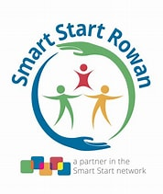
Register Online: www.rowan-smartstart.org

📋 Training Rules & Expectations

📍 In-Person Expectation Overview
🎯 Purpose
- Provide high-quality professional learning in a respectful and engaging environment.
🕒 Attendance & Participation
- ✅ Full Attendance: Participants must remain for the entire training to receive credit. Early departures may result in denial of credit.
- 🖊️ Sign-In: Participants must sign in at the beginning of the session. Missing signatures may forfeit credit.
- 💬 Active Participation: Ask questions, join discussions, and complete required activities.
🤝 Professional Conduct
- 🙌 Respectful Behavior: Be respectful to trainers and other attendees. Disruptive or inappropriate behavior will not be tolerated.
- 📱 Electronic Devices: Silence phones and avoid texting or unrelated device use unless directed as part of the session.
- 👔 Dress Code: Dress appropriately for a professional learning environment.
🧾 Credit Eligibility & Documentation
- 📝 Verification: Trainers will verify participation through attendance logs and engagement.
- 🗒️ Pre & Post Questionnaire: Must be completed to receive credit.
- 📝 Evaluation Form: Required for certificate issuance.
- 🧾 Accurate Information: Name on sign-in sheet must match your official DCDEE documentation.
- 🌐 Full Expectations are available on our website.

💻 Virtual Expectations Overview
🕒 Attendance & Participation
- ✅ Timeliness: Join on time. Late arrivals may not be eligible for credit.
- ✅ Full Attendance: Remain for the entire training.
- 🎥 Engagement:
  - Camera must be on (unless pre-approved for accessibility/technical reasons).
  - Participate in discussions, polls, breakout rooms, and activities.
  - Avoid multitasking or unrelated activities.
🧾 Credit Eligibility & Documentation
- 📝 Verification: Attendance verified by login data, engagement tracking, and visible participation.
- 🗒️ Pre & Post Questionnaire: Required for training credit.
- 📝 Evaluation Form: Must be completed for certificate issuance.
- 🧾 Correct Name Usage: Log in with your registration/official DCDEE name, or type full name into chat if not possible.
- 🌐 Full Expectations are available on our website.
🖊️ How to Register
- 🌐 Online: www.rowan-smartstart.org
- 📞 By phone: (704)-603-3433
- ✉️ By mail or in person: Send registration form and payment to:
Smart Start Rowan
1329 Jake Alexander Blvd. S.
Salisbury, NC 28146

💳 Registration & Payment Information
- 🌐 Online: All major credit cards accepted at www.rowan-smartstart.org
- 📞 By phone: Trainings over $10 may be paid by credit card.
- ✉️ By mail or in person: Pay by cash, check, or credit card with your registration form.
⚠️ Spaces cannot be held without payment!
Note: Several trainings are provided by non–Smart Start Rowan employees. Please check the training calendar for registration instructions for those sessions.

🏫 Center Trainings
We are available to provide custom trainings either off-site at your center or at our office.
- 💲 $50 per hour (with a 2-hour minimum) for standard trainings
- 📚 CEU trainings: $35 per participant (minimum of 8 participants required)

🎓 Training Certificates
- Certificate distribution: Training certificates are distributed to participants when the session concludes for most trainings.
- CEU courses: For some learning events, such as CEU courses, certificates are mailed after successful completion.
- Series trainings: Some trainings are offered as a series with additional assignments to be completed outside of the scheduled training. Participants must attend all sessions in the series and complete any assignments to receive the training certificate.
- Replacement certificates: Replacement training certificates cannot be provided.
  - Smart Start Rowan can issue an official letter verifying participation in a training within 2 years from the date of the training.
  - Please provide the title and date of the training and the participant’s name.
  - The first official letter is free; afterwards, a $3.00 fee will be charged.

❌ Cancellations & Refunds
- Participant cancellations:
  - You may cancel up to 24 hours prior to the training date to receive credit toward another training.
  - A substitute may attend in your place.
  - Failure to cancel within 24 hours will result in forfeiture of the registration fee.
- No-shows / partial attendance:
  - Registered participants who do not attend a session, or do not complete a series in its entirety, and have not canceled per policy, will not receive a refund and cannot transfer fees to another learning event.
- Provider cancellations:
  - If Smart Start Rowan must cancel due to inclement weather, staff emergency, or low enrollment, your fee may be applied to another training or you may request a refund.
  - Money credited for canceled trainings will expire 1 year from the date issued.
  - If fewer than 8 participants are registered, the training may be canceled. Registered participants will be notified by telephone.

📞 More Information
For more information on trainings, please contact
Betty Trujillo, Early Education Program Manager
(704) 603-3351

💬 We Value Your Feedback!
Smart Start Rowan is committed to providing trainings that meet the needs of our community. We would love to hear your feedback!
Send your ideas for future trainings to: btrujillo@smartstartrowan.org

📍 In-Person Trainings
First Aid / CPR
📅 Monday, January 12, 2026 | 5:15 pm -9:15pm
📍 311 Webb Rd
🧾 Kristen Zapata 💲 $75 | Pay Trainer
This course provides child care professionals with essential lifesaving skills to respond confidently during emergencies. Participants will learn the fundamentals of Basic First Aid, including how to recognize and care for injuries, sudden illnesses, and common childhood emergencies. The training also covers CPR techniques for infants, children, and adults.
Through hands-on practice, demonstrations, and real-life scenarios, educators will gain the knowledge and skills needed to respond quickly and effectively in critical situations. Upon successful completion, participants will receive certification in Basic First Aid and CPR, meeting state child care licensing requirements.
Autism in Child Care: A foundation for early educators
📅 Tuesday, January 15, 2026 | 6:30 pm - 8:30 pm
📍 Smart Start Rowan
🧾 Kimberly Cruz 💲 $10 | 🧾 2.0 hrs
Participants will have an increased knowledge of early signs and detection of autism for young children, while also gaining the knowledge to share concerns with caregivers, identify resources that support and assist young children with autism in the ECE setting, and explore developmentally appropriate activities and inclusion practices to young children with autism.
Allergies and Anaphylaxis
📅 Thursday, February 12, 2026 | 6:30 pm - 8:30 pm
📍 Smart Start Rowan
🧾 Kimberly Cruz 💲 $10 | 🧾 2.0 hrs
Participants will learn about allergies and common allergens, how to reduce the risk of developing allergies and reduce exposure to allergens, to recognize signs and symptoms of severe allergic reactions, including anaphylaxis, become familiar with proper storage and use of epinephrine auto-injectors, how to follow emergency follow-up procedures, and about required documentation.
First Aid / CPR
📅 Monday, March 9, 2023 | 5:15 pm -9:15pm
📍 311 Webb Rd
🧾 Kristen Zapata 💲 $75 | Pay Trainer
This course provides child care professionals with essential lifesaving skills to respond confidently during emergencies. Participants will learn the fundamentals of Basic First Aid, including how to recognize and care for injuries, sudden illnesses, and common childhood emergencies. The training also covers CPR techniques for infants, children, and adults.
Through hands-on practice, demonstrations, and real-life scenarios, educators will gain the knowledge and skills needed to respond quickly and effectively in critical situations. Upon successful completion, participants will receive certification in Basic First Aid and CPR, meeting state child care licensing requirements.
ITS_SIDS
📅 Tuesday, March 17, 2026 | 6:30 pm - 8:30 pm
📍 Smart Start Rowan
🧾 Kimberly Cruz 💲 $10 | 🧾 2.0 hrs
ITS-SIDS was developed by the NC Healthy Start Foundation's ITS-SIDS Project. This session meets state requirements for ITS-SIDS training. Participants will learn to reduce the risk of SIDS through safe sleep practices for infants. Participants will also review Safe Sleep Policy guidelines, NC Division of Child Development and Early Education licensing rules, and maintenance of the proper forms.

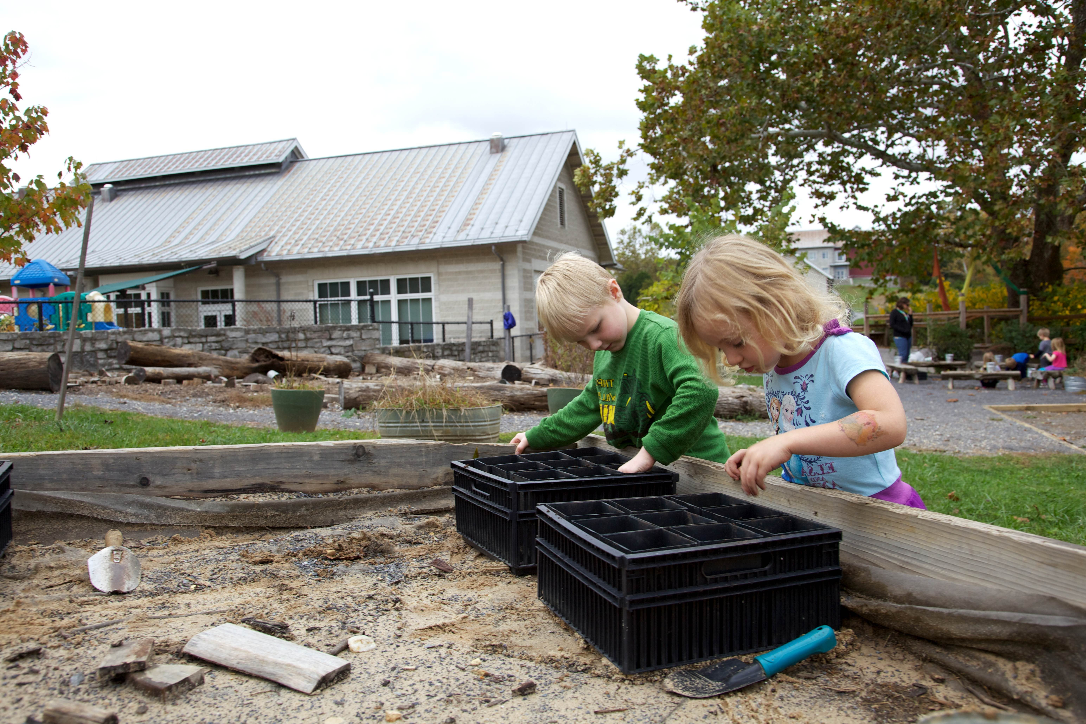
💻 Virtual Trainings
Sensory Exploration: beyond the basics
📅 Thursday, January 22, 2026 | 6:30 pm - 8:30 pm
📍 Rowan/Zoom
🧾 Betty Trujillo 💲 $10 | 🧾 2.0 hrs
This interactive training helps teachers design meaningful sensory experiences that support early brain development. Participants will explore hands-on sensory stations and learn how to create affordable sensory bins that build language, fine motor skills, and self-regulation. Educators will leave with a ready-to-use sensory toolkit and practical strategies aligned with ECERS-3 and NC FELD.
Use Your Words: How Our Words Impact Children
📅 Thursday, January 29, 2026 | 6:30pm -8:30 pm
📍 Rowan/Zoom
🧾 Jessica Lane 💲 $10 | 🧾 2.0 hrs
“Sticks and Stones may break my bones, but words will never hurt me” a phrase that has been used for many years spreading a false sentiment. Research has shown that the words we use in the classroom as early childhood professionals have lasting effects on a child’s cognitive and social-emotional development. We often find ourselves reminding students to “use their words” or “we only use kind words”, but are we being mindful of the words we are using? This training focuses on informing, reflecting on, and providing strategies that support teachers in using intentional language and tones that support the healthy development of the students in their care.
Positive Guidance & Behavior Support Toolkit
📅 Thursday, February 5, 2026 | 6:30 pm - 8:30 pm
📍 Rowan/Zoom
🧾 Betty Trujillo 💲 $10 | 🧾 2.0 hrs
This training introduces simple, developmentally appropriate tools that help reduce challenging behaviors and promote emotional regulation. Teachers will participate in real-world scenario practice and create a calm-down kit to use immediately in their classroom. Strategies support the Pyramid Model, ECERS-3 interactions, and trauma-informed practice.

STEM for Littles: Creating Simple STEM Bins
📅 Thursday, February 19, 2026 | 6:30 pm - 8:30 pm
📍 Rowan/Zoom
🧾 Betty Trujillo 💲 $10 | 🧾 2.0 hrs
STEM doesn’t require expensive materials—just curiosity and the right strategies. In this hands-on training, teachers create STEM exploration bins and practice supporting children’s problem-solving using open-ended questions. Participants will explore building challenges, science exploration, and ways to integrate math and engineering into everyday play.
Teacher Talk Toolkit: Expanding Language & Literacy
📅 Thursday, February 26, 2026 | 6:30 pm - 8:30 pm
📍 Rowan/Zoom
🧾 Betty Trujillo 💲 $10 | 🧾 2.0 hrs
Quality teacher-child interactions form the foundation for strong language development. In this training, participants will practice modeling language, asking open-ended questions, and embedding literacy in all classroom centers. Through hands-on practice activities and role-play, teachers build confidence in responsive conversation strategies to strengthen children’s vocabulary and communication skills.
Behavior Basics: Routines, Consistency & Visual Supports Tool Kit
📅 Thursday, March 5, 2026 | 6:30 pm - 8:30 pm
📍 Rowan/Zoom
🧾 Betty Trujillo 💲 $10 | 🧾 2.0 hrs
This online training focuses on using predictable routines, consistent expectations, and visual supports to reduce challenging behaviors and increase children’s independence. Participants learn how to create and use a “Behavior Support Tool Kit” that can be shared with families or used in virtual coaching sessions. The training includes modeling, scenarios, and printable templates teachers can customize.
Emergency Preparedness and Response
📅 Thursday, March 26, 2026 | 6:00 pm - 8:30 pm
📍 Rowan/Zoom
🧾 Betty Trujillo 💲 $15 | 🧾 2.5 hrs
Emergency Preparedness and Response (EPR) in Child Care Training provides early educators with information and tools to prepare for many types of emergencies. The EPR in Child Care Training addresses NC Child Care Rules on emergency preparedness, current best practices recommendations, and guidance on completing the online EPR Plan.


📝 Registration Form
Please complete this form to register for trainings. You may fill it out digitally and email it to us, or print and return with payment.
First Name: ____________________________
Last Name: ____________________________
Email: ____________________________
Phone: ____________________________
Employer: ____________________________
County: ____________________________
Select Trainings:
[ ] First Aid / CPR📅 Monday, January 12, 2026 | 5:15 pm -9:15pm 🧾 Kristen Zapata 💲 $75 | Pay Trainer
[ ] Autism in Child Care: A foundation for early educators📅 Tuesday, January 15, 2026 | 6:30 pm - 8:30 pm 🧾 Kimberly Cruz 💲 $10 | 🧾 2.0 hrs
[ ] Allergies and Anaphylaxis 📅 Thursday, February 12, 2026 | 6:30 pm - 8:30 pm 🧾 Kimberly Cruz 💲 $10 | 🧾 2.0 hrs
[ ] First Aid / CPR 📅 Monday, March 9, 2023 | 5:15 pm -9:15pm 🧾 Kristen Zapata 💲 $75 | Pay Trainer
[ ] ITS_SIDS 📅 Tuesday, March 17, 2026 | 6:30 pm - 8:30 pm 🧾 Kimberly Cruz 💲 $10 | 🧾 2.0 hrs
[ ] Sensory Exploration: beyond the basics 📅 Thursday, January 22, 2026 | 6:30 pm - 8:30 pm
🧾 Betty Trujillo 💲 $10 | 🧾 2.0 hrs
[ ] Use Your Words: How Our Words Impact Children 📅 Thursday, January 29, 2026 | 6:30pm -8:30 pm 🧾 Jessica Lane 💲 $10 | 🧾 2.0 hrs
[ ] Positive Guidance & Behavior Support Toolkit 📅 Thursday, February 5, 2026 | 6:30 pm - 8:30 pm 🧾 Betty Trujillo 💲 $10 | 🧾 2.0 hrs
[ ] STEM for Littles: Creating Simple STEM Bins 📅 Thursday, February 19, 2026 | 6:30 pm - 8:30 pm 🧾 Betty Trujillo 💲 $10 | 🧾 2.0 hrs
[ ] Teacher Talk Toolkit: Expanding Language & Literacy 📅 Thursday, February 26, 2026 | 6:30 pm - 8:30 pm 🧾 Betty Trujillo 💲 $10 | 🧾 2.0 hrs

[ ] Behavior Basics: Routines, Consistency & Visual Supports Tool Kit 📅 Thursday, March 5, 2026 | 6:30 pm - 8:30 pm 🧾 Betty Trujillo 💲 $10 | 🧾 2.0 hrs
[ ] Emergency Preparedness and Response 📅 Thursday, March 26, 2026 | 6:00 pm - 8:30 pm
🧾 Betty Trujillo 💲 $15 | 🧾 2.5 hrs

Total Payment: $ ____________
Register online at: www.rowan-smartstart.org

