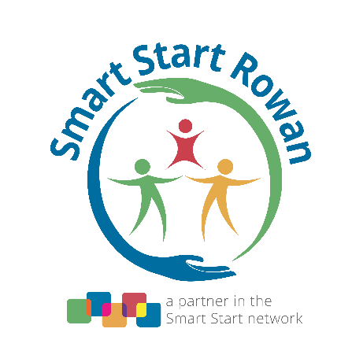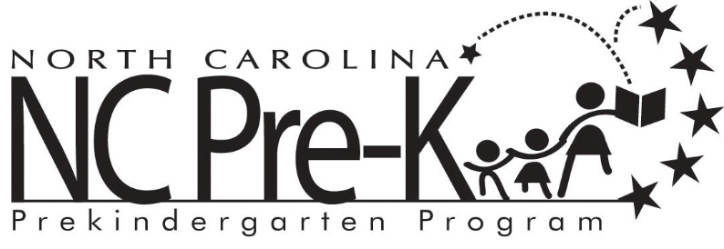

**2023-2024 NC Pre-K Non-Conflicted Committee Meeting Schedule**

July 19, 2023 at 2:00 pm

August 16, 2023 at 2:00 pm

October 18, 2023 at 2:00 pm

January 17, 2024 at 2:00 pm

March 20, 2024 at 2:00 pm

June 19, 2024 at 2:00 pm

*If you are a community member who would like to attend virtually, please contact Amanda May at amay@smartstartrowan.org in order to receive access to the meeting.