**The Hooker Lake Management District**

**Will be holding a meeting on**

**August 19TH, 2025**

**At 7:00 P.M. at the**

**Salem Lakes Village Hall**

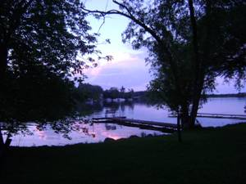

**Agenda**

1. Call meeting to order.
2. Roll Call
3. Approval July 22ND meeting minutes
4. Treasurer’s Report
5. Discuss 2025 weed treatment
6. Discuss 2026 weed treatment
7. 2026 Budget Planning
8. Discuss Lake quality monitoring
9. Any Old Business as allowed by law.
10. Any New Business as allowed by law
11. Set next meeting Date
12. Adjournment