The Ramp That Belongs On Every Shed!
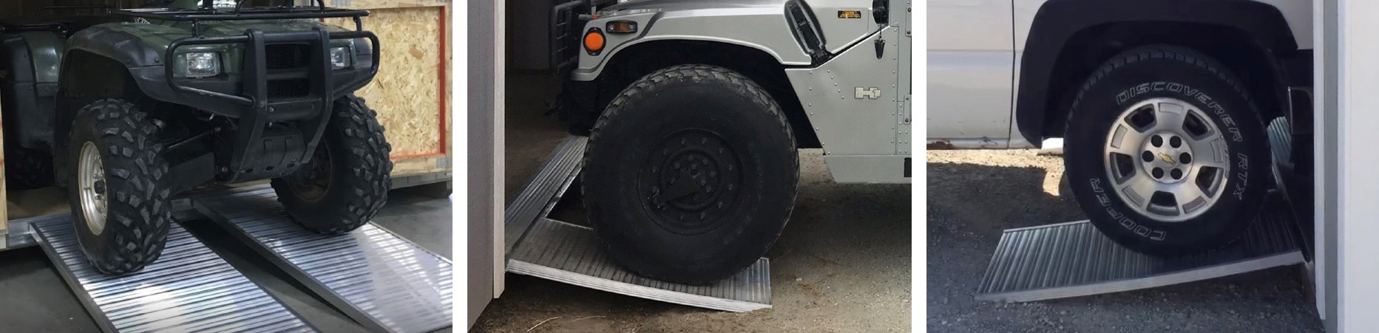
 | STANDARD |  | HEAVY-DUTY |  | ULTRA HEAVY-DUTY |  | AL-W-A
SIZE | WEIGHT | CAPACITY | WEIGHT | CAPACITY | WEIGHT | CAPACITY | CAPACITY
23 x 30 | 11 lbs. | 1,445 lbs. | 12 lbs. | 1,771 lbs. | 13 lbs. | 1,955 lbs. | 1,105 lbs.
23 x 36 | 13 lbs. | 1,335 lbs. | 14 lbs. | 1,615 lbs. | 15 lbs. | 1,774 lbs. | 1,026 lbs.
23 x 42 | 15 lbs. | 1,226 lbs. | 17 lbs. | 1,507 lbs. | 18 lbs. | 1,625 lbs. | 940 lbs.
23 x 48 | 17 lbs. | 1,117 lbs. | 19 lbs. | 1,349 lbs. | 20 lbs. | 1,507 lbs. | 849 lbs.
23 x 54 | 19 lbs. | 1,007 lbs. | 21 lbs. | 1,187 lbs. | 23 lbs. | 1,410 lbs. | 752 lbs.
23 x 60 | 21 lbs. | 898 lbs. | 24 lbs. | 1,020 lbs. | 26 lbs. | 1,329 lbs. | 649 lbs.
23 x 66 | 23 lbs. | 789 lbs. | 25 lbs. | 881 lbs. | 27 lbs. | 1,258 lbs. | 840 lbs.
23 x 72 | 25 lbs. | 680 lbs. | 27 lbs. | 757 lbs. | 29 lbs. | 1,190 lbs. | 425 lbs.
